

Advice on
NZ ETS unit limits and
price control settings
for 2027–2031

Technical annex 1: Unit limit settings

April 2026

Contents
1 Introduction 3
1.1 About this document 3
Part 1: The NZ ETS emissions cap 5
2 About the NZ ETS emissions cap 5
2.1 Calculation of the NZ ETS emissions cap used in our recommendations 6
Agriculture 7
Non-municipal waste 7
F-gases 7
Industrial processes and product use 7
Biomass combustion 8
Forests not covered by the NZ ETS 8
Overall breakdown of projected emissions 9
2.2 Annual distribution of emission cap 11
2.3 Other emissions cap options considered 11
The second emissions budget 11
The third emissions budget 12
Part 2: Unit limits method 14
3 Step 1: Convert and align emissions and units (technical adjustments) 14
3.1 Waste 15
Unique emissions factors 16
Discrepancy between landfill gas (LFG) capture rates 17
3.2 Liquid fossil fuels and gas 17
3.3 Coal and steel production 18
3.4 Geothermal, IPPU and F-gases 19
3.5 Forestry 19
3.6 Overall step 1 results – conversion of emissions cap to unit volumes 21
4 Step 2: Account for industrial free allocation 21
Changes in industrial allocation forecast 22
5 Step 3: Estimate surplus range 23
5.1 Total unit holdings 23
5.2 Pre-1990 units held long-term 24
5.3 Units held for surrender for past emissions (holding volume) 25
5.4 Units held for forward hedging by emitters 26
Hedging assumptions 26
Base year for hedging estimates 27
Detailed assumptions relating to hedging 27
5.5 Units held for post-1989 harvest liabilities 27
Harvest age data and assumptions 28
Exotic forests assumed to be managed as permanent 29
Low-risk units 31
Range of estimated units held for post-1989 harvest liabilities 33
5.6 Forestry unit reconciliation 34
5.7 Forestry technical adjustment 35
5.8 Surplus range estimate 35
6 Step 5: Range of possible auction volumes 37
6.1 Range of auction volumes for 2027–2030 37
6.2 Auction volumes for 2031 38
Surplus reduction volumes post 2030 38
Auction volumes 39
6.3 Proposed auction volumes over settings period 39
7 References 41

- Introduction
This document is published by He Pou a Rangi Climate Change Commission (the Commission) in support of our advice to Government on the NZ ETS unit limits and price control settings for 2027–2031 (the advice report).
It is a technical annex to that advice, providing further information on the data, methodology, and key assumptions we have taken to reach our final unit limit settings recommendations.
The document should be read alongside the NZ ETS emissions cap and Unit limits chapters of the advice report. The accompanying unit limit calculations Excel workbook is also published on our website.
Separate documents are available that provide more in-depth information on the analysis we completed around differences between forestry accounting methodologies within the NZ ETS and under target accounting, and additional information on the Commission’s NZ ETS forestry model.
  - About this document
This document sets out further detail on the calculations which support our analysis for determining the NZ ETS emissions cap, and the unit limits method which determines the range of possible auction volumes.
As set out in the Unit limits chapter of the advice report, we have used a unit limits method with five steps to determine auction volume options.
The five steps are:
- Convert and align emissions and units (technical adjustments)
- Account for industrial free allocation
- Estimate surplus range
- Set limit on approved overseas units (not discussed in this annex)
- Determine range of possible auction volumes.
As discussed in the advice report, the unit limits method has been presented differently compared to previous NZ ETS settings advice. This presentation now highlights that setting the NZ ETS emissions cap is an overarching step that underpins the analysis for both the unit limits and price controls. We have also removed what was previously step 1 of the unit limits method as it related to how the NZ ETS settings should align with emissions reduction targets. This step is no longer needed due to amendments to the Climate Change Response Act which mean the NZ ETS settings are no longer required to accord with nationally determined contributions.
This document first discusses the calculation of emissions covered and not covered by the NZ ETS, used as part of determining the NZ ETS emissions cap. It then discusses the steps in the unit limits method.

Part 1: The NZ ETS emissions cap
- About the NZ ETS emissions cap
The NZ ETS emissions cap is the intended constraint on emissions from sectors covered by the NZ ETS. In our advice we consider the emissions caps for both the second emissions budget (2026–2030) and the third emissions budget (2031–2035).
In August 2025, the Government announced decisions on the emissions cap for the second emissions budget (89.4 MtCO₂e), and a provisional cap for the third emissions budget (40.7 MtCO₂e). The Government’s provisional emissions cap for the third emissions budget was based on the second emissions reduction plan emissions projections for NZ ETS sectors, minus the total additional abatement required to reach the third emissions budget.¹
Since this announcement, the 2025 government emissions projections were released. These show lower emissions overall but higher agricultural emissions than in the previous projections. Based on this new information, we assess that neither of the Government’s previously announced emissions caps still aligns with emissions budgets.
As set out in the advice report, we have based the emissions cap used in our advice on the 2025 government emissions projections. To do this we determined an allocation of NZ ETS and non-NZ ETS sector emissions based on the projections. The projections do not meet the third emissions budget and the Commission’s proposed emissions cap for that period assumes all extra abatement required to meet the budget will need to be delivered by NZ ETS sectors.
Figure 1 shows the resulting allocation of emissions to non-NZ ETS and NZ ETS sectors over the period of the settings (2027–2031).
In this section we set out in more detail the calculation of emissions covered and not covered by the NZ ETS, applied to the 2025 government emissions projections to work out the proposed NZ ETS emissions cap used for our NZ ETS settings recommendations.
In the advice report we present alternative options for the NZ ETS emissions cap which we have considered. At the end of this section we set out at a high level how these options were calculated.

Figure 1: Breakdown of NZ ETS and non-NZ ETS emissions projections over settings period, including proposed NZ ETS cap

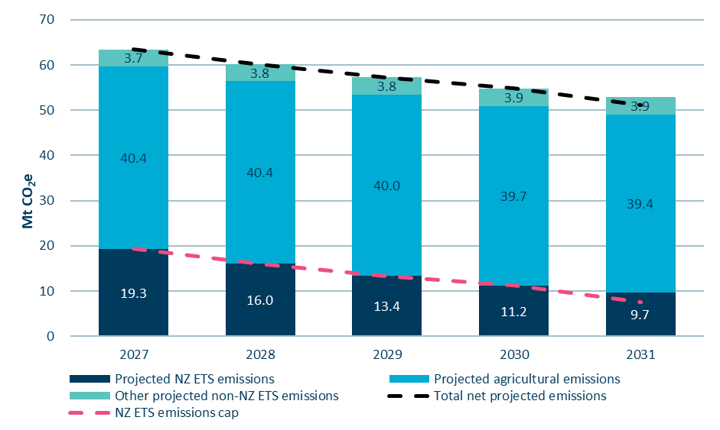
Source: Commission analysis

  - Calculation of the NZ ETS emissions cap used in our recommendations
This section sets out more detail on our allocation of the allowed emissions volume under emissions budgets to the six sectors listed below, which are not covered, or are only partially covered, by the NZ ETS:
- Agriculture
- Non-municipal waste
- F-gases
- Industrial Processes and Product Use (IPPU)
- Biomass combustion
- Forestry.
Below, we describe how we reached our updated estimates of projected emissions covered and not covered by the NZ ETS for each of these sectors. We note where we have used the government’s emissions projections as the basis for the allocation, or where other data and analysis has been used to enable a more granular emissions allocation to the sectors outside the NZ ETS. As discussed in the advice report, we have used the “with additional measures” (WAM) central projection in our emissions cap calculations.

Agriculture
Agricultural emissions, including biogenic methane and nitrous oxide emissions from agriculture, are not covered by the NZ ETS. All agricultural emissions are therefore allocated as being outside of the NZ ETS.

Non-municipal waste
Non-municipal waste emissions are outside the NZ ETS, as only methane emissions from municipal landfill facilities are subject to NZ ETS obligations. In our calculations for the NZ ETS emissions cap, we used the projected non-municipal waste emissions in the detailed breakdown of the Energy and Emissions in New Zealand (ENZ) modelling used in the updated 2025 government emissions projections. This detailed ENZ breakdown was supplied to us by the Ministry for the Environment (MfE).

F-gases
Some fluorinated gas emissions (F-gases) associated with certain goods and vehicles are priced via the Synthetic Greenhouse Gas (SGG) levy instead of being covered by the NZ ETS. A breakdown of NZ ETS and SGG levy F-gases is not provided in the government emissions projections and therefore needs to be estimated. We have assumed that 80% of forecast
F-gas emissions will not be covered by the NZ ETS. This is based on comparing F-gas emissions reported in the NZ ETS over 2019–2023 with those recorded in the Greenhouse Gas (GHG) Inventory.
This is a different approach than we have taken in previous years, where we compared
NZ ETS reported F-gas emissions with those covered by the SGG levy, which gave an assumption of 52%. Our previous approach did not account for discrepancies between F-gas emissions reported in the NZ ETS and through the SGG levy, and the GHG Inventory. This was considered separately through a later step in the unit limits method. This year we have simplified the approach and compared directly to the GHG Inventory.

Industrial processes and product use
Several small emissions sources in the Industrial Processes and Product Use (IPPU) inventory category are outside of the NZ ETS. These include:
- non-energy products from fuels and solvent use
- sulphur hexafluoride and perfluorocarbons from medical and other product use
- nitrous oxide from medical applications
- other uses of carbonate.
The 2025 government emissions projections do not separate IPPU emissions into this level of detail. To determine an estimate, we took historical data from the GHG Inventory Common Reporting Format (CRF) tables that separate out these categories. We then determined their average historic proportion of total IPPU emissions. Over the last five years the average percentage was 4.4%. We have applied this percentage to future IPPU emissions projections to estimate the volume not covered by the NZ ETS. This is a minor update from 4.2% used in our previous advice.

Biomass combustion
When biomass is combusted, in addition to carbon dioxide emissions, a small amount of methane and nitrous oxide emissions is produced. These methane and nitrous oxide emissions from biomass combustion are not covered by the NZ ETS. The projected biomass emissions are provided in the detailed breakdown of the ENZ modelling used for the 2025 government emissions projections.

Forests not covered by the NZ ETS
For owners of post-1989 forests, participation in the NZ ETS is voluntary. Some deforestation of native forests is also outside the NZ ETS. In determining our proposed NZ ETS emissions cap, we estimate the net effect of these forestry emissions and removals outside the scheme and subtract them from the emissions budget volume..

Exotic forests
To determine the area of post-1989 exotic forest outside the NZ ETS we compared the total annual area of afforestation reported in the GHG Inventory with the area of forest registered in the NZ ETS.
For forests planted before 2006, the NZ ETS-registered area is consistently lower than the area reported in the GHG Inventory. From 2006 onwards, there are some slight discrepancies between the NZ ETS-registered area and the area reported in the GHG Inventory. Discrepancies in recent years are likely due to a time lag between planting being reported in the GHG Inventory and the forest being registered in the NZ ETS. We consider that, over time, the NZ ETS-registered area is likely to closely match the GHG Inventory. Therefore, we have assumed that:
- for 1990–2005 only the NZ ETS-registered forest area is within the NZ ETS
- for 2006–2023 the full area reported in the GHG Inventory will be registered in the NZ ETS.
The Government has announced it intends to partner with the private sector to plant forests on Crown-owned land. The Government’s stated intention is that as little as possible of this new forestry should be registered in the NZ ETS.²
Based on information provided to us by MfE, we have calculated the assumed impact of the afforestation on Crown-owned land policy as the difference between the forecast area of afforestation in the “with existing measures” and the “with additional measures” central emissions projections.
Based on this we assume that 175,000 hectares of afforestation over 2027–2050 will not be registered in the NZ ETS. We assume the remaining projected afforestation, from 2024–2050, will be registered in the NZ ETS.

Native forests
There are significant year-to-year differences between the areas of post-1989 native forest reported as established in the GHG Inventory and the areas registered in the NZ ETS. However, looking over a longer time period (1990–2020), these differences even out and the aggregate figures match very closely. Our assumption is that the year-to-year differences between the two data sets arise from differences in when forests are recorded as having been established. The close match in areas over the longer time period suggests that nearly all post-1989 native forests are now registered in the NZ ETS. Accordingly we assume that 100% of post-1989 native forest is in the NZ ETS.

Forecast deforestation outside the NZ ETS
Two categories of deforestation emissions are outside the NZ ETS:
- deforestation of pre-1990 native forest
- deforestation of post-1989 forests that have not registered into the NZ ETS.
The 2025 government emissions projections detail the total area of expected deforestation, but do not break this down by type of forest (e.g., native versus exotic, post-1989 versus pre-1990). We assume that all projected deforestation occurs outside the NZ ETS.

Overall breakdown of projected emissions
Table 1 shows the resulting breakdown of the total projected emissions into emissions outside and inside of the NZ ETS over the second and third emissions budget periods.

Table 1: WAM central projections broken down into NZ ETS and non-NZ ETS emissions
 | Sector (MtCO₂e) | 2026–2030: second emissions budget | 2031–2035: third emissions budget
Total allowed emissions under emissions budget |  | 305 | 240
Total net projected emissions |  | 301.4 | 248.7
Emissions outside of the NZ ETS | Agriculture | 200.9 | 194.0
Emissions outside of the NZ ETS | Non-municipal waste | 8.9 | 9.4
Emissions outside of the NZ ETS | F-gases | 3.5 | 3.1
Emissions outside of the NZ ETS | IPPU | 0.7 | 0.6
Emissions outside of the NZ ETS | Biomass combustion | 0.3 | 0.3
Emissions outside of the NZ ETS | Forestry removals | -0.2 | -1.8
Emissions outside of the NZ ETS | Forestry emissions | 5.4 | 5.5
Sum of net projected emissions outside of the NZ ETS |  | 219.5 | 211.1
 | Gross emissions in the NZ ETS | 151.9 | 135.5
 | Forestry in the NZ ETS | -70.0 | -97.8
Sum of net projected emissions in the NZ ETS |  | 81.9 | 37.7
Difference to notified budgets |  | -3.6 | +8.7
Emissions cap used in our advice |  | 81.9 | 28.9
  - Annual distribution of emission cap
Although we determine emissions caps for each emissions budget period, to calculate annual unit limits it is necessary to distribute the emissions cap volume to each year. In other words, we need to set a trajectory for how allowed emissions track down over time.
For the second emissions budget period, we allocate the emissions cap across each year in line with the projected NZ ETS emissions.
For the third emissions budget period, if the emissions cap is proportionately distributed in line with the emissions projections, this leads to an emissions cap volume in 2035 which is lower than the forecast level of industrial allocation. We have therefore adjusted the way the cap is distributed across 2031–2035, to reduce the volume allocated to earlier years and increase it in later years. This ensures its consistency with forecast industrial allocation.
  - Other emissions cap options considered
As set out in the advice report, we considered other emissions cap options. These are summarised in this section along with some further explanation of how each option was calculated. The other emissions cap options were not calculated in as much detail as the emissions cap option which we propose. Therefore, the numbers presented in this section should be considered as indicative estimates.

The second emissions budget
Table 2 summarises the alternative emissions cap options which we considered. The subsections following set out at a high level how the alternative options have been calculated.
Table 2: Emissions cap options for the second emissions budget period (2026–2030)
Cap option  (MtCO₂e) | Net cap | Sum cap + non-NZ ETS emissions | Difference to budget (305 MtCO₂e) | Further effort for NZ ETS
1.Status quo | 89.4 | 308.9 | 3.9 | 7.5
2. 2025 projections (preferred) | 81.9 | 301.4 | –3.6 | 0
3. CCC 2024 budget advice | 72.9 | 292.4 | –12.6 | –9.0
4. First NDC | –3.0 | 216.5 | –88.5 | –84.9

Status quo
This option is based directly on the Government’s decision on an emissions cap for the second emissions budget period.

CCC (Climate Change Commission) 2024 budget advice
This option is based on the summary of emissions in the fourth emissions budget demonstration path, which was released with our 2024 advice on the level of the fourth emissions budget. For this estimate, granular details such as biomass combustion and the breakdown of municipal versus non-municipal waste emissions, were based on the same assumptions as used for option 2: 2025 projections, as described in section 2.1 above. This emissions cap option uses the non-NZ ETS emissions estimated for the period based on the government emissions projections.

First NDC
This option is based on a provisional budget for the first nationally determined contribution (NDC) of 574.7 MtCO₂e, calculated using the 2025 GHG Inventory. This assumes linear reductions in emissions over 2020–2030 to achieve the target of a 50% reduction in net emissions in 2030 compared to 2005 gross emissions. We then subtracted 358.2 MtCO₂e from this budget to account for emissions that have already occurred over 2020–2025 (using the government emissions projections for 2024 and 2025). This left a remaining budget of 216.5 MtCO₂e. We then applied the non-NZ ETS emissions estimated for this period based on the government emissions projections of 219.5 MtCO₂e to reach the net cap of -3.0 MtCO₂e.

The third emissions budget
Table 3 below summarises the alternative emissions cap options which we considered. The subsections following set out at a high level how the alternative options have been calculated.
Table 3: Emissions cap options for the third emissions budget period (2031–2035)
Cap options  (MtCO₂e) | Net cap | Sum cap + non-NZ ETS emissions | Difference to budget  (240 MtCO₂e) | Further effort for NZ ETS
1. Status quo | 40.7 | 251.8 | 11.8 | 3.0
2. 2025 projections | 37.7 | 248.7 | 8.7 | 0
3. Further reductions (preferred) | 28.9 | 240.0 | 0 | –8.7
4. Second NDC | 24.5 to 14.2 | 235.5 to 225.3 | –4.5 to –14.7 | –13.2 to –23.5
5. CCC 2024 budget advice | 22.9 | 234.0 | -6.0 | -14.8
6. Further reductions (based on WEM agriculture projection) | 23.9 | 240.0 | 0 | -13.7

Status quo
This option is based directly on the Government’s decision on a provisional emissions cap for the third emissions budget period.

Second NDC
This option is a range as the second NDC is expressed as a range (a reduction of 51–55% on 2005 emissions). The second NDC is a point year target so this net emissions cap has been estimated assuming a straight line between 2030 projected emissions and the 2035 second NDC target emissions. Other trajectories for meeting the second NDC are possible. This results in combined NZ ETS and non-NZ ETS emissions over the period of 235.5–225.3 MtCO₂e. We then applied the non-NZ ETS emissions estimated for this period based on the government emissions projections of 211.1 MtCO₂e to reach the net cap of 14.2–24.4 MtCO₂e.

CCC 2024 budget advice
This option is as described in the section above on the corresponding cap for second emissions budget period.

Further reductions (based on WEM projection for agriculture and WAM projection for other sectors)
This option followed the same process for calculating the emissions cap as we used for our recommendations. That process was based on the WAM central scenario from the government’s latest emissions projections. The only difference is that, for the agriculture sector, in this option we used the WEM central scenario.

Part 2: Unit limits method
- Step 1: Convert and align emissions and units (technical adjustments)
Step 1 focuses on converting the NZ ETS emissions cap to a volume of allowed units for the NZ ETS that is consistent with emissions budgets. Adjustments can be necessary due to differences in the way emissions are estimated in the GHG Inventory and target accounting as compared to the NZ ETS.
Any consistent differences between the GHG Inventory emissions used in target accounting, and emissions reported in the NZ ETS, may affect the NZ ETS settings’ ability to accord with emissions reduction targets. This makes it necessary to identify what differences exist and whether a technical adjustment is needed to keep the units in the scheme aligned with targets.
On average, there is a 16-month lag between when emissions occur and when they are reported in the GHG Inventory, which is released annually in April. In contrast, NZ ETS reporting has a shorter delay of about eight months, with reported emissions published in August following the last compliance period which runs on a calendar year basis. Because of these timelines, we can only compare GHG Inventory and NZ ETS data up to 2023. The 2025 government emissions projections have been considered as a reference point for evaluating emissions relating to the 2024 calendar year.
Table 4 groups emissions by NZ ETS activities, compared to the corresponding GHG Inventory category. The forestry grouping shows the ‘Target Accounting’ categories rather than the GHG Inventory categories. Target accounting emissions are a specialised measure of emissions and removals by forests used to track progress towards emissions budgets and targets.
The analytical approach and categorisations remain broadly consistent with our previous advice.
Table 4:NZ ETS activities and corresponding GHG Inventory emissions
Grouping | NZ ETS activities | GHG inventory /Target Accounting categories
Liquid fossil fuels (LFF) and gas | - owning obligation fuels  - purchasing obligation fuel  - combusting used or waste oil  - using crude oil or other liquid hydrocarbons  - mining natural gas  - importing natural gas  - purchasing natural gas  - embedded substances | CRF Table 1.A(a)s1:  - LFF combustion (including LPG)  All gases:  - 1B: fugitive emissions, natural gas venting and flaring  - 2B: IPPU chemical industry, excluding H2 production
Coal and steel production* | - importing coal  - mining coal  - purchasing coal  - producing iron or steel | CRF Table 1.A(a)s1:  - solid fuels combustion emissions  All gases:  - 1B.1.a: fugitive emissions, coal mining  2.C.1: iron and steel production
Geothermal | - using geothermal fluid | 1.B.2.d: fugitive emissions, geothermal
IPPU | - producing aluminium  - producing clinker or burnt lime  - producing glass using soda ash  - operating electrical switchgear using sulphur hexafluoride (SF₆) | - 2.A.1: cement production  - 2.A.2: lime production  - 2.A.4.b: other uses of soda ash  - 2.C.3: aluminium production  - 2.G.1: electrical equipment (SF₆)
Synthetic greenhouse gases (SGG) | NZ ETS:  - importing hydrofluorocarbons (HFCs)  - exporting HFCs  - SGG levy:  - Products containing SGGs  - SGGs in motor vehicles | - 2.F: product used as substitutes for ozone depleting substances (ODS)
Waste | - operating a disposal facility | 5.A.1: managed waste disposal sites
Forestry | - deforestation of pre-1990 forests  - harvest and deforestation of post-1989 forests  - post-1989 forest CO₂ removals | - afforestation exotic  - afforestation native  - deforestation exotic  - deforestation native
*Emissions from use of coal as a reduction agent in steel production are classified differently in the NZ ETS versus the GHG Inventory, so it is necessary to combine total coal and steel emissions in the comparison.

  - Waste
We have applied a technical adjustment of 1.1 MtCO₂e over 2027–2031 relating to waste landfill gas capture rates.
As shown in Figure 2, NZ ETS waste emissions have consistently been lower than those reported in the GHG Inventory, with the scale of difference increasing in 2022 and 2023 to as much as 0.9 MtCO₂e.
Figure 2:Waste emissions reported in the NZ ETS and 2025 GHG Inventory
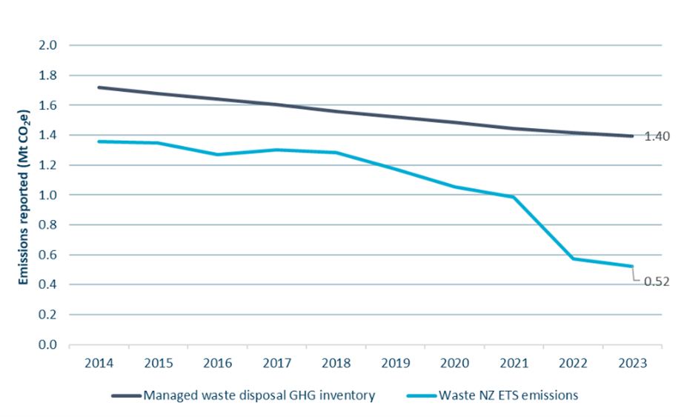
Source: Commission analysis

We identified two primary causes for this discrepancy:
- A significant drop in the Unique Emissions Factors (UEF) used in the NZ ETS to calculate the emissions of waste disposal facilities in 2022
- An ongoing difference between assumed landfill gas (LFG) recovery rates in the GHG Inventory and the NZ ETS.
There is already a process underway to address the first issue, which is expected to be resolved for emissions occurring in 2025. Therefore, our proposed technical adjustment only relates to the second issue, relating to LFG recovery rates.

Unique emissions factors
We understand that the significant reduction in the NZ ETS reported waste emissions in 2022 is partly attributable to a significant decrease in the unique emissions factors (UEFs) applied to many waste disposal facilities. In 2025, MfE advised us that the lower UEFs were due to an error in calculation and were being reviewed.
In 2024 and 2025 MfE consulted on several changes to the methodology for calculating landfill UEFs.³ These changes, including an increase in the default emissions factor (DEF) for landfill gas systems, are expected to raise waste disposal UEFs, and thereby increase overall waste emissions reported in the NZ ETS. This adjustment should reduce the discrepancy between NZ ETS and GHG Inventory reported emissions. The revised UEFs will apply in the NZ ETS for 2025 emissions, reported in 2026, so we consider that a technical adjustment is not needed to correct for this issue.

Discrepancy between landfill gas (LFG) capture rates
A second factor contributing to the discrepancy in waste emissions relates to differences in assumed LFG capture rates. We understand that the GHG Inventory applies a default LFG capture rate of 20 per cent, based on the Intergovernmental Panel on Climate Change (IPCC) default values. By contrast, the NZ ETS allows for significantly higher values for LFG capture efficiency, resulting in lower reported emissions. We understand that MfE is currently considering how best to address this inconsistency. Any changes made will likely not be reflected until GHG Inventory reporting in 2027 at the earliest.
We have applied a technical adjustment of 0.2–0.3 MtCO₂e per year over 2027–2031 to waste. We derived this technical adjustment based on the average discrepancy from 2017–2021 - the five years preceding the change in UEFs, during which NZ ETS emissions were 24% lower than those reported in the GHG Inventory.
  - Liquid fossil fuels and gas
We have not implemented a technical adjustment for liquid fossil fuels (LFF) and gas.
The comparison of GHG Inventory and NZ ETS reported emissions for LFF and gas is shown in Figure 3 below. There is a difference of approximately 0.4 MtCO₂e, or 1.7%, in the emissions reported for the 2023 calendar year. However, emissions in the 2022 year are aligned and the total difference across the five years of the 2019–2023 is only approximately 1.5%. Given this context, we consider that an ongoing technical adjustment is not warranted at this stage.
Figure 3: LFF and gas emissions reported in the NZ ETS and GHG Inventory
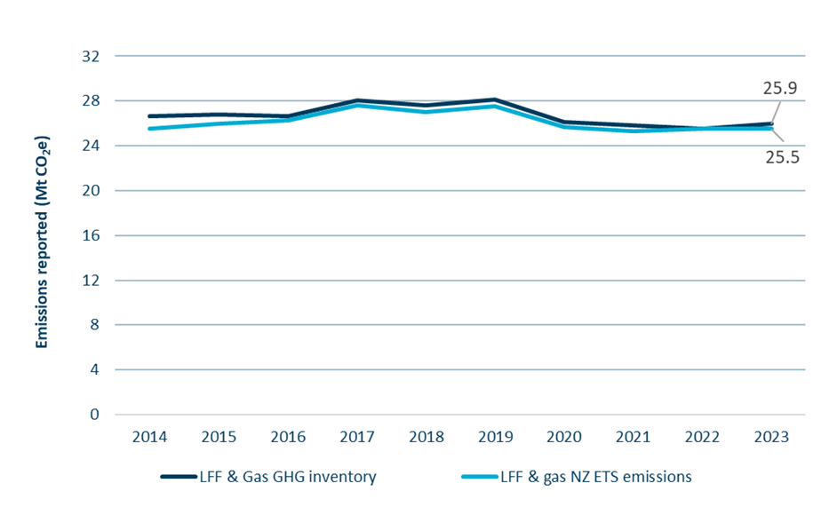
Source: Commission analysis
  - Coal and steel production
We have not implemented a technical adjustment for coal and steel production.
There are minor discrepancies between the GHG Inventory and the NZ ETS emissions reported each year for coal and steel production. The primary source of these discrepancies is between emissions related to the importing and mining of coal reported in the NZ ETS, and solid fuel combustion reported in the GHG Inventory.
As shown in Figure 4, there is a discrepancy of approximately 0.4 MtCO₂e between emissions reported in the GHG Inventory and in the NZ ETS for the 2023 calendar year.
As this discrepancy is relatively small, we have decided not to apply an ongoing technical adjustment related to coal and steel in this year’s advice. This is consistent with our approach in last year’s advice. We will monitor this issue to evaluate how the discrepancy develops over time, and whether it is necessary to apply a technical adjustment.
Figure 4: Coal and steel production emissions reported int he NZ ETS and 2025 GHG Inventory
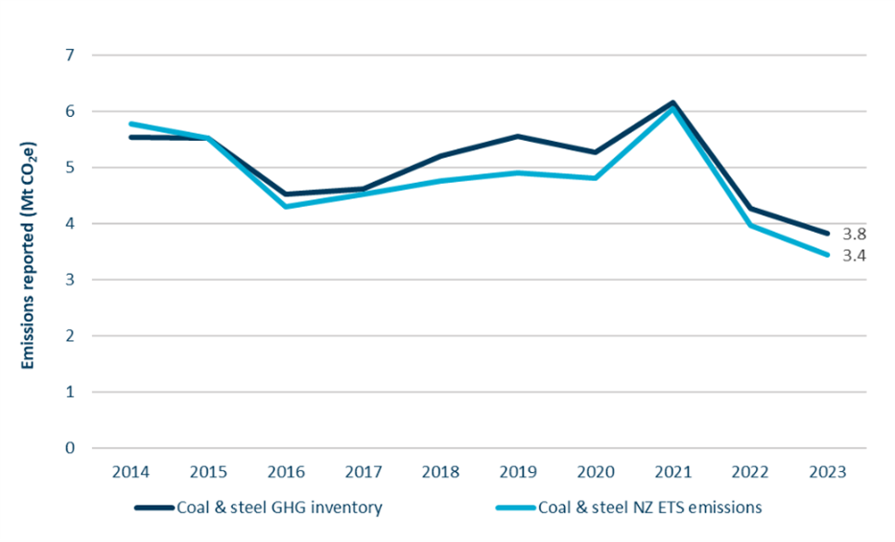
Source: Commission analysis
  - Geothermal, IPPU and F-gases
We have not implemented a technical adjustment for geothermal, IPPU or F-gases.
Geothermal and IPPU emissions show no significant discrepancies between GHG emissions reported in the NZ ETS and GHG Inventory.
No adjustment is needed for F-gases as we have already aligned the NZ ETS emissions cap with the GHG Inventory through our assumption on the share of F-gas emissions outside the NZ ETS, discussed in the section above on calculation of the NZ ETS cap.
  - Forestry
We have implemented a technical adjustment of 3.2 MtCO₂e over 2027–2031 relating to forestry.
This year we have undertaken a significant piece of analysis exploring the impacts of differences in how forestry emissions and removals are accounted for in the NZ ETS and Aotearoa New Zealand’s target accounting. This found that, in the NZ ETS, more units are being allocated to NZ ETS-registered forests than the net carbon removals recognised in target accounting for those forests. This is projected to continue until 2036.
A key input to this analysis is the NZ ETS carbon yield tables, which are used to determine the volume of units allocated in each year based on forest age. There are two key uncertainties in relation to the carbon yield tables which could significantly affect the size of the technical adjustment.
First, the Government is expected to consider updates to the NZ ETS default carbon yield tables in the first half of this year, following consultation in 2025. If these yield tables are updated, it is important that the Government updates this analysis when making its decision on the 2026 NZ ETS settings update. We have estimated the necessary technical adjustment if the Government were to adopt the default carbon yield tables contained in its 2025 consultation document.
Second, the forestry model used to undertake this analysis uses area-weighted carbon yield tables. We have used the area-weighted carbon yield tables provided to us by the Ministry for Primary Industries (MPI), as we do not have the detailed level of information required to develop our own. However, we note that the weightings used to create these tables assume that approximately 35% of total forest area uses the default carbon yield tables. This is despite only 20% of total forest area registered in the NZ ETS in the third mandatory emissions reporting period (MERP) having its carbon measurement method listed as using default tables as of October 2025. We understand that there are reasons for this difference, which we discuss in further detail in Technical Annex 2: Forestry accounting, published separately on our website. However, we suggest that the appropriate weightings to use in this analysis be further considered and updated if necessary as part of the Government’s 2026 decision on the NZ ETS settings for 2027–2031.
Table 5 summarises the different results that could arise from this analysis depending on the default carbon yield tables used, and the weightings used to create the area-weighted table. Other than the value used in our advice, these are indicative estimates to provide a sense of how changes to the default carbon yield tables and/or updating the area weightings can impact the results.
Table 5: Forestry technical adjustments based on alternative yield tables and/or area weightings
Technical adjustment over 2027–2031 (Million NZUs) | Using area weightings as provided by MPI | Using area weightings based on registered area by carbon measurement method
Default carbon yield tables as in regulation | 3.2 (used in our advice) | 6.9
Default carbon yield tables as in 2025 consultation | 6.1 | 8.4
The analysis and modelling that forms the basis of the forestry technical adjustment, including further description of the issues set out above, is contained in Technical Annex 2: Forestry accounting, published separately on our website.
  - Overall step 1 results – conversion of emissions cap to unit volumes
Table 6 shows the proposed annual technical adjustments related to waste and forestry, and the results of converting the NZ ETS emissions cap for each year to emissions budget-consistent unit volumes over 2026–2035.
Table 6: Overall step 1 results – application of technical adjustments to convert NZ ETS emissions caps to unit volumes
NZUs (millions) | 2026 | 2027 | 2028 | 2029 | 2030 | 2031 | 2032 | 2033 | 2034 | 2035
NZ ETS emissions cap | 21.9 | 19.3 | 16.0 | 13.4 | 11.2 | 7.6 | 6.7 | 5.8 | 4.7 | 4.1
Waste adjustment | 0.3 | 0.3 | 0.2 | 0.2 | 0.2 | 0.2 | 0.1 | 0.1 | 0.1 | 0.1
Forestry adjustment | 0.8 | 0.9 | 0.8 | 0.6 | 0.5 | 0.4 | 0.4 | 0.4 | 0.4 | 0.6
Total technical adjustments | 1.1 | 1.2 | 1.0 | 0.9 | 0.7 | 0.5 | 0.5 | 0.5 | 0.5 | 0.7
NZ ETS emissions cap aligned with unit volumes | 20.8 | 18.1 | 15.0 | 12.5 | 10.5 | 7.1 | 6.1 | 5.3 | 4.2 | 3.4
- Step 2: Account for industrial free allocation
Step 2 involves forecasting industrial free allocation volumes provided by the Government to firms undertaking emissions-intensive and trade-exposed (EITE) activities. Industrial free allocation uses up a portion of the units that would otherwise be available from the NZ ETS emissions cap. It must therefore be subtracted from the cap when determining auction volumes.
Our forecast of industrial allocation volumes has reduced compared to last year, from approximately 22.0 million units to 18.3 million over 2027–2031.
The method for forecasting industrial allocation has remained largely the same over the four years the Commission has provided advice on NZ ETS settings. It is based on the following equation, with the approach used for each term set out below.
Annual allocation = production volume × % level of assistance × allocative baseline
- Production volume: Update for the most recent unit allocation data broken down by industrial activity and apply estimated growth of production volumes.
- % level of assistance: Apply the annual industrial allocation level of assistance and phase-down rates.
- Allocative baseline: Apply any additional information on estimated changes to production levels, or on updates to the emissions intensity of production.

Changes in industrial allocation forecast
We have updated our forecast of industrial allocation to align with assumptions in the Ministry for the Environment’s latest industrial allocation projections.
Since our previous forecast, the most significant causes of change have been:
- A reduction in the forecast of aluminium allocations. This is due to incorporation of actual 2024 allocations data which accurately reflected changes to the Electricity Contracts Allocation Factor (ECAF). In our 2025 forecast, we were only able to estimate the impact of the ECAF change.
- A reduction in iron and steel industrial allocations from 2026 onwards. This is based on an updated estimate of the allocative baseline which will be reduced due to the installation of an electric arc furnace at NZ Steel.
- Decreased allocation for methanol. This aligns with the decreased methanol production levels assumed in the 2025 government emissions projections, which assume production reduces to 80% of 2024 levels in 2026 and 60% in 2027 before ceasing entirely in 2028.
- An increase in pulp and paper allocation forecasts. This is due to an increase in the observed production levels from 2023 to 2024, likely based on many plants cutting 2023 production for repairs and maintenance. Forecast reductions in pulp and paper allocations continue to apply from 2025 onwards due to the closure of Winstone Pulp, of Oji Fibre's Penrose mill, and ceasing of paper production at Oji Fibre’s Kinleith Mill.
Table 7 shows our updated industrial allocation forecast alongside our previous forecast used in the 2025 ETS settings advice. Figures are shown up to 2035 for visibility beyond the settings period (2027–2031).
Table 7: Comparison of 2026 and 2025 industrial free allocation forecasts
NZUs (millions) | 2026 | 2027 | 2028 | 2029 | 2030 | 2031 | 2032 | 2033 | 2034 | 2035
Updated 2026 forecast | 4.1 | 4.0 | 3.7 | 3.6 | 3.6 | 3.5 | 3.4 | 3.3 | 3.2 | 3.1
Previous 2025 forecast | 5.1 | 5.1 | 4.6 | 4.5 | 4.0 | 3.9 | 3.8 | 3.6 | 3.5 | 3.4
Difference | -1.1 | -1.1 | -0.9 | -0.9 | -0.4 | -0.4 | -0.4 | -0.3 | -0.3 | -0.3
- Step 3: Estimate surplus range
Step 3 involves estimating the volume of surplus units currently held in private accounts. We calculate a central estimate, as well as high and low estimates. This provides our estimated surplus range.
We calculate the unit surplus (the surplus) by taking the total units held in private accounts (the stockpile) and subtracting our estimates of non-surplus unit categories. Non-surplus units are those we assess as unlikely to be available for use in the NZ ETS to enable emissions above emissions budgets.
We base our surplus range and central estimate on four categories of non-surplus units:
- pre-1990 forest allocation units held long-term
- units held for post-1989 forest stock change harvest liabilities
- units held for emitters’ forward hedging
- units held by emitters for emissions that have already occurred (holding volume, or Y0 hedging).
This year we have also included a forestry unit reconciliation term. This adjustment reconciles the results from our forestry model (used to estimate post-1989 forest harvest liabilities) with actual forestry unit allocations and surrenders to date.
  - Total unit holdings
Total unit holdings, sometimes referred to as ‘the stockpile’, refers to the total of all privately held units in the NZ ETS registry at a point in time. We have used Environmental Protection Authority (EPA) data as of 31 December 2025, which puts total privately held units at 135.9 million units.⁴ This is a reduction of approximately 14.5 million units from the stockpile as of 31 December 2024.
We consider that, as far as possible, unit holdings data used for updated surplus estimates should be taken at a consistent date, which should be 31 December of each year. Using December data enables the final results of that year’s auctions to be taken into account.
  - Pre-1990 units held long-term
When the NZ ETS was first established, owners of forests planted before 1990 were allocated units (referred to as pre-1990 units) to partially compensate for the restriction the NZ ETS put on their future ability to change land use. Over 32 million units were originally allocated.
As long as the pre-1990 forests are not deforested, these units are not encumbered by surrender obligations. Theoretically, this would make them available for purchase and use by other NZ ETS participants and part of the surplus. However, we continue to assume, as per our previous advice, that a proportion of these pre-1990 units will remain held long-term by those who originally received them. That is, they are unlikely to be available for use by other NZ ETS participants before 2030 and so do not contribute to the surplus.
This assumption is based on feedback from market participants. The reasons cited by those we have engaged with for why these units may be held long-term include:
- to keep open the option of future land use change, to enable use of land for another purpose (e.g. developed for pasture or for housing)
- as insurance, in case requirements to replant post-harvest, or regenerate the land within the criteria and timeframes set by NZ ETS rules, are not met – particularly where the forest owner is asset-poor
- some iwi/Māori forest owners may wish to retain the units as an asset for future generations
- slow and deliberate decision-making about the sale of units, for example due to collective decision making within iwi/Māori entities
- some recipients of pre-1990 units may have low awareness of what the units are, how to sell them, or what the implications of selling them might be.
Estimating how many of these units may be retained is challenging, as to date no information specifically on the intentions or behaviour of the entities who received them has been collected.
The most relevant data that we have been able to source to inform our analysis is from the EPA about transfers of these pre-1990 units out of the accounts that originally received them. As of December 2025, there were approximately 10.5 million pre-1990 units held in the original accounts to which they were allocated. This is a reduction from 11.5 million taken as our base point in the previous year.
Consistent with our 2025 advice we have used a methodology that is based on an assumed percentage of units transferred each quarter. We have reviewed the historical transfer rates to determine a credible range and made only minor adjustments compared to our 2025 advice. These adjustments are due to us basing our assumptions on more recent data, from 2021 onwards, rather than the full series back to 2017. This is because there appears to have been a slight change in the trend from 2021 onwards. The assumed quarterly transfer rates between 2026–2030 are shown in Table 8.
Table 8: Quarterly pre-1990 units transfer rate assumptions
Quarterly transfer rates | Fast transfer path | Central transfer path | Slow transfer path
2026-2030 | 4.0% | 3.0% | 2.0%
These transfer rates represent a minor adjustment from our 2025 advice, with the fast transfer path decreasing from 5% to 4%, and the slow transfer path increasing from 1% to 2%. The central transfer rate of 3% is the same as in our 2025 advice.
The updated calculations of pre-1990 units likely to remain in original accounts in 2030 results in a central estimate of 5.7 million, with a range of between 4.6 and 7.0 million – shown in Figure 5.
Figure 5: Pre-1990 units remaining in original accounts (historic and projected)
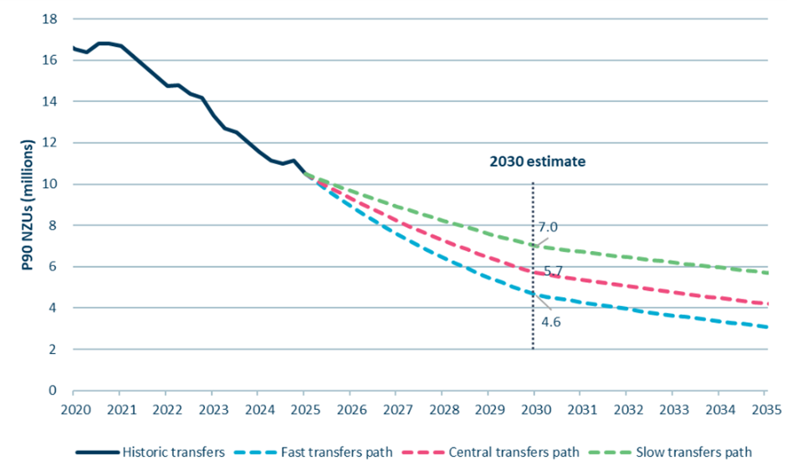
Source: Commission analysis

  - Units held for surrender for past emissions (holding volume)
In our 2025 advice, we introduced a new category of non-surplus units referred to as holding volume. These are units held for emissions that have already occurred, but for which emitters are yet to surrender NZUs.
We use a single estimate of holding volume across our surplus range estimates, as there is a high degree of certainty about this value. This is based on the gross emissions forecast for NZ ETS sectors for 2025 (32.5 MtCO₂e) minus a technical adjustment to waste emissions of 0.3m units. This results in a holding volume of 32.2m units.
We assess the surplus and unit stockpile at the end of the calendar year to account for the final auction results, and so also take the holding volume from the end of the year. We assume that emitters are accumulating units to match their emissions throughout the year, so by year-end 100% of emitters’ obligations from that year are held, and will be surrendered the following year. Therefore, our holding volume is based on the estimate of emissions that occurred in 2025.
  - Units held for forward hedging by emitters
It is common practice for participants in the NZ ETS to hold NZUs to cover a proportion of their emissions compliance obligations over a certain period in advance (‘hedging’). Hedging involves emitters pre-purchasing NZUs when they fix prices with customers or suppliers, to manage their exposure to NZU forward price risk.
As in our previous advice, our methodology assumes a portion of units in the registry are held by (or for) emitters for forward hedging purposes. These units need to be present in the scheme for the proper functioning of the NZ ETS, and they are unlikely to be available for use to enable emissions above emissions budgets given emitters need to constantly hold and refill their hedges over time.
Our central estimate of units held for forward hedging by emitters has reduced from 17.4 million units in our 2025 advice to 14.5 million units. This is due to a reduction in our hedging assumptions for the stationary energy and industrial process sectors. We adjusted our assumptions downward as feedback from engagement meetings as well as new public information relevant to the electricity sector indicated that our previous assumptions were overly generous.

Hedging assumptions
We estimate the portion of units held for hedging using the NZ ETS emissions cap volumes related to non-forestry sectors (resulting from step 1), taking into account that some emissions will be automatically hedged due to industrial free allocation (step 2).
Our hedging estimates are shown in Table 9. The values represent the percentage of forecast emissions that are assumed be held or purchased by the sector in advance. Our central estimate is presented along with low and high hedging practice scenarios.
The hedging practices of emitters vary significantly, both across and within industry groups. Our hedging assumptions are intended to represent a reasonable volume of hedging on average, across all emitters.
Table 9: Sector hedge profile assumptions (including low and high range)
Sector | Year 1 (Y1) | Year 2 (Y2) | Year 3 (Y3)
Liquid fossil fuels | 27%  (22%-31%) | 5%  (1%-8%) | 0%  (0%-1%)
Stationary energy & industrial processes | 75%  (75%-100%) | 50%  (25%-67%) | 25%  (0%-33%)
Waste | 100% | 0% | 0%

Base year for hedging estimates
Consistent with our previous advice, we have estimated the hedging volume at 2030, the Government’s target year for eliminating the surplus.
Using 2030 as the base year accounts for the fact that, as emitters decarbonise, their need for forward hedging will reduce. Over time, some units they hold for hedging now will no longer be needed, and will instead contribute to the surplus. This matches our approach to estimating pre-1990 units we expect to remain unsold in 2030.
This means that even if the surplus units that have accumulated in the NZ ETS due to historical factors are eliminated by 2030, we will still need to account for a small amount of units that will free up each year as non-forestry participants’ hedging volumes decline.

Detailed assumptions relating to hedging
The forecast volume of industrial allocation units is subtracted from the estimated hedging volumes, as emitters that receive industrial allocation are effectively already hedging a portion of their emissions by the units they expect to receive. Not all industrial allocation units are allocated to participants with direct surrender obligations, therefore only a portion of the total industrial allocation forecast is subtracted. Based on review of the sectors and participants receiving allocations, we estimate that all IPPU industrial allocations can be removed from hedging, and 70% of stationary energy allocations.
The GHG Inventory non-transport energy emissions category includes liquid fossil fuel (LFF) and stationary energy emissions. For the hedging assumptions we need to separate these to align with the NZ ETS definitions of LFF and stationary energy. This split is not specifically provided in the 2025 government emissions projections. We have applied assumptions based on historic GHG Inventory which provides a breakdown of emissions by fuel type. We assume that 39% of non-transport energy emissions relate to LFF in 2030. We also assume 100% of transport energy emissions relate to LFF in 2030.
  - Units held for post-1989 harvest liabilities
Two accounting approaches are used to calculate the allocations and liabilities of post-1989 forests registered in the NZ ETS, which affect how forestry units contribute to the surplus.
Since 2023, averaging accounting has been the required approach for newly registered forests, other than forests registered in the permanent category. Under averaging, forests earn units for carbon sequestered only until a fixed average age, but there are no liabilities when forests are harvested as long as the forests are replanted.
However, most post-1989 forests in the NZ ETS are subject to stock change accounting. Under stock change, forestry participants earn units for the carbon sequestered by their forest while it is growing but must surrender a significant portion of this volume when the forest is harvested. These units are not considered part of the surplus, as they will not be available for use by other participants to allow emissions above emissions budget levels. In this section we estimate how many units earned by forests using stock change accounting are being held for harvest liabilities and should be considered non-surplus.
To determine our estimate of units held for harvest liabilities we use a forestry model that is based on data of total area and species of forests registered in the NZ ETS, the mandatory emissions reporting period (MERP) in which the forest was registered, and information on carbon stored by the forests (yield tables). A description of the forestry model and its primary functions and limitations can be found in the Supporting material: NZ ETS Forestry Model description, published separately on our website.
There are significant uncertainties to consider when estimating units held for harvest liabilities, such as:
- the age at which forests are harvested
- the proportion of exotic forests managed as permanent
- the proportion of ‘low-risk’ units available to forestry participants – the units that may never have to be repaid under stock change, based on mix of forest age, rotation and species. These are the units that are more likely to be available for use by other NZ ETS participants and therefore contribute to the surplus.
We discuss each of these uncertainties in more detail below.

Harvest age data and assumptions
The forestry model requires an input assumption of the average age at harvest of NZ ETS-registered forests. The assumed age of forests when harvested can have a significant impact on the estimated results of units held for harvest since it changes the expected timing of foresters’ surrender obligations. Therefore, varying average harvest age can vary the forecast year, and potentially the MERP, when the unit surrenders will occur.
Only limited and incomplete information on the age of harvest for NZ ETS-registered forests is available. However, data is reported within the GHG Inventory for the proportion of total destocking area (all harvesting and deforestation) by age across all planted forests. As in our 2025 advice, we have used this to inform a weighted average harvest age across five ages for pinus radiata.
Similar to our 2025 estimate, the range of harvest ages for pinus radiata remains between 26 and 30. We have made minor adjustments to slightly reduce the weightings for harvest ages 26 and 27 and slightly increase the weightings for ages 29 and 30. The distribution is shown in Table 10. We have applied these updated assumptions consistently across our low, central and high estimates of units held for harvest.
Table 10: Weighted distribution of pinus radiata average harvest age
Harvest age | 26 | 27 | 28 | 29 | 30 | Area weighted average age
2025 estimate of % of area distribution | 19% | 23% | 22% | 20% | 17% | 27.9
Updated 2026 estimate of % of area distribution | 18% | 21% | 22% | 21% | 18% | 28.0
We have only used a single harvest age across the remaining exotic species, Douglas fir (45 years), exotic softwoods (40 years) and exotic hardwoods (21 years). These species each make up a minor portion of total exotic forest area compared to pinus radiata, and including multiple weighted average harvest age across these species has a very minimal impact on results. Also, given the average harvest age for Douglas fir and exotic softwoods is significantly older, we do not expect that any of these species planted post-1989 will have been harvested yet.

Exotic forests assumed to be managed as permanent
Forests registered under stock change accounting are only required to surrender units if the forest is harvested. Unlike those using averaging accounting, there is no requirement that foresters using stock change accounting register a forest as ‘permanent’ to keep earning units past the average harvest age. Therefore, there is no formal breakdown of the area of production versus permanent forests registered in the NZ ETS under stock change.
The area of stock change exotic forests managed as permanent may change over time as many factors may influence whether a forest transitions from production to permanent (or vice versa). This includes economic conditions, such as log prices, harvesting costs, international shipping costs, or the value of NZUs. The proportion of forest assumed to be managed as permanent has a significant impact on our estimate of units held for harvest.
In government emissions projections prior to 2025, forestry emissions and removals were calculated based on a flat-rate assumption of the proportion of permanent versus production exotic forests.
In the 2025 government emissions projections, MPI used more detailed data for the forestry emissions and removals projections, which included an estimated breakdown of permanent versus production exotic forest area by year of planting. We understand that MPI developed its permanent forest area estimates based on a combination of commissioned research into harvest, afforestation and deforestation intentions,^{5,6} analysis of historical trends, and expert judgement.
We have applied this more detailed data, which provides a central estimate of 17% of total area classified as permanent for forests planted between 1990–2024. This is slightly lower than our previous assumption, which was 20%.
Figure 6 below shows MPI data on the proportion of forest area assumed to be managed as permanent by year of forest planting. It also shows the total exotic forest area planted in each year, illustrated on the graph by the grey shaded area and the vertical axis to the right. There is a high degree of variation across the total area planted each year, meaning that the assumption of the proportion of area managed as permanent is much more consequential for some years than others. The overall central estimate of 17% is weighted based on the area planted in each year. This is shown by the dashed line on the graph.
Figure 6: Total exotic forest area planted and proportion assumed to be managed as permanent by year
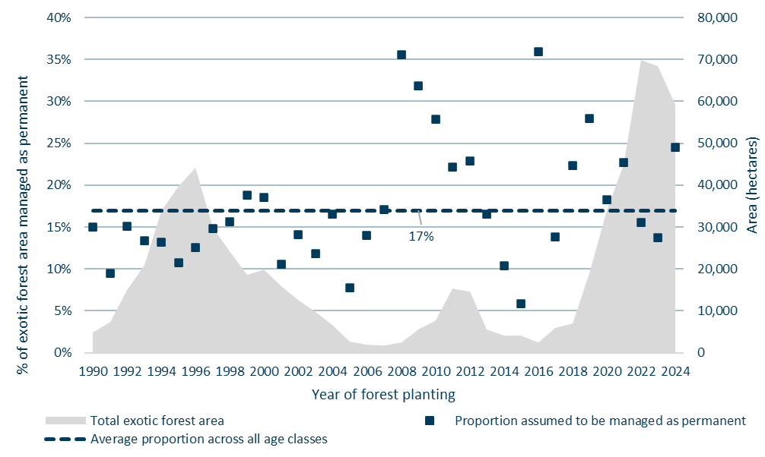
Source: Ministry for Primary Industries
We have used high and low estimates of 12% and 22%. These are based on varying the data provided by MPI by +/-30%. This compares to our high and low assumptions in previous advice of 10% to 30%, which represented a variation on the central 20% assumption of +/-50%. We have applied a narrower variation in these assumptions than in previous advice because these assumptions are now based on more up to date information. In particular, a 2024 survey of deforestation and harvest intentions commissioned by MPI provided a more current view of the likely proportion of forests being managed as permanent.⁵ Prior to this, the most recent data available was from a survey published in 2018.⁷
Figure 7 shows the low, central and high assumptions of the proportion of forest area managed as permanent.
Figure 7: Central, high and low assumptions of the proportion of forest area assumed to be managed as permanent by year of forest planting
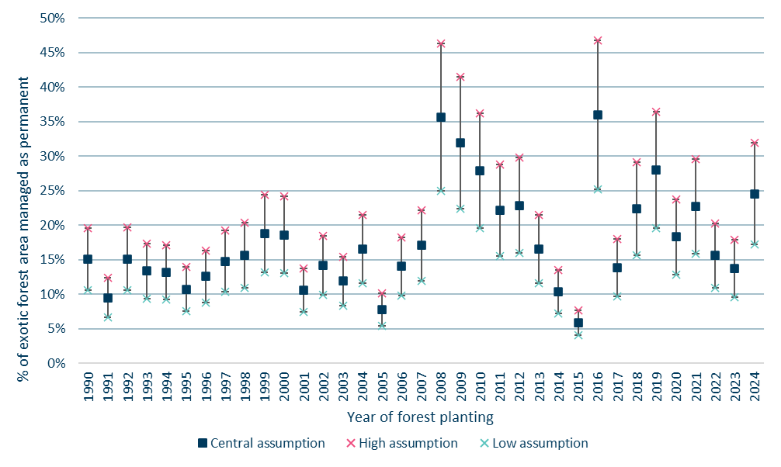
Source: Commission analysis

Low-risk units
The carbon stock of forests does not return to zero immediately on harvest due to residual carbon stored in roots underground. Some units earned by production forests on their first rotation can be considered ‘low risk’, as they will never have to be surrendered if the forest is replanted. However, additional units may also be considered low risk if a forestry participant can manage liabilities across a portfolio of forests of different ages, as harvest liabilities can be met using units allocated for forests at a different stage in their rotation.
We have analysed the range of possible levels for low-risk units available to owners of post-1989 forests registered in the NZ ETS under stock change. For each post-1989 forestry participant, the minimum level of low-risk units is the amount of low-risk units available for a single forest that is planted at one time. The maximum level of low-risk units is the theoretical low-risk units for a forest portfolio evenly split across all age classes (equal to the long-term average carbon stock).
All NZ ETS forestry participants sit somewhere on a spectrum between these minimum and theoretical maximum levels of low-risk units. Box 1 below illustrates how these levels work in practice.
Box 1. Forest owners can manage harvest liabilities to increase low-risk units
Imagine three different forestry participants each with 100,000 hectares of production forests registered in the NZ ETS in the year they were planted. The units each forest owner would earn and need to surrender at harvest per hectare would be the same over the long run but the timing of when they earn and surrender them will depend on their planting and harvest strategy.
To take radiata pine forests as an example (based on a 28-year harvest cycle), the residual carbon remaining after each harvest cycle will differ for each forest owner as follows:
- If Forest Owner A plants the full amount (and subsequently harvests) in a single year, they would not be liable for approximately 25% of units earned – minimum low-risk units scenario.
- If Forest Owner B plants at different times and correspondingly staggers harvests, for example around 25,000 hectares roughly every 7-8 years, they would not be liable for around 36% of units earned – central low-risk units scenario (the ‘Spread age classes’ in Figure 8 below).
- If Forest Owner C plants and harvests a set amount each year, for example 3,570 hectares each year for 28 years to represent the full age class in a rotation, they would not be liable for around 50% of units earned – maximum low-risk units.
Forest Owner C, with a more diverse forest portfolio, has maximised their low-risk carbon units compared with Forest Owner A and is able to sell a higher proportion of the units earned. Figure 8 provides an illustration of various low-risk carbon unit levels using radiata pine under the different hypothetical examples discussed above.
Figure 8 Net carbon stored from different illustrative forest planting portfolios
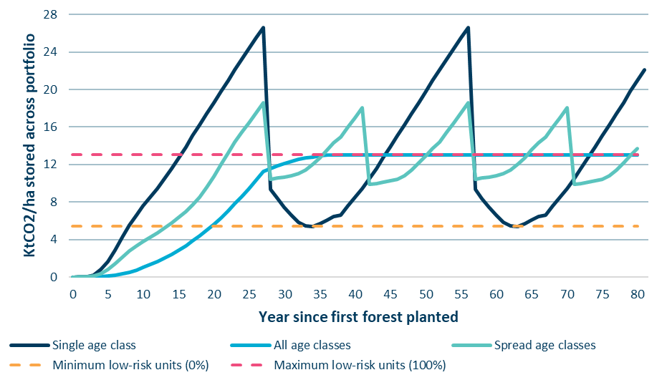
Source: Commission analysis.
To estimate the level of low-risk units likely to be achieved across all post-1989 forests on stock change in the NZ ETS, we have considered data on the breakdown of total forest area in the NZ ETS by forest estate size, shown in Table 11. Owners of small forest areas are likely to have a low proportion of low-risk carbon due to the total area being more likely to be planted in a single year or across fewer age classes. Large forest estates are more likely to be made up of diverse portfolios of multiple age classes, allowing increased low-risk units. More than 50 percent of forest area in the NZ ETS is made up of forest estates of larger than 1,000 hectares.
Table 11: Breakdown of total NZ ETS forest area by forest estate size
Forest estate size | 0-99 hectares | 100-499 hectares | 500-999 hectares | 1000+ hectares
% of total NZ ETS exotic forest area | 17% | 22% | 10% | 51%
These proportions are combined with assumptions about the additional low-risk units that can be achieved at different sizes of forest estate, shown in Table 12 below. Here ‘additional low-risk units’ refers to the proportion of low-risk units above the minimum, with 0% representing the minimum low-risk level, and 100% representing the maximum (i.e. the theoretical maximum low-risk units scenario discussed earlier). These are combined to produce a weighted average for the proportion of the additional low-risk units above the minimum level across the total area of post-1989 forests on stock change accounting in the NZ ETS.
Table 12: Assumed low-risk units achievable by different sizes of forest estate
Forest estate size | 0-99 hectares | 100-499 hectares | 500-999 hectares | 1000+ hectares
Low surplus assumption | 5% | 30% | 55% | 80%
Central surplus assumption | 15% | 40% | 65% | 90%
High surplus assumption | 20% | 50% | 75% | 100%
Based on the results of this calculation we have applied the following assumptions for the proportion of additional low-risk carbon:
- 55% of additional low-risk units (low surplus estimate)
- 65% of additional low-risk units (central surplus estimate)
- 75% of additional low-risk units (high surplus estimate).

Range of estimated units held for post-1989 harvest liabilities
To reach the estimated range of post-1989 units held for harvest liabilities, we apply variations to the low-risk unit and permanent forest area assumptions. We do not vary the average harvest age, as the uncertainty is already captured by using a weighted average. The results and variable estimates used are summarised below.
- Central surplus estimate: baseline permanent forest area and 65% additional low-risk units results in 40 million units held for harvest at the end of 2025.
- High surplus estimate: 30% higher permanent forest area and 75% additional low-risk units results in 34.3 million units held for harvest at the end of 2025.
- Low surplus estimate: 30% lower permanent forest area and 55% additional low-risk carbon results in 46.2 million units held for harvest at the end of 2025.
When assessing the suitability of assumptions and potential range of uncertainties we have considered how changes to the input assumptions impact the model’s results in comparison to the actual data reported on net unit allocation and surrenders in the completed MERP3 period over 2018–2022.
Based on the assumptions used for our central surplus estimate, the forestry model results are closely aligned to the actual net unit allocations reported by MPI in MERP3. The forestry model estimates net unit allocations of 44.9 million units over this five-year period, with actual units reported by MPI of 45.9 million.⁸ This is a difference of just 1 million units, or 2.2%. Although factors may change in future MERPs, comparing model results with actual volumes in this previous period helps provide assurance that the chosen assumptions reasonably represent what has occurred in the NZ ETS to date.
  - Forestry unit reconciliation
Some of the post-1989 forestry units earned over the fourth mandatory emissions reporting period (MERP4: 1 January 2023 to 31 December 2025) will only be allocated into the market after participants submit their end-of-MERP final emissions returns in the first half of 2026. Similarly, some surrenders for harvest or deforestation occurring over 2023–2025 will not be made until mid-2026.
This year, to account for this we have included a forestry unit reconciliation term to align results from our forestry model. The model estimates forestry unit allocations and surrenders year-by-year as removals and emissions occur, while actual forestry unit allocations and surrenders to date may follow different timing. In conjunction with the forestry technical adjustment described in step 1 and the units held for post-1989 forest harvest liabilities set out immediately above, it replaces the MERP4 additional surplus units included in our 2025 ETS settings advice.
This does not represent a substantive change in methodology, rather a simpler calculation method. The new approach will be easier to repeat over time. This year, we have modelled the units held for harvest as at the end of MERP4 (2023–2025) and then worked back from that, making an adjustment through the forestry unit reconciliation term to reflect actual data on surrenders and allocations to date. In contrast, in our 2025 NZ ETS settings advice we estimated the units held for harvest at the end of MERP3 and applied an adjustment to roll forward to the end of MERP4 to account for units not yet allocated or surrendered. The changed approach is mathematically equivalent and is why this year the forestry unit reconciliation term is subtracted while last year we added a volume of units.
This term is calculated by taking the difference between net allocations (total allocations less surrenders) produced by the forestry model and the NZ ETS post-1989 forestry net unit allocations to date. This gives the net amount of units we expect to be removed from the market when all MERP4 final emissions returns have been processed. This reflects that, for MERP4, our analysis indicates that a significant amount of surrenders have not yet happened and can be expected to come through in the final emissions returns submitted in 2026 (final data will only be available on this in the second half of 2026).
We have calculated a central estimate of 13.7 million units for the forestry unit reconciliation.
As in our estimate of post-1989 units held for harvest, we have developed an estimated range based on increasing and decreasing the baseline permanent versus production forests by 30%. Reducing the area of forest assumed to be permanent by 30% results in a higher estimate of future unit surrenders of 15.9 million, and increasing by 30% results in lower estimated unit surrenders of 11.6 million units. This variable is not impacted by estimates of additional low-risk carbon units.
  - Forestry technical adjustment
As discussed in Step 1, in this advice we have implemented a forestry technical adjustment based on differences between the NZ ETS and target accounting.
The estimate of the forestry technical adjustment used forestry model input assumptions consistent with those used in the central surplus estimate. To be consistent within our estimated surplus range, we have incorporated the impact on the forestry technical adjustment of varying the forestry model input assumptions in line with our high and low surplus estimates.
This is relevant because if we have overestimated the technical adjustment, additional units may need to be used from the surplus to meet demand. If we have underestimated the adjustment, fewer units will be used from the surplus.
  - Surplus range estimate
The calculation of our surplus estimate range, based on all the estimates made as part of step 3, is set out in Table 13. For each category of units, we have presented a range of low, central and high values, except for total units and holding volumes which use the same estimate across the range. These two terms are not varied as they have a high degree of certainty.

Table 13: Components of surplus estimates and their contributions to the surplus range
Surplus estimate (million NZUs) | Low | Central | High | Range
Total privately held units – the stockpile (31 December 2025) | 135.9 |  |  | 0.0
Pre-1990 units held long-term | 7.0 | 5.7 | 4.6 | 2.4
2025 holding volumes | 32.2 |  |  | 0.0
Hedging in 2030 | 18.8 | 14.5 | 10.3 | 8.5
Post-1989 forest harvest liabilities | 46.2 | 40.0 | 34.3 | 11.9
Forestry unit reconciliation | 15.9 | 13.7 | 11.6 | 4.3
Forestry accounting technical adjustment range | -1.3 | 0.0 | 1.2 | 2.5
Total surplus estimate | 17.1 | 29.7 | 41.7 | 24.6
Our uncertainty range around the central surplus estimate has decreased since last year, from approximately 39 million to 25 million units. The most significant cause of the reduced range is the reduction in range of our estimate of post-1989 units held for harvest. This is largely because we have applied a narrower variation in the proportion of forest area assumed to be managed as permanent, reflecting more up to date information on this being available.
Figure 9 compares the range of surplus estimates from our 2024 advice, 2025 advice and updated 2026 estimate. The 2024 estimate has been adjusted down by 33.3 million units to reflect the surplus reduction volumes in 2024 & 2025 (20.2 million units) and units that went unsold in auctions in 2024 and 2025 auctions (13.1 million). The 2025 estimate has been revised down by the 2025 surplus reduction volume (12.5 million) and units that went unsold in the 2025 auctions (6 million). The figures remaining after the adjustments enable comparisons of the size and range of the surplus based just on updates to estimates and methodology.
Figure 9: Comparisons of unit surplus estimate ranges
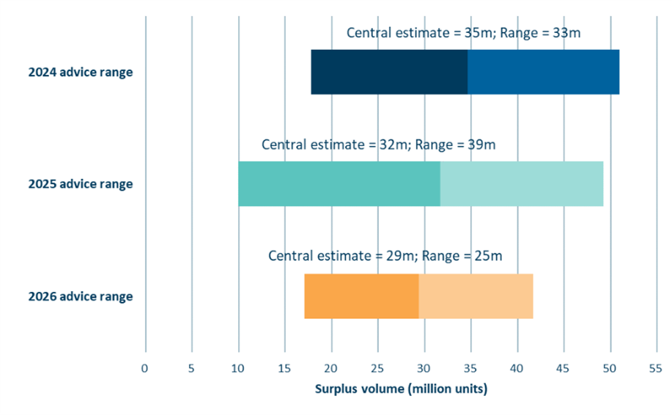
Source: Commission analysis
- Step 5: Range of possible auction volumes
Step 5 takes the NZ ETS emissions cap and subtracts estimates from the following four steps to identify the range of potential auction volumes. For the period 2027–2030, this produces a range of auction volumes reflecting the surplus range estimated in step 4. By 2031 the surplus is expected to be fully drawn down. This means that the auction volumes for 2031 can be determined in a more straightforward way from the outcome of the unit limit steps for that year.
  - Range of auction volumes for 2027–2030
We have calculated auction volumes that could be consistent with fully drawing down the surplus by 2030 based on the full surplus uncertainty range. As discussed in the advice report, we have considered options to update auction volumes from 2028 onwards.
Table 14 shows the results from each of the unit supply steps and lays out the corresponding auction volume results. The table shows results for all three surplus estimate scenarios, as well as the option of retaining the status quo settings in regulations for 2027–2030, which is equivalent to drawing down a surplus of 41.2 million units by 2030. We call this the “implied” surplus.
Table 14: Unit supply steps and auction volume options over 2026–2030
 | No change to auction volumes (but updates to the cap and steps 1 & 2) |  | Options to update auction volumes |  |  | SUM Emissions budget 2
Million Units | 2026 | 2027 | 2028 | 2029 | 2030 | 2026–2030
NZ ETS emissions cap  (MtCO₂e) | 21.9 | 19.3 | 16.0 | 13.4 | 11.2 | 81.9
1. Convert and align emissions and units (technical adjustment) | 1.1 | 1.2 | 1.0 | 0.9 | 0.7 | 4.9
2. Industrial free allocation | 4.1 | 4.0 | 3.7 | 3.6 | 3.6 | 18.9
3. Surplus reduction options
3a. Surplus implied by status quo auction volumes | 11.5 | 9.8 | 3.3 | 2.8 | 2.3 | 29.7
3b. Surplus reduction volume – low | 11.5 | 9.8 | -1.7 | -1.4 | -1.2 | 17.1
3c. Surplus reduction volume – central | 11.5 | 9.8 | 3.3 | 2.8 | 2.3 | 29.7
3d. Surplus reduction volume - high | 11.5 | 9.8 | 8.0 | 6.7 | 5.6 | 41.7
4. Approved overseas units | 0.0 | 0.0 | 0.0 | 0.0 | 0.0 | 0.0
5. Auction volume options
5a. Status quo | 5.2 | 4.3 | 8.1 | 6.2 | 4.7 | 28.4
5b. Based on low surplus estimate | 5.2 | 4.3 | 13.1 | 10.3 | 8.2 | 41.0
5c. Based on central surplus estimate | 5.2 | 4.3 | 8.1 | 6.2 | 4.7 | 28.4
5d. Based on high surplus estimate | 5.2 | 4.3 | 3.4 | 2.2 | 1.4 | 16.4
  - Auction volumes for 2031
This advice is the first time the settings period has covered a portion of the third emissions budget, which runs from 2031 to 2035. The surplus is expected to be fully drawn down by the end of 2030, however minor ongoing surplus reduction volumes are needed post 2030 to reflect reductions in hedging requirements and ongoing sale of pre-1990 units.

Surplus reduction volumes post 2030
Following drawdown of the base surplus by 2030, we apply an annual ongoing surplus reduction volume. An ongoing reduction volume recognises the risk of generating new surplus units from reduced hedging requirements (due to reducing emissions) and continued selling of pre-1990 allocation units.
We have based the ongoing hedging reductions on the hedging assumptions used in our central surplus estimate.
Our assumed quarterly transfer rate of pre-1990 units after 2030 is 1.5%. This is a slower rate than the 3% transfer rate assumed in our central surplus estimate over 2026–2030. This is because we expect that the transfer rate is likely to decrease over time, as those units which are least likely to be sold make up a greater proportion of the remaining pre-1990 units.
To determine the annual surplus reduction volume we have taken the sum of the units we forecast to become surplus over the 2031–2035 period (2.3 million), and distributed the reduction annually in proportion with the emissions cap over the period.

Auction volumes
Table 15 shows the unit limit steps 1–5 applied to the third emissions budget period.
Table 15: Auction volumes over emissions budget three, 2031–2035
 | New | For visibility |  |  |  | Sum
Million units | 2031 | 2032 | 2033 | 2034 | 2035 | 2031–2035
NZ ETS emissions cap  (MtCO₂e) | 7.6 | 6.7 | 5.8 | 4.7 | 4.1 | 28.9
1. Convert and align emissions and units (technical adjustment) | 0.5 | 0.5 | 0.5 | 0.5 | 0.7 | 2.8
2. Industrial free allocation | 3.5 | 3.4 | 3.3 | 3.2 | 3.1 | 16.4
3. Ongoing surplus reduction | 0.6 | 0.5 | 0.5 | 0.4 | 0.3 | 2.3
4. International units | 0 | 0 | 0 | 0 | 0 | 0
5. Auction volume | 3.0 | 2.2 | 1.5 | 0.7 | 0.0 | 7.5
  - Proposed auction volumes over settings period
Our final proposed auction volumes over the settings period are a combination of status quo auction volumes over 2027–2030 and a newly proposed auction volume for 2031. These volumes are shown combined in Table 16.
Table 16: Proposed auction volumes over settings period
 | Status quo |  |  |  | New | Sum
Million units | 2027 | 2028 | 2029 | 2030 | 2031 | 2027–2031
Proposed auction volumes | 4.3 | 3.3 | 2.4 | 1.7 | 3.0 | 14.7

- References
1. Ministry for the Environment Manatū Mō Te Taiao. NZ ETS Settings decisions for 2026-2030 package. 2025. 12 September 2025. https://environment.govt.nz/assets/publications/Cabinet-papers-briefings-and-minutes/2025-update-to-New-Zealand-Emissions-Trading-Scheme-settings-and-regulations.pdf
2. Request for Information Overview Document: Partnering to plant trees on Crown-owned land (2025).
3. Proposed changes to the New Zealand Emissions Trading Scheme regulations 2025 (2025).
4. Environmental Protection Authority Te Mana Rauhī Taiao. Privately held units. Accessed 26 March 2026, https://www.epa.govt.nz/industry-areas/emissions-trading-scheme/market-information/privately-held-units/
5. Manley B. Post-1989 Deforestation and Permanent Forest. 2024. https://www.mpi.govt.nz/dmsdocument/70373-Post-1989-Deforestation-and-Permanent-Forest
6. Manley B. Afforestation and Deforestation Intentions Survey 2024. May 2025. https://www.mpi.govt.nz/dmsdocument/70372-Afforestation-and-Deforestation-Intentions-Survey-2024
7. Manley B. Intentions of forest owners following harvest of post-1989 forests. 2018. https://www.mpi.govt.nz/dmsdocument/30687-intentions-of-forest-owners-following-harvest-of-post-1989-forests
8. Ministry for Primary Industries Manatu Ahu Matua. Application wait times and statistics for forestry in the ETS. Accessed 26 January 2026, https://www.mpi.govt.nz/forestry/forestry-in-the-emissions-trading-scheme/news-and-changes-to-the-ets/application-wait-times-and-statistics-for-forestry-in-the-ets

This figure is 1.8 MtCO₂e lower than the NZ ETS emissions released by MfE along with the emissions projections. MfE’s NZ ETS projections do not have a breakdown of the types of emissions, but we believe this difference is primarily a result of our more granular estimates of non-NZ ETS emissions, such as in F-gases and non-NZ ETS registered forestry.
More specifically, we assume that the units to be surrendered exist in the stockpile by the end of the calendar year. Whether they are held by emitters directly, indirectly via third parties, or are yet to be purchased does not affect the overall calculation of the surplus so long as the units are in the registry.
Note, the central surplus estimate is based on our incorporation of a forestry technical adjustment. The low surplus estimate represents that based on 30% less permanent exotic forests and 55% low-risk carbon, we estimate the required technical adjustment would be 1.3m units less than our central assumption. Based on 30% more permanent forests and 75% additional low-risk carbon the required technical adjustment would be 1.2m units more than based on the central assumptions.
Even though 2026 is not part of the settings period, it has been included in this table because the results from the updated steps have an impact on the calculated surplus reduction volumes in the following years.

