

Advice on
NZ ETS unit limits and
price control settings
for 2027–2031

Technical annex 2: Forestry accounting

April 2026

Contents
1 Introduction 2
1.1 Context 2
1.2 About this analysis 3
1.3 Scope of the analysis 3
2 Summary of results 4
3 Differences in afforestation accounting under the NZ ETS and target accounting 5
3.1 Activity data 5
Exotic/planted forest 5
Native/natural forest 6
Activity data assumptions 7
3.2 Accounting approaches 8
Scope and treatment 8
Averaging, stock change, and permanent forestry 10
3.3 Comparison on a per hectare basis 11
Native/natural forests 11
Permanent exotic forest 13
Production exotic forests on averaging accounting 15
Production exotic forests on stock change accounting 16
3.4 Comparison at the national level 18
Total target accounting removals versus low-risk NZ ETS allocations 18
4 Sensitivity analysis and uncertainties 22
4.1 Level of low-risk units for production forests on stock change accounting 22
4.2 Proportion of exotic forests assumed to be managed as permanent 23
4.3 Future afforestation rates 25
4.4 Combined impact of sensitivity analysis 26
4.5 Uncertainties with applied carbon yield tables 27
Weightings used to produce the area-weighted carbon yield tables 28
Updated default carbon yield tables 29
Appendix A: Detailed information about how area-weighted carbon yield tables have been developed (text supplied by MPI) 31
References 32

- Introduction
This document is published by He Pou a Rangi Climate Change Commission (the Commission) in support of our 2026 advice on NZ ETS unit limits and price control settings for 2027–2031 (the advice report).
It is a technical annex to that advice, providing further information on our analysis on a forestry technical adjustment as part of Step 1 of the unit limits method: Convert and align emissions and units (technical adjustments).
This document should be read alongside Chapter 4: Unit limits of the advice report and Technical Annex 1: Unit limit settings. The NZ ETS forestry model used in this analysis is published on our website, alongside an additional document that provides information on the development and functionality of the model.
  - Context
To determine our recommended unit limits we first set the NZ ETS emissions cap and then apply a five-step unit limits method to identify the range of possible auction volumes.
Step 1 of the unit limits method, Convert and align emissions and units (technical adjustments), is used to convert the NZ ETS emissions cap to a volume of allowed units that is consistent with emissions budgets. This involves comparing emissions reported in the NZ ETS with New Zealand’s Greenhouse Gas Inventory (GHG Inventory) and target accounting. Target accounting is the net emissions methodology for land use, land-use change and forestry used to measure progress against emissions budgets. If we identify differences, then adjustments may need to be applied to the emissions cap to align the NZ ETS with emissions budgets.
In the past, we have applied technical adjustments to account for discrepancies in gross emissions reported in the NZ ETS for specific sectors compared to emissions reported in the GHG Inventory. However, in part due to lack of data and information about target accounting, we previously had not been able to assess the differences in NZ ETS forestry emissions and removals as compared to target accounting, and signalled more work on this would be done in the future.
Comparing forestry emissions and removals reported in the NZ ETS with those used for target accounting is challenging for several reasons:
- There are two accounting approaches in the NZ ETS for post-1989 forests (stock change and averaging, with most forests currently using stock change). In target accounting, most post-1989 forests are subject to accounting that is similar to averaging.
- The NZ ETS does not require annual emissions reporting by forestry participants. Emissions returns are only required at the end of a Mandatory Emissions Reporting Period (MERP), although forestry participants can choose to submit returns more frequently through provisional emissions returns.
- Different carbon yield tables are used in target accounting and the NZ ETS to estimate carbon sequestration.
- There is misalignment in forest area and age classes reported under target accounting compared to forests registered in the NZ ETS.
  - About this analysis
We undertook this analysis to inform whether a technical adjustment was necessary as part of step 1 of the unit limits method: Convert and align emissions and units (technical adjustments). A summary of the results is set out in the following section.
In this document we set out differences between forest area registered in the NZ ETS versus forest area reported as part of the GHG Inventory and target accounting. We then describe and compare the accounting approaches taken in the NZ ETS and target accounting. This then leads us to calculate the discrepancy that arises between these two approaches, which forms the basis for the forestry technical adjustment we have applied.
This analysis is subject to uncertainty in some key parameters. We present results of sensitivity testing in section 4. We also a highlight a key input to our modelling which may be subject to change – area-weighted carbon yield tables.
  - Scope of the analysis
New Zealand’s target accounting approach for land use, land-use change and forestry covers afforestation and reforestation, deforestation, and forest management. This analysis focuses on afforestation and reforestation (referred to as ‘afforestation’ for short).
Deforestation has not been a focus of this analysis because most deforestation emissions are assumed to occur outside of the NZ ETS. We currently assume all post-1989 deforestation occurs among forests that are not registered in the NZ ETS. Since pre-1990 native forests are not covered by the NZ ETS, this leaves pre-1990 exotic deforestation as the only category with emissions inside the NZ ETS.
Net emissions from pre-1990 exotic deforestation are projected to total around 0.2 MtCO₂e over the 2027–2031 period. This amounts to just 0.3% of the projected net removals by forests under target accounting over the same period (79.5 MtCO₂e). Therefore, any differences in NZ ETS versus target accounting deforestation emissions will have negligible impact compared to afforestation, so were not a focus of our analysis.
This analysis also does not review impacts of forest management. From the information provided by the government it is not yet clear whether and how forest management will apply to domestic emissions budgets.
- Summary of results
Our analysis found that presently more units are being allocated for forests registered in the NZ ETS than the net carbon removals recognised in target accounting for those forests. In other words, there is net over-crediting for forestry in the NZ ETS. Under baseline assumptions, net over-crediting is projected to be 3.2 million NZUs over the 2027–2031 period, and 2.0 million NZUs over the 2032–2036 period, followed by a period of significant net under-crediting from 2037 onwards due to age class dynamics.
We have implemented a forestry technical adjustment in the 2026 NZ ETS settings advice to reflect the estimated net over-crediting over the 2027–2031 period. While we consider it appropriate to include a technical adjustment to account for the over-crediting occurring over 2027–2031, we note that this will need to be regularly reviewed. If, over future settings periods, there is net under-crediting, it will be important to consider if and how this should be addressed.
The two main causes of the current over-crediting are: the NZ ETS not including initial biomass and soil carbon losses as in target accounting; and differences in activity data between what is reported in the NZ ETS and GHG Inventory. Under-crediting from 2036 on is primarily due to the higher average age used in target accounting due to inclusion of harvested wood products.
Our sensitivity analysis looked at the impacts of varying low-risk units, the proportion of forest area assumed to be managed as permanent, and future afforestation rates. Combined, they result in approximately 2 million units higher or lower than our central estimate of 3.2 million over-credited units over the 2027–2031 period.
A key input to our analysis is the area-weighted carbon yield tables which are an input into the NZ ETS forestry model. We suggest that these tables should be the focus of further work prior to the Government making its 2026 NZ ETS settings decision.
The Government has consulted on changes to the default carbon yield tables which, if implemented, could significantly impact the results of this analysis. We suggest that this analysis be updated prior to the Government making its decisions on the 2026 NZ ETS settings to reflect any changes to the default carbon yield tables. We also suggest that further consideration be given to the appropriate default table area weightings, as the weightings used can significantly impact the results. This is discussed in detail in Section 4.5: Uncertainties relating to carbon yield tables.

- Differences in NZ ETS and target accounting for forestry
There are several differences in how forestry emissions and removals are estimated under the NZ ETS and target accounting. These can be grouped into two types of differences:
- Activity data: the areas of forest by age class and forest category.
- Accounting: accounting approaches, technical parameters such as carbon yield tables, and what is included in the estimates of CO₂ absorbed and emitted by forestry activities.
These two sources of differences are discussed in detail in the following sections.
  - Activity data
In both target and NZ ETS accounting, there is a distinction between forests first established before 1 January 1990 (pre-1990) and after 31 December 1989 (post-1989). Afforestation refers solely to post-1989 forests. Only post-1989 forests can be registered to earn NZUs in the NZ ETS.
In the GHG Inventory and target accounting, activity data is sourced from national land-use mapping through the Land Use and Carbon Analysis System (LUCAS), supplemented by other data sources. This includes Afforestation and Deforestation Intentions Surveys conducted annually over recent years for the Ministry for Primary Industries. There are two forest types, ‘planted’ forest and ‘natural’ forest. These terms are used to identify whether the trees were established from managed planting or from natural regeneration.
In the NZ ETS, forest areas and age (or year of establishment) come from data submitted by participants when they register their forest. This includes a digital map file which must adhere to the Ministry for Primary Industries’ Geospatial Mapping Information Standard.¹
The forest definitions and size and cover requirements in the NZ ETS largely align with those in the GHG Inventory.² Forests in the NZ ETS are distinguished by their dominant species type. Currently, the categories are radiata pine, Douglas fir, exotic softwoods, exotic hardwoods, and native (indigenous) forest.
The ‘natural’ forest category in the GHG Inventory corresponds to the native (indigenous) forest category in the NZ ETS. The ‘planted’ forest category in the GHG Inventory encompasses the remaining NZ ETS exotic forest categories.

Comparison of exotic/planted forest activity data
Figure 1 compares the latest data on NZ ETS-registered area of exotic forests by year of planting with the GHG Inventory-reported post-1989 planted forest area. Key observations are:
- For forests planted before 2006, the current NZ ETS-registered area is consistently lower than the GHG Inventory-reported area. Cumulatively the registered area for forests planted from 1990–2005 is around 212,000 hectares (41%) lower.
- For forests planted over 2006–2020, the current NZ ETS-registered area is cumulatively higher overall, by around 13,000 hectares (10%).
- For forests planted over 2020–2023, the current NZ ETS-registered area is below the GHG Inventory-report area. However, it is common for there to be a time lag before recently planted forests are registered in the NZ ETS, so we expect that this gap will close.
Figure 1: Post-1989 exotic forest area registered in the NZ ETS (as at 2 October 2025) compared with post-1989 planted forest area in the GHG Inventory by age class
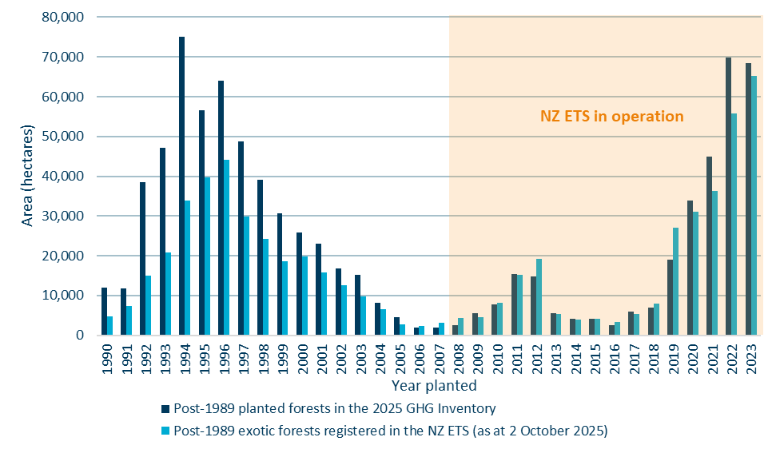
Source: Commission analysis

Comparison of native/natural forest activity data
Figure 2 compares the latest data on area of post-1989 native forests registered in the NZ ETS by year of establishment with the GHG Inventory post-1989 natural forest area. Key observations are:
- Native/natural forest area does not align as closely as exotic/planted forests.
- The NZ ETS-registered native forest area has high variability in the area established year-to-year, but is generally higher than the GHG Inventory-reported area for natural forests, particularly for forests established in the 1990s.
- Cumulatively, for native/natural forests established over 1990–2020 the NZ ETS-registered area is around 49,000 hectares (51%) higher than that reported in the GHG Inventory.
Figure 2: Post-1989 native forest area registered in the NZ ETS (as at 2 October 2025) compared with post-1989 natural forest area in the GHG Inventory by age class
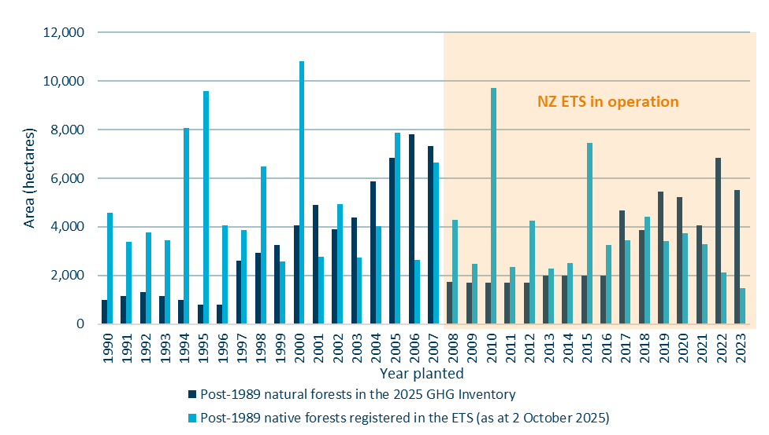
Source: Commission analysis

Activity data assumptions
There is a general pattern of greater areas being registered in the NZ ETS than reported in the GHG Inventory for native forests, and the same also applies for exotic forests planted since 2005.
It is beyond the scope of our NZ ETS settings advice to determine causes for the differences in activity data. On the surface, the rules for registering forests in the NZ ETS appear to be well-aligned with the mapping definitions of the GHG Inventory. Two areas where potential differences may lie are:
- in the handling of land that was originally pre-1990 forest land and was deforested
- detailed mapping methodologies.
Resolving the observed discrepancies would require in-depth investigation by the relevant lead agencies (Ministry for Primary Industries for NZ ETS data and Ministry for the Environment for GHG Inventory/LUCAS data).
It is important to recognise that, for this analysis, the question of which dataset more accurately reflects the real world does not affect the case for making a technical adjustment. As the method used for tracking progress towards emissions budgets, target accounting (and hence GHG Inventory data) is the starting point for the unit supply calculations – whether ‘right’ or ‘wrong’, even if discrepancies exist.
Table 1 below summarises the key assumptions we have made in this analysis relating to forest area assumed to be registered in the NZ ETS. These assumptions are consistent with those used throughout our 2026 NZ ETS settings advice, including to calculate the NZ ETS emissions cap and to estimate the volume of surplus units in the scheme. The assumptions reflect some minor changes since our 2025 advice.
Table 1: Assumptions about post-1989 forest area covered by the NZ ETS
 | Exotic forests | Native forests
Inside NZ ETS | - Actual NZ ETS-registered areas by planting year 1990-2005.  - GHG Inventory-reported areas from 2006 onwards and 100% of projected afforestation (with the exception of forecast afforestation on Crown-owned land beginning in 2027). | - 100% of GHG Inventory-reported areas by year established over all past years and 100% of projected afforestation (i.e. assume all native afforestation is covered by the NZ ETS).
Outside NZ ETS | - Additional GHG Inventory-reported areas by planting year 1990-2005. | - No native afforestation outside the NZ ETS.
  - Accounting approaches
This section discusses key differences between target and NZ ETS accounting for forests.

Scope and treatment
Table 2 below summarises the similarities and differences in how distinct sources of emissions and removals by forests are accounted for in target accounting and the NZ ETS. The different accounting approaches for forest growth are described in more detail in the subsections which follow.
Table 2: Scope and treatment of emissions and removals by forests under target and NZ ETS accounting
Net emissions from Afforestation activities include:³ | Target accounting | NZ ETS accounting
Net emissions from the growth of post-1989 forests | Accounted using averaging approach: emissions and removals are accounted for until the forests attain their long-term average carbon stock. | Forests registered from 2023 must choose between averaging or permanent forestry category. Forests registered before 2019 are all on stock change accounting, while those that registered into the NZ ETS between 2019 to 2022 may be on stock change or averaging, as in 2023 they had an opportunity to choose whether to continue on the stock change approach, or switch to averaging or permanent.
Net emissions from the growth of post-1989 forests | Carbon yield tables (average carbon stored by forest age) derived from national plot network through the LUCAS system. | Carbon yield tables for larger forests (100 ha or more) measured using field measurement approach; smaller forests use default lookup tables.
Emissions from the decay of post-1989 forest harvest residues | Included in long-term average carbon stock. | Stock change: Included.  Averaging: Included in long-term average carbon stock.
 | Different decay profiles assumed.
Emissions and removals from harvested wood products derived from post-1989 forests | Included in long-term average carbon stock. | Not accounted.
Emissions from the conversion of land to post-1989 forest (biomass losses from previous land use and soil carbon changes) | Accounted separately from long-term average carbon stock. | Not accounted.
Carbon dioxide emissions from biomass burning | Accounted separately from long-term average carbon stock. | Not accounted.

Averaging, stock change, and permanent forestry

Averaging approach
Under averaging in target accounting, emissions and removals are accounted for until the age at which forests attain their long-term average carbon stock. After this point, no further emissions and removals are recorded if the forest is replanted after harvest.
Averaging in the NZ ETS operates similarly. The main difference is that emissions from harvested wood products are not covered by the NZ ETS, and therefore not included in the forests’ long-term average carbon stock. This means the ‘average age’ – the age at which forests attain their long-term average carbon stock – is several years lower compared with under target accounting (Table 3).
Table 3: Average age at which long term carbon stock is reached, by forest type
Forest type/species | Average age
Target accounting³
Post-1989 rotational planted forests (weighted average across all species) | 23
NZ ETS⁴
Radiata pine | 16
Douglas-fir | 26
Exotic softwoods | 22
Exotic hardwoods | 12
Native (indigenous forests) | 23

Stock change approach
Under stock change accounting, annual emissions and removals continue to be accounted indefinitely based on calculations of the carbon stores in the forest at the time. Forests on stock change accounting in the NZ ETS earn NZUs each year up to the time of harvest but are then liable to surrender a portion of the NZUs earned over their first rotation, before starting to earn NZUs again during the second rotation. This means the NZUs foresters receive are a combination of:
- units that will not need to be surrendered at harvest (‘low-risk units’), which can be safely sold to emitters so long as the forester does not intend to deforest, and
- units that will need to be held to cover harvest liabilities.
The proportion of low-risk units will vary for different foresters depending on the makeup of their portfolio (particularly the different age classes of forests they own) and is uncertain at the overall estate level.
When comparing removals under target accounting against NZUs allocated under stock change, it is the supply of low-risk units that matters. In the NZ ETS, the low-risk units can be used to cover gross emissions and so are the quantity of removals relevant to compare to target accounting removals. The allocation and surrender of units with harvest liabilities net out overall and so should have no effect on target accounting net emissions.

Permanent forestry
In the NZ ETS, the permanent forestry category is for forests that will not be clear-felled for at least 50 years. Forests registered in this category use stock change accounting. Forests registered before 2023 and still in the stock change category will also continue to earn NZUs for as long as they are not harvested.
In target accounting, post-1989 planted forests are split into categories of production planted forests and permanent planted forests, which reach their long-term average carbon stocks at different ages. New Zealand’s First Biennial Report states that “Further work is planned to determine the permanent forest long-term average, however, it is currently estimated to be more than 40 years, putting it beyond the NDC1 period for forests planted after 1989”.³ This means that – until 2030 at the very earliest – there is no practical difference between this approach and stock change accounting.
  - Comparison on a per hectare basis
This section presents analysis comparing net removals under target accounting with the average number of NZUs earned for a single forest area of different types. The results show whether forests are on average ‘over-credited’ or ‘under-credited’ in the NZ ETS (i.e. receive more or fewer units relative to the net removals under target accounting) at different ages.

Native/natural forests
Native forests are, on average, cumulatively over-credited in the NZ ETS at all ages (Figure 3). For example, at age 20, the average native forest will have earned around 150 NZUs per hectare (pink line) compared with cumulative net removals of 133 tCO₂ per hectare under target accounting (dark blue line). This happens primarily because the NZ ETS does not account for emissions from loss of soil carbon and biomass from previous land use.
Figure 3: Comparison of net carbon stock change under target accounting to cumulative NZUs earned for post-1989 native forests
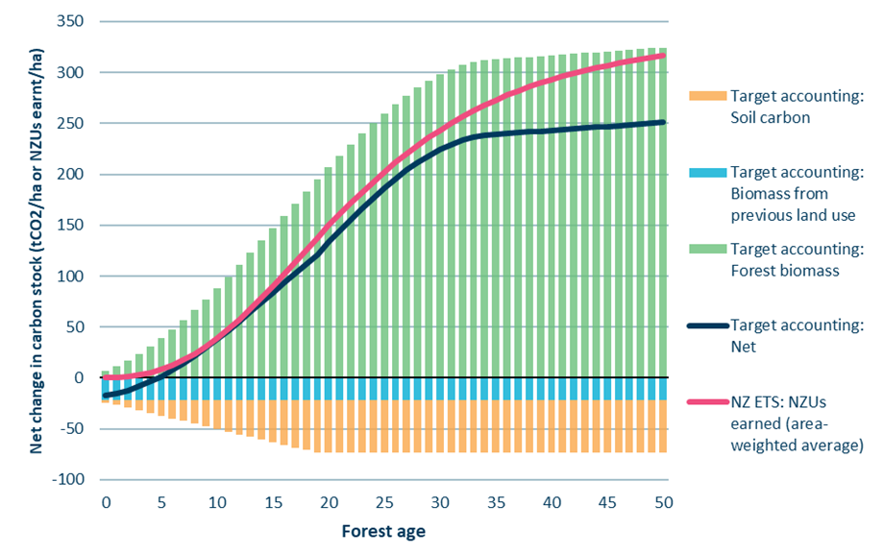
Source: Commission analysis

Figure 4 below shows the annual and cumulative over/under-crediting per hectare for native forests. A positive number here means over-crediting. After an initial convergence between NZUs earned and net removals, the difference grows larger from age 10 as the GHG Inventory yield table flattens off faster than the area-weighted NZ ETS yield table.
Figure 4: Annual and cumulative over/under-crediting per hectare for native forests in the NZ ETS
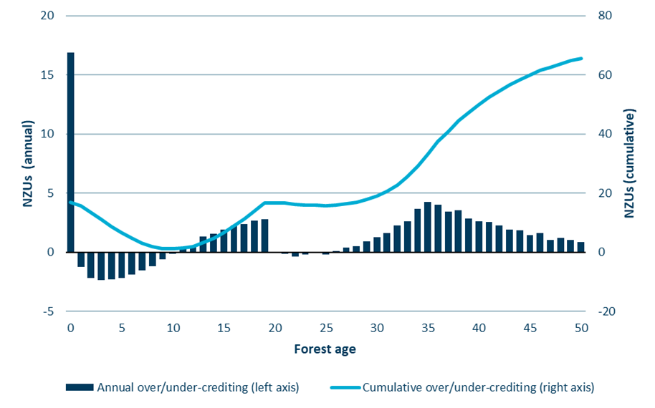Source: Commission analysis

Permanent exotic forest
Permanent exotic forests are, on average, cumulatively over-credited up to around age 37, then subsequently under-credited (Figure 5). Similar to native forests, the initial over-crediting is due to the NZ ETS not accounting for emissions from loss of soil carbon and biomass from previous land use. Over time, this is outweighed by the GHG Inventory’s post-1989 exotic forest yield table being higher than the NZ ETS yield tables on an area-weighted average basis.
On an annual basis (Figure 6), there is an over-crediting phase up to around age 23 followed by an under-crediting phase.
Figure 5: Comparison of net carbon stock change under target accounting to cumulative NZUs earned for post-1989 permanent exotic forests
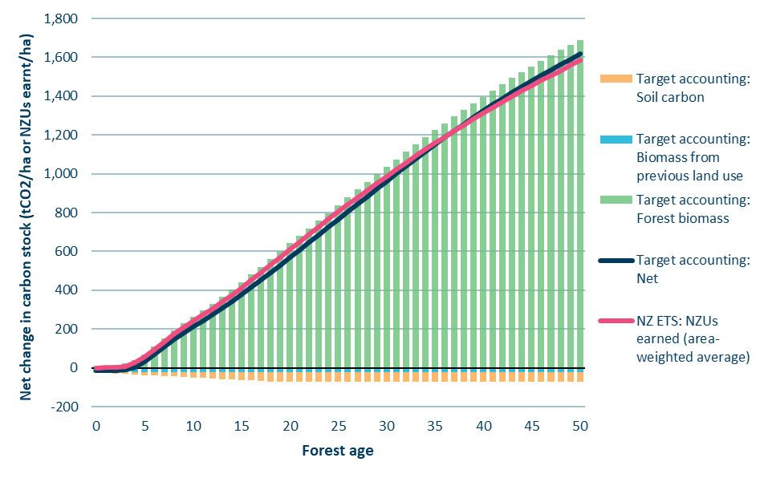
Source: Commission analysis
Figure 6: Annual and cumulative over/under-crediting per hectare for permanent exotic forests in the NZ ETS
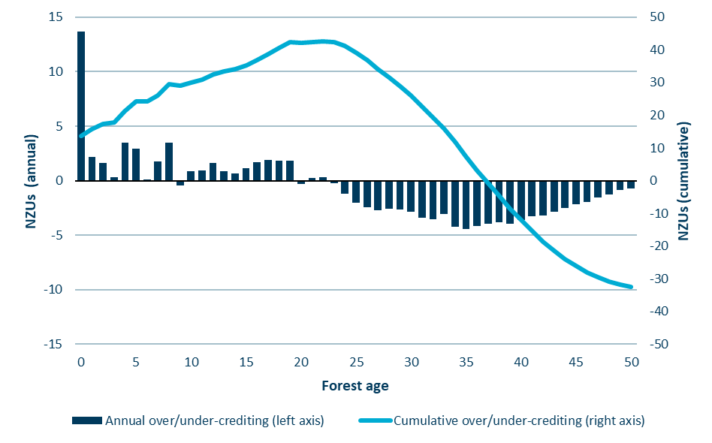
Source: Commission analysis

Production exotic forests on averaging accounting
Production exotic forests are over-credited up to their NZ ETS average age, but heavily under-credited beyond that point (Figure 7). This is because of the higher long-term average carbon stock and older average age under target accounting due to the inclusion of harvested wood products. By the time the forest reaches its average age under target accounting (23 years), this leads to a cumulative under-crediting of around 200 NZUs per hectare (Figure 8). Beyond this age, no further removals are counted.

Figure 7: Net carbon stock under target accounting compared to cumulative NZUs earned for post-1989 production exotic forests on averaging accounting in the NZ ETS
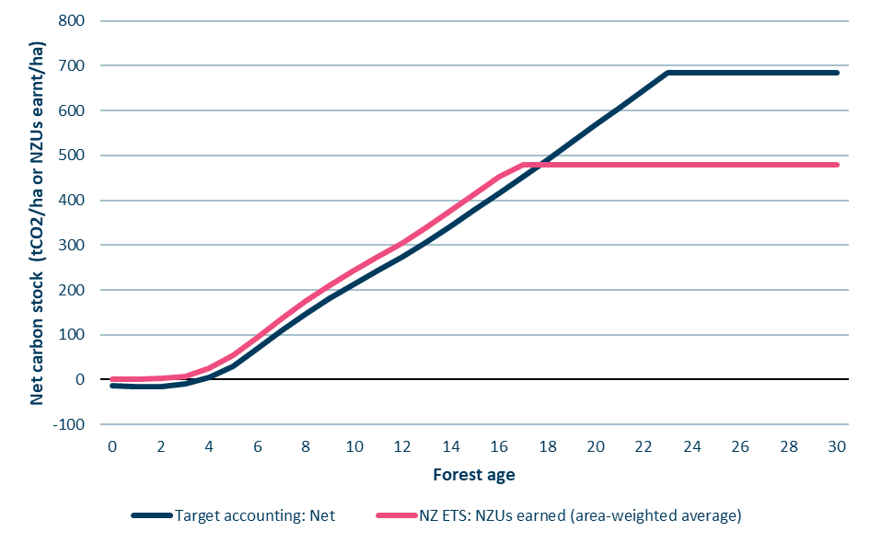
Source: Commission analysis

Figure 8: Annual and cumulative over/under-crediting of NZUs per hectare for production exotic forests on averaging accounting in the NZ ETS
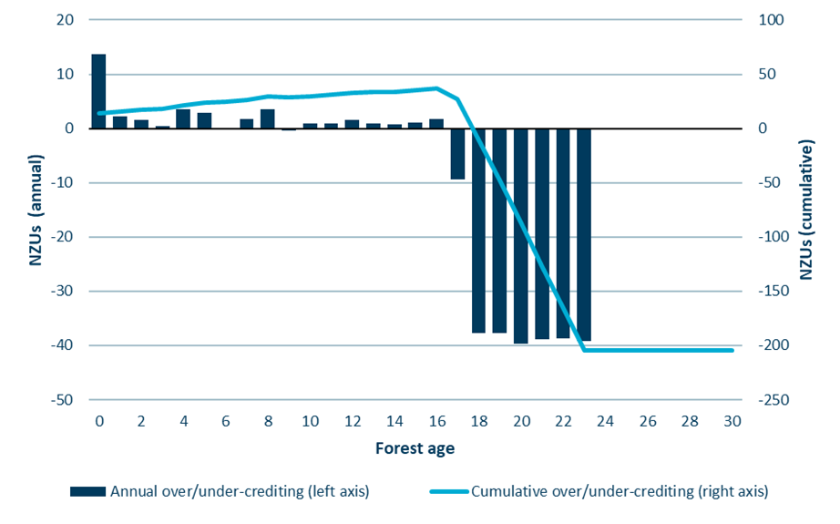
Source: Commission analysis

Production exotic forests on stock change accounting
As discussed earlier in Section 3.2: Accounting approaches in the subsection on stock change accounting, it is the supply of low-risk units (units unlikely to be needed by foresters for harvest surrenders) that matters when comparing NZU supply from stock change forests against net removals. For the quantity of low-risk units, Figures 9 and 10 below use an assumption of 65% additional low-risk units, consistent with the central assumption we use in other aspects of the 2026 NZ ETS settings advice that rely on forestry model outputs. Additional low-risk units refers to the proportion of low-risk units above the theoretical minimum. For further information see Technical Annex 1: Unit limit settings, published on our website.
The results are similar to those for the averaging approach, but with a larger amount of under-crediting. This is because the estimate of low-risk units is less than the long-term average carbon stock under averaging, which is equivalent to an average age of around 14 years.
Figure 9: Net carbon stock under target accounting compared to cumulative low-risk NZUs earned for post-1989 production exotic forests on stock change accounting in the NZ ETS
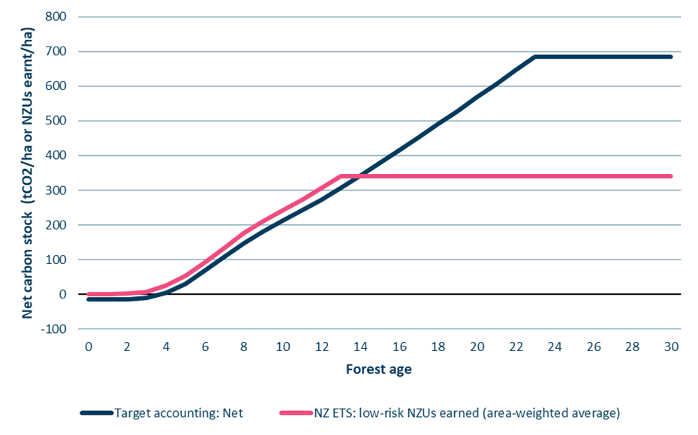
Source: Commission analysis
Figure 10: Annual and cumulative over/under-crediting of low-risk NZUs per hectare for production exotic forests on stock change accounting in the NZ ETS
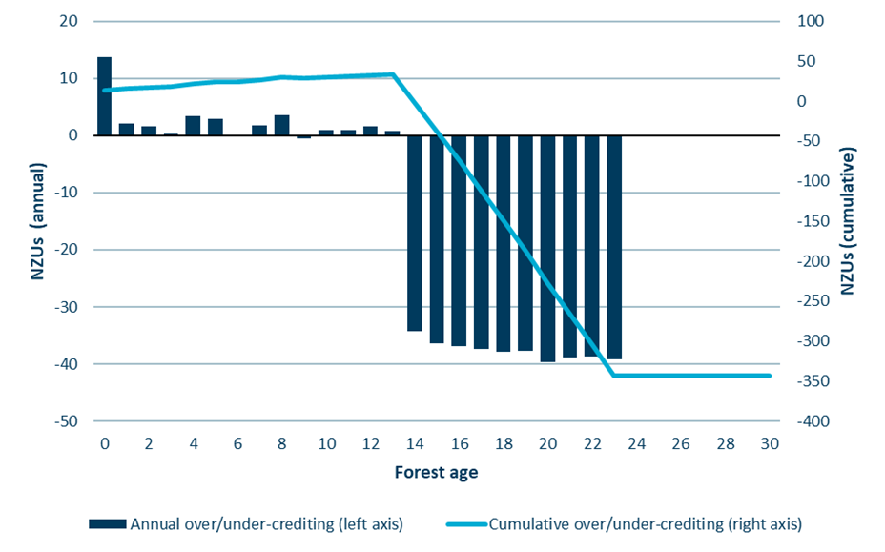
Source: Commission analysis
  - Comparison at the national level
The analysis in the previous section shows that the net effect of accounting differences between the NZ ETS and target accounting varies significantly with forest age. The net effect at the national level will therefore depend on the age class distribution of NZ ETS-registered forests at the point in time.
Because of the age class effects, a technical adjustment for forestry cannot be based on a comparison of historical data between the NZ ETS and the GHG Inventory, like they have been for other emissions sectors. Also, a technical adjustment cannot be based on a comparison of the total NZUs issued to foresters versus net removals under target accounting, because the former includes units with harvest liability issued to stock change forests.
Therefore, the technical adjustment has been based on a model projection of forestry NZU supply, excluding units with harvest liabilities, against a corresponding projection of target accounting forestry removals.

Total target accounting removals versus low-risk NZ ETS allocations
Figure 11 shows results from our NZ ETS forestry model. The dark blue line shows projected net removals by forests under target accounting, excluding estimates of forests outside the NZ ETS (assumptions discussed in section 3.1). The pink line shows the projected allocations of low-risk NZUs for the same forests in the NZ ETS.
Figure 11: Projected allocations of low-risk NZUs compared with target accounting removals for forests covered by the NZ ETS
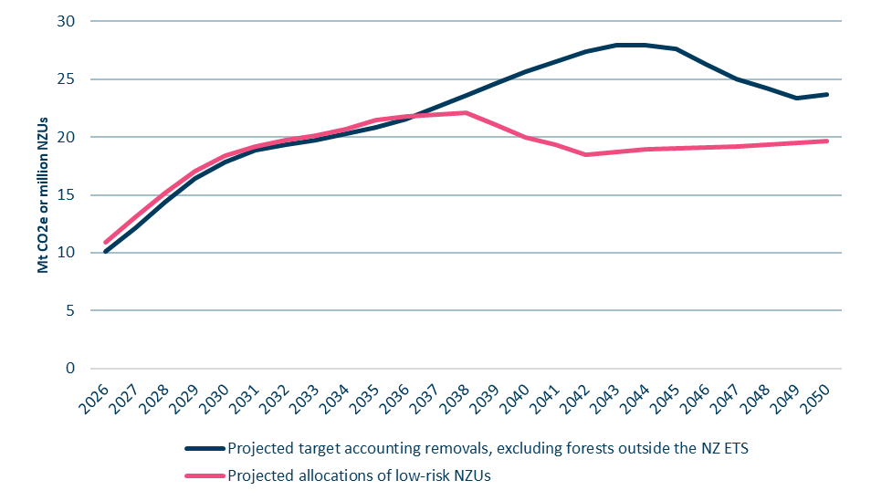
Source: Commission analysis

These results suggest that there is presently net over-crediting happening in the NZ ETS. Over 2026–2030 over-crediting is an average of 0.7 million NZUs per year, reducing to an average of 0.4m NZUs over 2031–2036, before transitioning to a period of significant under-crediting from 2037 on.
The main reasons for this are to do with age class, the different accounting approaches, and the lower long-term average carbon stock in the NZ ETS due to exclusion of harvested wood products. Currently, most forests are either less than five years old (due to the surge in planting beginning in 2019), or already past their long-term average. The divergence beginning in the mid-2030s happens when the large area of recently planted forests start to reach their NZ ETS average age, where they no longer receive further NZUs, but will still be contributing net removals under target accounting (i.e. the period of significant under-crediting from age 17 to 23 shown in Figure 8).
Figure 12 illustrates the detailed long-term breakdown of contributions to over- and under-crediting from different causes (activity data and accounting differences) over time. Table 4 shows the figures in detail over the second and third emissions budget periods.
Figure 12: Projected contributions to over- and under-crediting by year across all forests covered by the NZ ETS
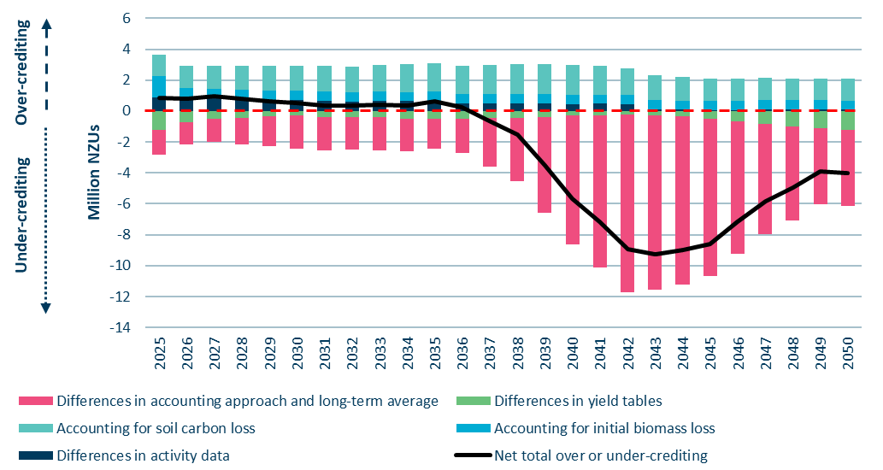
Source: Commission analysis
Table 4: Breakdown of causes for over or under-crediting over 2026–2035
NZUs (millions) | 2026 | 2027 | 2028 | 2029 | 2030 | 2031 | 2032 | 2033 | 2034 | 2035
Differences in activity data | 0.9 | 0.8 | 0.8 | 0.7 | 0.7 | 0.7 | 0.6 | 0.7 | 0.6 | 0.7
Accounting for initial biomass loss | 0.6 | 0.6 | 0.6 | 0.6 | 0.6 | 0.6 | 0.6 | 0.6 | 0.6 | 0.6
Accounting for soil carbon loss | 1.5 | 1.5 | 1.6 | 1.6 | 1.6 | 1.7 | 1.7 | 1.7 | 1.8 | 1.8
Differences in yield tables | -0.7 | -0.5 | -0.5 | -0.3 | -0.3 | -0.4 | -0.4 | -0.4 | -0.5 | -0.5
Differences in accounting approach and long-term average carbon stock | -1.4 | -1.5 | -1.7 | -2.0 | -2.1 | -2.2 | -2.1 | -2.1 | -2.1 | -2.0
Net total over or under-crediting | 0.8 | 0.9 | 0.8 | 0.6 | 0.5 | 0.4 | 0.4 | 0.4 | 0.4 | 0.6
As shown, over the 2027–2031 period covered by the 2026 NZ ETS settings advice, the projected net over-crediting is 3.2 million units.
An additional breakdown of this by cause and forest type is presented in Figure 13.
Figure 13: Contributions to over/under-crediting over the 2027–2031 period by forest type
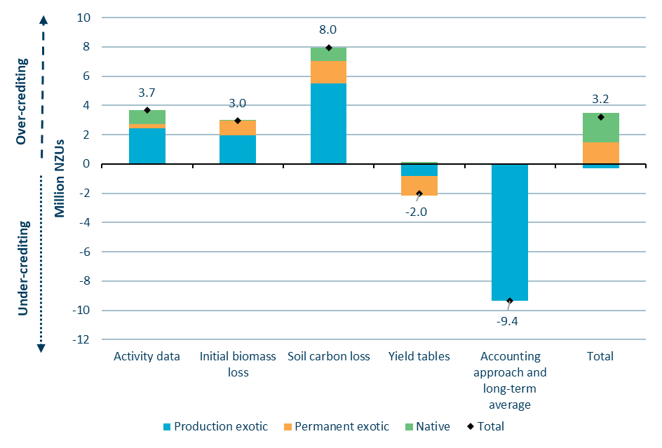
Source: Commission analysis

- Sensitivity analysis and uncertainties
The analysis presented in this document relies on projections of forestry units which are output from the NZ ETS forestry model. Because of this reliance on projections, there are uncertainties in the analysis.
We have tested the sensitivity of the results to three key variables:
- Level of low-risk units for production forests on stock change accounting.
- Proportion of permanent (unharvested) exotic forests.
- Future afforestation rates.
The impacts of changes to NZ ETS default tables and area weightings have also been reviewed and are discussed under uncertainties.
  - Level of low-risk units for production forests on stock change accounting
As explained earlier (Section 3.2: Accounting approaches), forests on stock change accounting may have different levels of low-risk units depending on the forest owner’s portfolio, and the average level in the NZ ETS is uncertain. The minimum level of low-risk units occurs for a single forest age class, while the theoretical maximum level occurs for a perfectly diversified age class portfolio (and is equal to the long-term average).
We have used a central assumption of 65%, between the theoretical minimum and maximum levels. The lower and upper assumptions for sensitivity testing are 55% and 75% respectively. These assumptions are consistent with those used in other aspects of the 2026 NZ ETS settings advice which rely on outputs from the forestry model. For further information see Technical Annex 1: Unit limit settings, published on our website.
Table 5 shows how changing the assumed level of low-risk units affects projected net over-crediting over the 2027–2031 period.
Table 5: Results of sensitivity testing to the assumed level of low-risk units (million NZUs)
Million NZUs | Central assumption (65% additional low-risk units) | Lower assumption (55% additional low-risk units) | Upper assumption (75% additional low-risk units)
Net over-crediting over 2027-2031 period | 3.2 | 2.7 | 3.8
Difference to baseline assumption | - | –0.6 | +0.6
The results show that a higher level of low-risk units would increase the extent of over-crediting. Conversely, a lower level of low-risk units would decrease net over-crediting.
The impact of uncertainty around this assumption is limited by the fact that most forests using stock change accounting in the NZ ETS are already over the age at which it would make any difference (approximately 15 years for pine).
  - Proportion of exotic forests assumed to be managed as permanent
NZ ETS forest owners – particularly those with forests on stock change accounting – have choices around harvesting their forest or transitioning it to ‘permanent’ to avoid harvest liabilities and continue earning NZUs. This creates uncertainty for projected net forestry emissions and NZ ETS unit supply and estimated over/under crediting.
Forestry emissions projections supplied by the Ministry for Primary Industries (MPI) include assumptions about the proportion of permanent and production forest area by year of planting. In line with this we have used a central assumption that 17% of the total exotic forest area over 1990–2024 will be managed as permanent. We have used high and low assumptions of 22% and 12%, developed by varying the permanent forest area by 30% more or 30% less than the central assumption. These assumptions are consistent with those used in other aspects of the 2026 NZ ETS settings advice which rely on outputs from the forestry model. For further information see Technical Annex 1: Unit limit settings, published on our website.
Figure 14 shows MPI data on the proportion of forest area assumed to be managed as permanent by year of forest planting. It also shows the total exotic forest area planted in each year, illustrated on the graph by the grey shaded area. The overall central estimate of 17% is weighted based on the area planted in each year and shown by the dashed line on the graph.
Figure 14: Total exotic forest area planted and proportion assumed to be managed as permanent by year
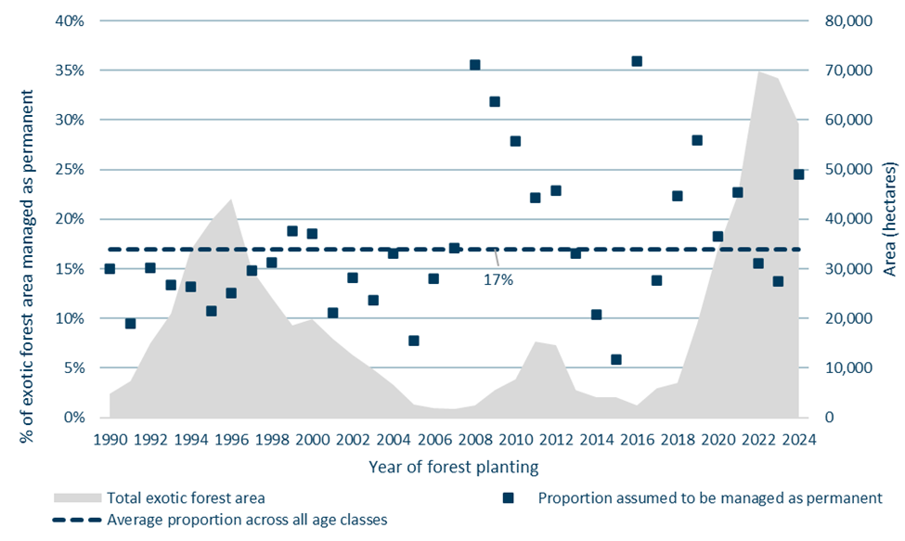
Source: Ministry for Primary Industries
Figure 15 shows the low, central and high assumptions of the proportion of forest area managed as permanent. This is based on varying the data provided by MPI by +/-30%.
Figure 15: Central, high and low assumptions of the proportion of forest area assumed to be managed as permanent by year of forest planting
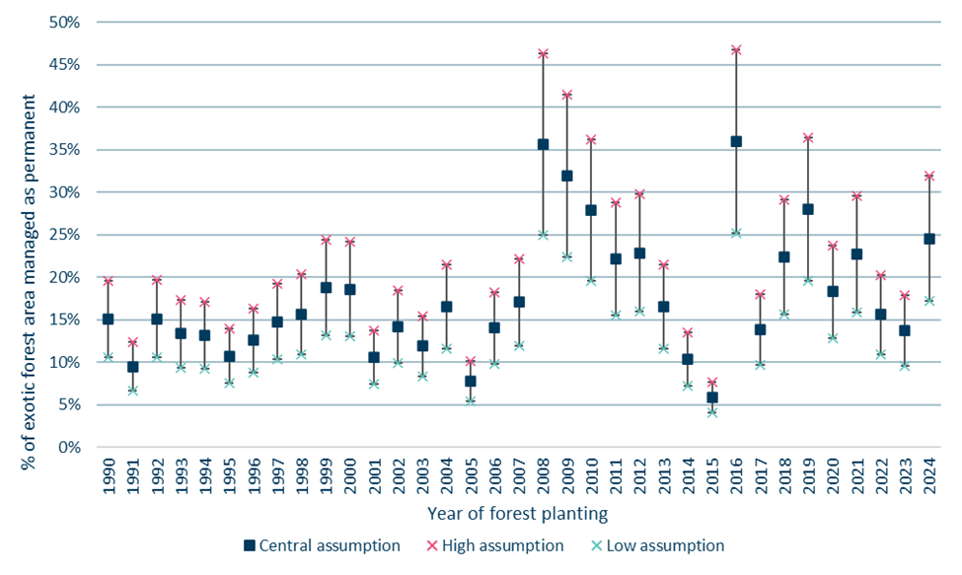
Source: Commission analysis
Table 6 shows how the different assumptions on permanent exotic forest area affect the projected net over-crediting over the 2027–2031 period.
Table 6: Results of sensitivity testing to the proportion of exotic forest area managed as permanent (million NZUs)
Million NZUs | Central assumption  (Area for each age class in MPI’s 2025 projections) | Low assumption  (Area managed as permanent reduced by 30%) | High assumption  (Area managed as permanent increased by 30%)
Net over-crediting over 2027–2031 period | 3.2 | 2.5 | 3.9
Difference to baseline assumption | - | -0.7 | 0.7
Net over-crediting is lower than the central estimate under the low assumption, and higher under the high assumption.
  - Future afforestation rates
Sensitivity to future afforestation rates was tested using the ‘Lower’ and ‘Upper’ scenarios in the forestry projections contained in the 2025 government emissions projections (Table 7).
Table 7: Afforestation rates in MPI’s 2025 forestry projections
 | Exotic afforestation | Native afforestation
Central projection | 2025: 60,600 ha  2026 on: 27,200 ha | Falls from 2,200 ha in 2025 to 100 ha from 2028
Lower projection | 2025: 44,000 ha  2026 on: 21,100 ha  Lower proportion of permanent forestry | Falls from 2,200 ha in 2025 to 50 ha from 2028
Upper projection | 2025: 70,600 ha  2026 on: 33,300 ha  Higher proportion of permanent forestry | Falls from 2,200 ha in 2025 to 150 ha from 2028
Table 8 shows how the different afforestation rates affect the projected net over-crediting over the 2027–2031 period.
Table 8: Results of sensitivity testing to future afforestation rates (million NZUs)
Million NZUs | MPI 2025 Central projection | MPI 2025 Lower projection | MPI 2025 Higher projection
Net over-crediting over 2027–2031 period | 3.2 | 2.4 | 4.0
Difference to baseline projection | - | –0.8 | +0.8
Higher rates of future planting would increase over-crediting initially, for at least the first 16 years, because all forest types are over-credited on this timeframe. This is due to the NZ ETS not accounting for emissions from initial biomass and soil carbon loss. Conversely, lower rates of future planting would initially reduce over-crediting. In the lower projection scenario, net under-crediting begins from 2031, five years earlier than in the central projection (see Figure 12).
  - Combined impact of sensitivity analysis
We have reviewed the combined impact of the sensitivity analyses. For sensitivities related to low-risk units, proportion of permanent exotic forests, and future afforestation this is based on the low and high scenarios.
Results are shown in Table 9, with annual results shown in Figure 15.
Table 9: Combined results of sensitivity testing on central estimate of 3.2 million over-crediting over 2027–2031 (million NZUs)
Size of technical adjustment over 2027–2031 (Million NZUs) | Central | Low | High
Low-risk units | - | –0.6 | +0.6
Permanent/harvest | - | –0.7 | +0.7
Future afforestation | - | –0.8 | +0.8
Total difference to central estimate |  | –2.1 | 2.0
Resulting over-crediting | 3.2 | 1.1 | 5.2
Figure 16: Annual impacts of over/under-crediting based on low, central and high combined sensitivity testing scenarios
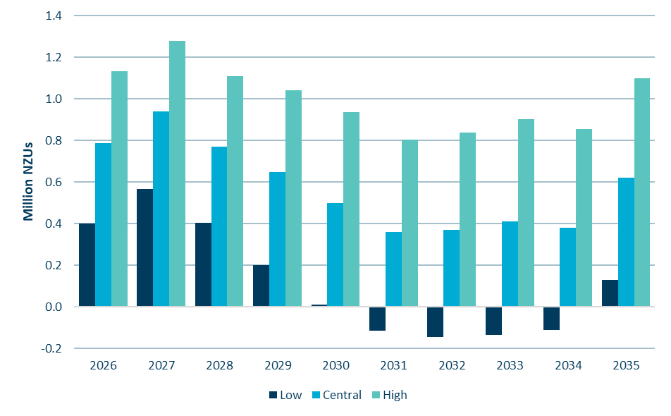
Source: Commission analysis
  - Uncertainties related to carbon yield tables
A key input into the NZ ETS forestry model is the area-weighted carbon yield tables, which are used to determine the volume of units allocated in each year based on forest age. There are five input tables, each for different tree species, which aggregate the yield tables used in the NZ ETS and which the model applies across all forests registered in the scheme.
In the NZ ETS, carbon yield tables are used to estimate the amount of carbon stored per hectare in forests based on different forest types, ages, and regions. There are two carbon measurement methods used for forests in the NZ ETS and therefore two types of carbon yield tables:
- default yield tables, used for forests under 100 hectares
- participant specific tables (PSTs), used for forests above 100 hectares, developed specifically for forests required to use the field measurement approach (FMA) using sample plot locations.
In the analysis for this 2026 NZ ETS settings advice, our forestry model uses area-weighted carbon yield tables provided by MPI in November 2024. Each yield table combines an area-weighted average of PSTs with an area weighting of participants using default tables for each species.
Details of how the MPI area-weighted carbon yield tables have been developed are set out in Appendix A.
There are two important uncertainties related to carbon yield tables that could affect the results of our analysis – the weightings of the carbon measurement methods (default tables versus PSTs) in the area-weighted tables used in the model, and proposed updates to the NZ ETS default carbon yield tables that are under consideration by the Government. These are discussed below.

Weightings of carbon measurement methods used in the area-weighted carbon yield tables
Participants who are subject to the FMA are generally required to undertake measurements and generate a PST for each mandatory emissions return. However, in some circumstances it is possible for a participant subject to the FMA to apply for a waiver to use the default tables.
The mix of forest area subject to default tables versus PSTs varies over time as new forests are registered. Further to this, there is not always a current PST available for forest area subject to the FMA. This could be because the participant has applied for a waiver to use the default tables, or it could be because the participant has not yet measured their forest to get an up-to-date PST for the current MERP.
This means that determining the most appropriate carbon yield table to use in the forestry model requires some judgement.
We understand that the area-weighted yield tables supplied to us by MPI were based only on PSTs that had been approved for use in MERP3 at the date the data was extracted (1 November 2024). However, some participants subject to the FMA had not yet had their PSTs approved, and in the area-weighted tables they were classified as using default tables. This resulted in an area weighting of approximately 35% of total forest area using the default tables. However, additional information published by MPI shows that only around 20% of the total forest area registered in MERP3 is not subject to the FMA (and therefore is subject to the default tables).⁵
While some participants will have waivers to allow them to use the default tables despite being subject to the FMA, this is unlikely to explain the entire 15% difference. It seems likely that for a substantial proportion of the forest area, the default tables were used in the calculations as proxies for the PSTs which were not yet available.
We have based our analysis on the area-weighted carbon yield tables provided by MPI, as we do not have the detailed level of information required to develop our own. However, variation in the weightings used can significantly impact the results. Because of this we suggest that further consideration be given to the most appropriate weightings to be used for this analysis.
Table 10, below, shows the proportion of forest area assumed to use the default carbon yield tables in the area-weighted table provided by MPI. It also shows the proportion of forest area which is not subject to the FMA (and therefore automatically uses the default tables) for MERP3. This is shown for each species and overall.
Table 10: Comparison of proportion of forest area using default carbon yield tables
Area weightings | Overall | Pine | Douglas Fir | Exotic softwoods | Exotic hardwoods | Indigenous forest
MPI % on default tables | 35% | 30% | 13% | 38% | 54% | 56%
% of forest area not subject to FMA (MERP3) | 20% | 14% | 26% | 25% | 48% | 37%
Difference | 15% | 16% | -14% | 13% | 7% | 18%
*Discrepancies may exist due to rounding

Potential updates to NZ ETS default carbon yield tables
In April 2025, MPI launched consultation on proposed updates to the default lookup tables used in the NZ ETS for small-scale forests (under 100 ha).⁶ Updates were proposed for radiata pine, exotic hardwoods, and exotic softwoods – including introducing a separate forest type for redwoods. Future updates for indigenous forests and potentially Douglas fir were also signalled. The proposed changes would be implemented in 2026 and apply from the next mandatory emissions return period (MERP5, 2026–2030).
The proposed updates would significantly increase the overall number of NZUs foresters using the default lookup tables would receive.
If these changes are confirmed they will significantly affect the results of this analysis.

Potential impact of carbon yield table uncertainties
We have estimated the impact on over-crediting of updating the weightings used in the area-weighted carbon yield tables and/or updating the default carbon yield tables based on tables contained in the consultation document. These estimates are presented in Table 11 below.
Table 11: Estimated over-crediting over 2027–2031 based on alternative yield table and/or area weightings
Estimated over-crediting over 2027–2031 (Million NZUs) | Using area weightings as provided by MPI | Using area weightings based on October 2025 registered area by carbon measurement method
Default carbon yield tables as in regulation | 3.2 (used in our advice) | 6.9
Default carbon yield tables as in 2025 consultation | 6.1 | 8.4
As shown, potential changes to the default carbon yield tables and/or the area weightings applied have the potential to significantly impact the estimated unit over-crediting over 2027–2031.

Appendix A: Detailed information about how area-weighted carbon yield tables have been developed (text supplied by MPI)
This appendix provides additional detail about how the area-weighted carbon yield tables supplied to us by MPI have been developed.
Area weighting for participant specific tables (PSTs) is based on the participant’s registered area at the time the PST was generated. The areas recorded at that time may differ significantly from areas registered today. In some cases, participant land holdings may have changed materially between measurement and PST approval or generation.
Area weighting for default tables is based on the total area registered as at 31 December 2022 for participants who were not subject to the Field Measurement Approach (FMA) in MERP3, plus areas of forest for which FMA participants do not have a PST.
Please note the following:
- Weighting is based only on areas where the predominant species can be matched to the forest type groupings used in the PSTs (Pinus radiata, Douglas fir, exotic softwoods, exotic hardwoods, and indigenous). Areas without standardised forest types are excluded.
- Predominant species are recorded at the time of registration. Subsequent rotations may be of a different forest type and are not reflected in the data.
- In this extract, it is assumed that all exotic forest area is planted. Historically, this information was not captured at registration. A small number of PSTs may include data from plots flagged as natural regeneration, which is the only point at which this information is recorded in the system used to administer the FMA.
- PSTs are calculated using all contributing plots, with and without regeneration. While it would be possible to exclude PSTs that include any regeneration plots, doing so would also remove all other information contained in those PSTs.
- PSTs may be derived from measurements taken from either very young or very old forests. Regardless, each PST extrapolates values for ages 0 to 50. Area weighting does not account for how close extrapolated values are to the actual measurement age. As a result, extrapolated values from large forests may outweigh more accurate values from smaller forests, reducing overall accuracy. In practice, participants who remain in the FMA typically update their PSTs each MERP.
- When combining forest types, one limitation is that the exotic hardwood table extends only to age 35, whereas other tables extend to age 50. As a result, exotic hardwood data is included in amalgamated tables only up to and including age 35. Ages above 35 exclude both exotic hardwood carbon values and their associated area weighting factors.
- Participants subject to the FMA who do not have an approved PST for MERP3 are excluded from PST weighting but included in the default table weighting.
Data is as at 1 November 2024

References

1. Ministry for Primary Industries Manatu Ahu Matua. How to map forestry for the Emissions Trading Scheme. Updated 31 October 2025. Accessed 18 April 2026, https://www.mpi.govt.nz/forestry/forestry-in-the-emissions-trading-scheme/mapping-and-managing-forest-land-in-the-ets/how-to-map-forestry-for-the-emissions-trading-scheme
2. Ministry for Primary Industries Manatu Ahu Matua. How forest land is defined in the ETS. Updated 31 October 2025. Accessed 18 April 2026, https://www.mpi.govt.nz/forestry/forestry-in-the-emissions-trading-scheme/about-forestry-in-the-emissions-trading-scheme-ets/how-forest-land-is-defined-in-the-ets
3. Ministry for the Environment. New Zealand’s First Biennial Transparency Report under the Paris Agreement. 2024. https://environment.govt.nz/publications/new-zealands-first-biennial-transparency-report-under-the-paris-agreement/
4. Ministry for Primary Industries Manatu Ahu Matua. Averaging accounting. Updated 18 December 2025. Accessed 21 April 2026, https://www.mpi.govt.nz/forestry/forestry-in-the-emissions-trading-scheme/emissions-returns-and-carbon-units-nzus-for-forestry/accounting-for-carbon-in-the-ets/averaging-accounting
5. Ministry for Primary Industries Manatu Ahu Matua. Application wait times and statistics for forestry in the ETS. Accessed 26 January 2026, https://www.mpi.govt.nz/forestry/forestry-in-the-emissions-trading-scheme/news-and-changes-to-the-ets/application-wait-times-and-statistics-for-forestry-in-the-ets
6. Te Uru Rākau New Zealand Forest Service. Proposed changes to forestry in the New Zealand Emissions Trading Scheme (NZ ETS). 2025. April 2025. https://www.mpi.govt.nz/dmsdocument/68796-Proposed-changes-to-forestry-in-the-New-Zealand-Emissions-Trading-Scheme-NZ-ETS

Target accounting differs from the land use, land-use change and forestry emissions reported in New Zealand’s GHG Inventory. The inventory also reports target accounting emissions in an annex.
For more information on forest management, see New Zealand’s first Biennial Transparency Report (https://environment.govt.nz/assets/publications/New-Zealands-first-Biennial-Transparency-Report-2024.pdf)
We use the terms ‘over-crediting’ and ‘under-crediting’ here merely to intuitively indicate the treatment of different forests under NZ ETS accounting versus target accounting. These terms should not be taken to indicate that either accounting system is more accurate or correct, or that more or fewer units are being allocated for forestry in the NZ ETS than is appropriate. For clarity we also note that forestry NZUs in the NZ ETS are not ‘carbon credits’ in the way this term is typically defined in voluntary or international carbon markets.
For production pine forests on stock change accounting, NZUs earned after age ~12–16 are liable for surrender when the forest is harvested. Therefore, there has generally been less incentive to register older production forests into the NZ ETS, except for managing unit flows within a forestry portfolio. Since the move to averaging accounting, there is only incentive to register a forest from 2005 or earlier if it is either a permanent forest or of a species with a longer average age, such as Douglas fir (see Table 3).
Excepting more recent years (from 2020) where further registrations are highly likely still to come.
To our knowledge, detailed rules on this are not provided in the GHG inventory.
Afforestation on Crown-owned land is a government policy to partner with the private sector to plant trees on government-owned land. The Government has indicated that as little as possible of this new forestry should be registered in the NZ ETS.
While the 2026 settings advice covers the period out to 2031, even in the unlikely event that the permanent forest long-term average was determined to be only 40 years, this would have minimal effect on results for 2031 as it would only affect forests planted in 1990.
The NZ ETS yield table used here is an area-weighted average across all exotic species and the two yield table approaches (default lookup tables and participant-specific tables using the field measurement approach).
A further confounding factor in comparing to the number of NZUs allocated is that foresters net off harvest surrenders from their unit allocations in their emissions returns, so total allocations and surrenders are not reported, just the net allocations within each Carbon Accounting Area (CAA).
This means all units issued above the assumed low-risk carbon level, including any units from second and subsequent rotations.
Forests on averaging accounting may also switch to the permanent forest category at any time.
We understand that MERP3 data has been used as the subsequent MERP4 has only just ended in December 2025, and all final emissions returns have not yet been submitted.

