Technical note on 2022 updates to the Commission’s demonstration path

Republished with 2023 Advice on the direction of policy for the Government's second emissions reduction plan
November 2023

Technical Annex 2: ENZ Modelling
August 2022
Contents
1 Purpose and contents 1
2 Updates to the ENZ model since Ināia Tonu Nei 1
3 Updates to historical data sources 1
3.1 2022 National greenhouse gas inventory report 2
3.2 Energy statistics 2
3.3 Other data source updates 2
4 Updated current policy reference scenario 4
4.1 Updates to assumptions 4
4.2 Comparison to Ināia Tonu Nei 2021 current policy reference scenario 7
5 Updated demonstration path 11
5.1 Updates to assumptions 11
5.2 Comparison to Ināia Tonu Nei 2021 demonstration path 12
References 13

Purpose and contents
This document provides information on the 2022 update to the Commission’s demonstration path and current policy reference scenario in the Energy and Emissions in New Zealand (ENZ) model. This content and the associated data set were previously published alongside Commission’s advice on New Zealand Emissions Trading Scheme unit limits and price control settings for 2023-2027.
We updated the model and scenarios in 2022 to incorporate new source data and information released since the Commission’s advice on emissions budgets, Ināia Tonu Nei, was published in June 2021. This includes the latest national greenhouse gas inventory, updated agriculture and forestry projections from the Ministry for Primary Industries, and decisions or announcements affecting future industrial activity.

Updates to the ENZ model since Ināia Tonu Nei
Improvements have been made to the ENZ model since the release of Ināia Tonu Nei based on new information and internal review, as summarised in the box below. The overall impact of these improvements on emissions forecasts was very small at around 0.2% of net emissions from 2020–2050.
Industrial sectors | - For the cement and lime sector, a unique emissions factor has been added for the combustion of tyre-derived-fuel, and the estimation of biomass resource now better considers regional availability.  - The price of coal for the food processing sector has been inflated to reflect 2019 prices.  - For the agricultural and commercial sectors, the calculation of the abatement from the use of liquid biofuels has been revised.  - Electricity consumption for the ‘other chemicals’ sector has been revised.
Transport sectors | - Revised the total historic vehicle-kilometres travelled (VKT) calculation to include plug-in hybrid vehicles.
Land sectors | - Updated the breakdown of emissions by gas for technologies applied to the sheep and beef sector.  - Updated projection of wood harvest volumes to account for non-harvested exotic forest.

Updates to historical data sources
Since the release of Ināia Tonu Nei in June 2021 several of the key data sets used in the ENZ model have been updated. This section lists all updates to historical data sources used in the Commission’s analysis.

2022 National greenhouse gas inventory report
The Ministry for the Environment (MfE) compiles and publishes the National Inventory Report (the ‘national greenhouse gas inventory’) which provides official estimates of greenhouse gas emissions by sector along with other official statistics related to emissions. In 2022, we updated ENZ to use the national greenhouse gas inventory published in April 2022, which includes emissions up to the calendar year 2020, which includes emissions up to the calendar year 2020. This dataset forms the basis for the emissions projections in ENZ. We have updated the model base year for projections from 2019 to 2020.
The 2022 national greenhouse gas inventory included some significant methodological changes which affected the emissions projections. Most notably, approximately 1 Mt CO₂e of emissions from the combustion of liquid fuel were reallocated from road transport to recreational marine usage in the residential sector. This decreased total transport sector emissions in 2019 by 10% and increased residential sector emissions by 167%.
There was also a methodological change around how emissions from the leakage of HFCs are estimated. This update reduced estimated HFC emissions for the 2019 calendar year by around 15%, or 0.25 Mt CO₂e.

Energy statistics
The Ministry of Business Innovation and Employment (MBIE) compile and publish national energy statistics on a quarterly and annual basis. We have updated ENZ with the latest oil, fossil gas, coal and biomass consumption and supply statistics from the Energy Balance Table, and electricity generation and consumption (including Installation Control Point (ICP) numbers) data from the Electricity Statistics Table. Natural gas field reserves have also been updated from the New Zealand Oil and Gas Reserves tables.
The latest energy statistics are complete for the calendar year of 2021, which is 12 months ahead of the latest national greenhouse gas inventory. The model estimates emissions for the 2021 calendar year based on the actual reported fuel consumption assuming consistent emission factors.

Other data source updates
Vehicle fleet statistics | - Added 2020 vehicle entry and exit by type and fuel  - Added 2020 New/used vehicle split by type and fuel
Vehicle fleet emission model base case 2022 update | - Updated estimated historic road transport fleet emissions 2001 – 2020  - Updated VKT by vehicle type 2001 – 2020
GDP | Added 2020 GDP
Oil price | Added 2020 oil price
EV sales | EV registrations in 2021 and 2022 were added using motor vehicle register data up to April 2022. Registrations in 2022 were forecast based on the average of the previous 12 months May 2021 - April 2022
Dairy statistics | Added milking cow population and milk solids production for 2020 and 2021.

Updated current policy reference scenario
This section lists updates to the ‘current policy reference’ scenario (CPR) presented in Ināia Tonu Nei. It does not include measures detailed in the Government’s first ERP or an update to model emissions values in line with recent changes in NZU price. The assumption updates detailed here also apply to the updated demonstration path scenario.

Updates to assumptions
Macro assumptions
Short-term GDP projection | Updated short-term GDP projection from 2021 to 2023 based on the Treasury’s Budget 2022 forecast. From 2024, GDP reverts to the original projections.

Industrial activity
Aluminium smelting | We assume that Tiwai Point aluminium smelter continues to operate beyond 2024 at the conclusion of their main electricity supply contract. This is a change from our default assumption in Ināia Tonu Nei that the smelter would close at the end of 2024.  The smelter consumes around 13% of national electricity and its future state has a considerable influence on the energy system. The change in assumption increases emissions due to:  - Direct emissions from the smelting process  - Indirect impact on the electricity system. More thermal generation runs for longer in the system if the smelter remains.  - Impact on electricity prices. Wholesale electricity prices are higher if the smelter remains, which has impact on electrification rates primarily in industrial process heat.  The smelter owners have signalled a desire to continue operation and as of July 2022 aluminium commodity prices remain high. High commodity prices are likely to increase the profitability of the smelter whereas the closure announcement coincided with a period of very low global aluminium prices. We note that the electricity system operator (Transpower) assumes continued operation in their current security of supply assessment and that their position was tested through public consultation.  The future operation of the smelter remains uncertain, but we have changed our default assumption based on this new evidence. This ensures our scenarios reflect the level of effort required to meet emissions budgets in the case that the smelter continues to operate.
Methanol production | We have increased our assumption of the future levels of methanol production by 43% so that plants operate at 95% capacity by 2023. We have not changed our assumptions on the timing of closure of the methanol producing trains at Motunui, or the restarting of the Waitara Valley train.  Recent gas supply shortages are being alleviated through investment in upstream production and a reduction in baseload gas demand.
Refining | The Marsden Point refinery converted to an import terminal in May 2022. We have incorporated this into the model projections. For Ināia Tonu Nei we had assumed that the refinery would continue operating.
Pulp production | Norske Skog’s Tasman pulp mill closed in 2021. We have incorporated this into the model projections.

The methodology applied for projecting other industrial emissions has been improved. Previously ENZ used the most recent actual reported emissions as the starting point for projections. Because in 2020 many industries curtailed production due to the COVID-19 pandemic response, this approach was no longer appropriate and could underestimate emissions in future years. The new methodology uses the average of emissions over recent years as the projection basis. For sectors which are not constrained by plant capacity and activity has demonstrated robust trends in recent years, we project this trend to estimate future activity.
Energy prices
Oil price | Near-term oil prices have been updated using the U.S Energy Information Agency (EIA) short-term oil price outlook 2022-2023. Prices gradually return to the 2030 values assumed in Ināia Tonu Nei.
Electricity prices | We have aligned our short-term wholesale electricity prices with our recent electricity market modelling (see Technical Annex 3). A dynamic has been introduced into the ENZ model which adjusts short-term prices based on emissions values/prices.
Gas prices | Wholesale prices have been increased for the 2021 and 2022 model years. Actual reported prices have been used for 2021. For 2022, we used the midpoint of the reported price and the model equilibrium price.
Coal prices | Huntly coal prices are elevated from 2022 to 2026.

Agriculture and forestry
Updated MPI projections | MPI produced its most recent projections of agriculture and forestry activity and emissions in June 2021. The Government took these updated projections into account when setting the final emissions budgets.  We use MPI’s projections as the basis for our updated current policy reference scenario. We undertook a full update to incorporate these more recent projections. This includes projected land areas (including afforestation and deforestation), livestock populations, production metrics, and fertiliser use.
Provisional exotic afforestation estimates for 2021 and 2022 | We have replaced projected levels of exotic afforestation in 2021 and 2022 with provisional estimates based on reported tree stock sales in 2021 and expected seedling sales in 2022. We estimated a likely new planting area of approximately 60,000 ha in 2022, assuming a replanting area in line with the recent trend.

Other
Hydrofluorocarbons (HFCs) | The latest national greenhouse gas inventory updates the methodology used for estimating emissions of HFCs. This led to a misalignment between reported emissions and the emissions projected in Ināia Tonu Nei.  The emissions projection used in Ināia Tonu Nei was based on standalone scenario modelling of HFC phaseout scenarios. We have reused these projections but have scaled the entire time series so that base year emissions align.

Comparison to Ināia Tonu Nei 2021 current policy reference scenario
In this section we compare the impact of the updated CPR to the previous iteration published in Ināia Tonu Nei and discuss the main changes.
Totalled across the first three emissions budgets, the combined effect of all updates results in a 2% decrease in net emissions in the CPR. Figures 8 to 11 compare the updated CPR to Ināia Tonu Nei with different splits by greenhouse gas and sector.
The updated forestry projections from MPI, with higher levels of both afforestation and deforestation, cause the largest difference in the CPR emissions projections. Net forestry emissions increase slightly in emissions budget 1 mainly due to the higher deforestation. However, during emissions budgets 2 and 3 the increase in CO₂ removals due to higher afforestation lowers net emissions substantially compared with Ināia Tonu Nei (Figure 8).
Note that the Government took these updated forestry projections into account when setting the emission budgets and made corresponding adjustments to the Commission’s recommended budget levels. This means the increase in projected removals by forests has been absorbed into the final emissions budgets.
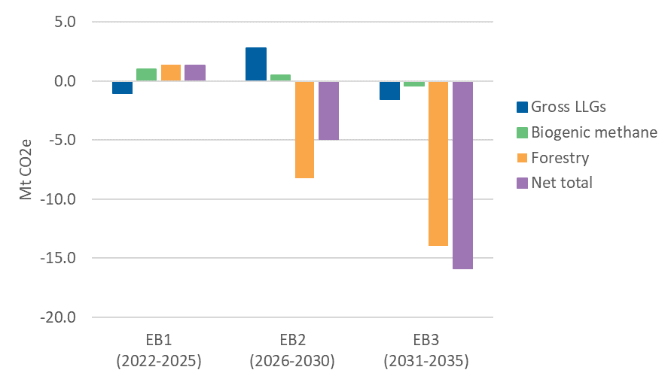
Figure 8: The difference between the updated CPR and Ināia Tonu Nei with gross long-lived gases (carbon dioxide, nitrous oxide, and HFCs), biogenic methane, and forestry removal totals (a positive value means the updated CPR emissions are higher)

The increased contribution of forestry removals persists beyond 2035, with net emissions falling further below those projected in Ināia Tonu Nei, while gross emissions are similar (Figure 9).

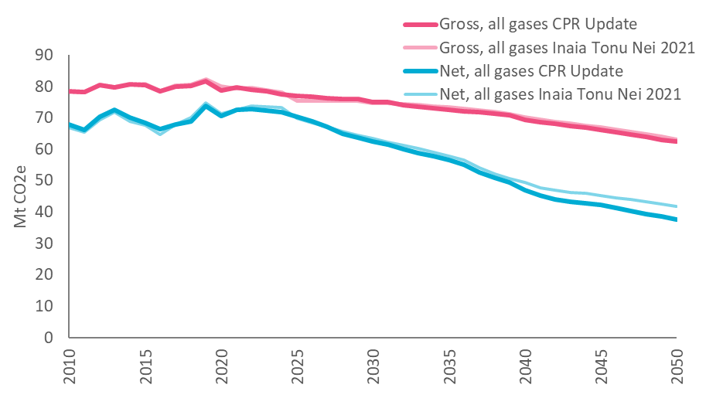
Figure 9: Gross and net emissions in the updated CPR compared with Ināia Tonu Nei

The assumed continued operation of the Tiwai Point aluminium smelter beyond 2024 has considerable impact in emissions budgets 2 and 3 and the final year of emissions budget 1. The smelter’s continued operation causes an increase in industrial process (IPPU) emissions and electricity system emissions compared with Ināia Tonu Nei. However, this impact is offset by the conversion of the Marsden Point refinery to an import-only terminal in 2022 and the downwards revisions to HFC emissions in the latest national greenhouse gas inventory.
The updates to the CPR also result in a faster electrification of the vehicle fleet, due to the higher uptake seen in 2021 and 2022 and higher oil prices throughout the 2020s.
In agriculture, the updated projections from MPI feature a significantly higher baseline productivity assumption and a relative increase in land area for dairy farming, causing higher emissions. Emissions from sheep and beef farming are similar over emissions budget 1, but lower beyond that due to reduced land area from higher afforestation.
The combined effect of these changes by sector are shown in Figure 10. Note here we show energy and transport as a combined sector due to the national greenhouse gas inventory reallocation issue discussed below.
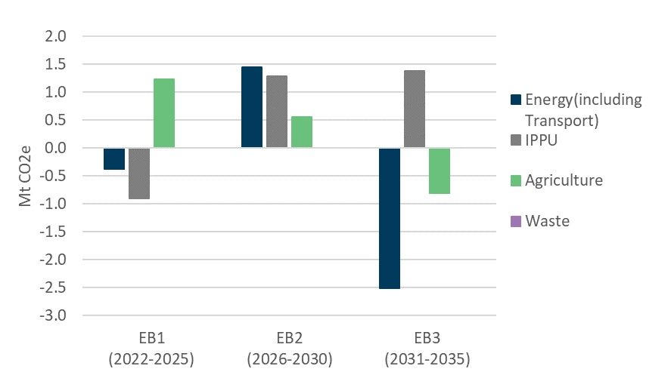
Figure 10: Differences by sector between the updated CPR and Ināia Tonu Nei (a positive value means updated CPR emissions are larger)

As mentioned, methodological changes in the 2022 national greenhouse gas inventory reallocated emissions between the transport and non-transport energy sectors. In the transport sector, inventory changes and faster electrification result in consistently lower transport emissions through to 2050. Emissions are higher for non-transport energy for much of this projection, however they converge to approximately the same level by 2050. This is due to multiple factors.
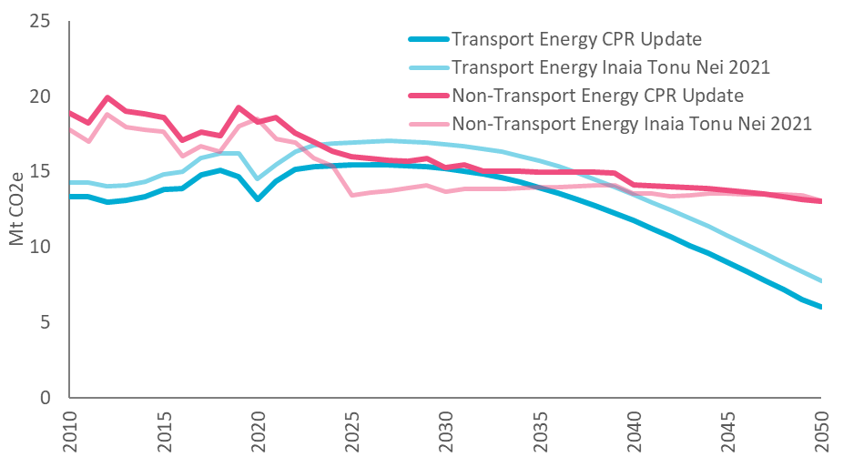
Figure 11: Transport and non-transport energy emissions in the updated CPR compared with Ināia Tonu Nei

Updated demonstration path
The demonstration path was the core scenario the Commission used in developing its recommended emissions budgets in Ināia Tonu Nei. We have updated this for use in the NZ ETS settings advice. All updates to data and baseline assumptions made to the CPR scenario have also been applied to the demonstration path. We have made two additional updates as summarised in the boxes below.

Updates to assumptions
Emissions value price path | The emissions values in ENZ represent a shadow emissions price which drives the uptake of low emission technologies in the energy and transport sectors. The values for 2021 and 2022 are aligned with actual NZU prices, deflated to 2019 dollars. For 2022 we used a year-to-date average up to 31 March.  We slightly increased the future emissions values so that the updated demonstration path accords with emissions budgets 1, 2, and 3. To do this, we increased the 2050 value from $250/t CO₂e to $260 (in 2019 dollars), while maintaining the same discount rate (3%) and approach using a straight-line trajectory to 2030. The updated values are shown in Figure 13.
Committed electricity generation | We have reviewed the assumed build schedule of committed generation. The Mt Cass windfarm has been removed from the short-term build schedule as development has not progressed at the rate previously assumed.

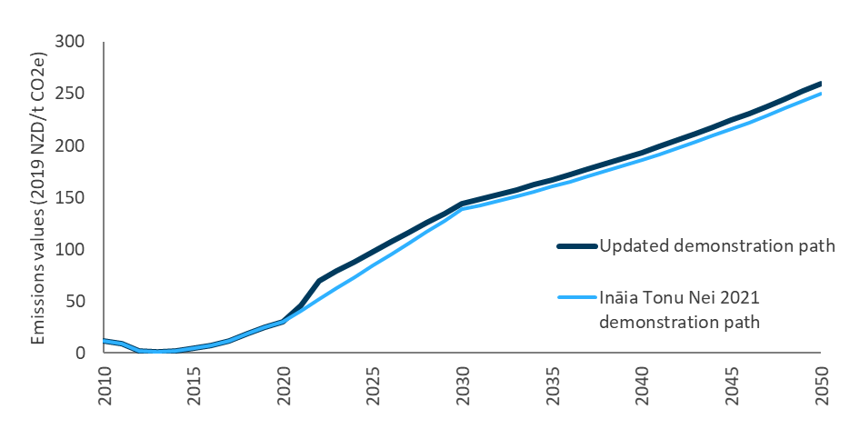
Figure 13: Emissions values in the updated demonstration path compared with Ināia Tonu Nei

Comparison to Ināia Tonu Nei 2021 demonstration path
Total gross emissions are slightly higher in the updated demonstration path whilst net emissions are lower (Figure 15). While this increase is due to several factors, changes to levels of industrial activity (aluminium smelting, refining and methanol production) has the most significant impact on non-transport energy and IPPU emissions. As in the CPR, the lower net emissions of the updated demonstration path are due to higher projected removals from forestry, which was considered in the government’s emissions budgets. In the transport and non-transport energy sectors (Figure 15), the differences introduced by the methodological changes in the national greenhouse gas inventory gradually reduce as fossil fuels are phased out.
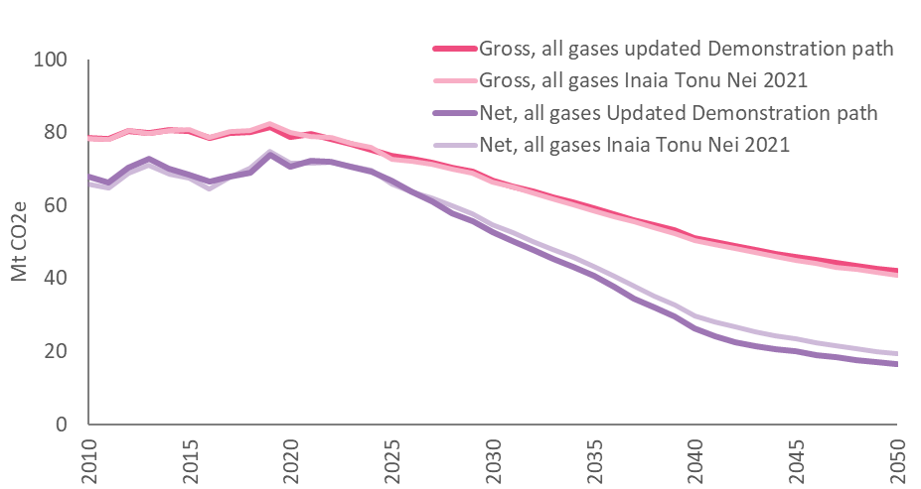
Figure 14: Total gross and net emissions in the updated demonstration path and Ināia Tonu Nei
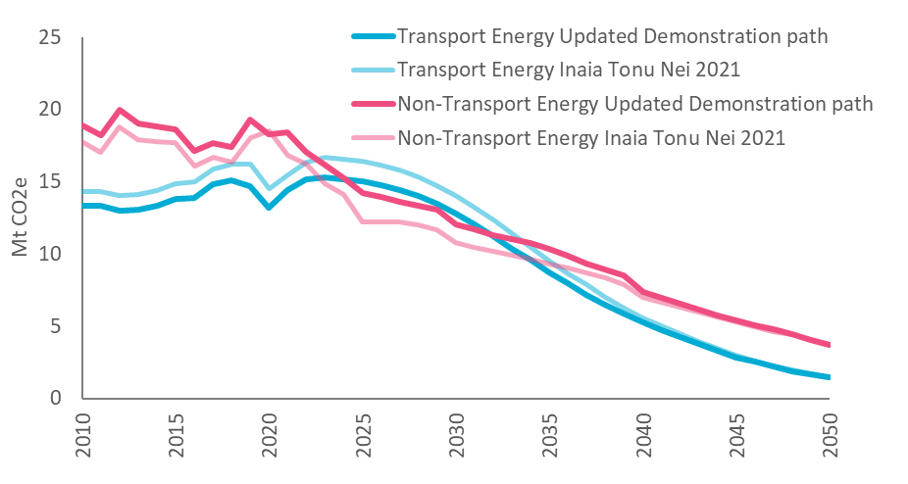
Figure 15: Transport and non-transport energy emissions in the updated demonstration path and Ināia Tonu Nei
References
Concept Consulting. (2021). Gas demand and supply projections—2021 to 2035 (p. 34). Concept Consulting. https://www.gasindustry.co.nz/work-programmes/gas-supply-and-demand/gas-demand-and-supply-projections-2021-to-2035/document/7268
He Pou a Rangi, Climate Change Commission. (2022). Advice on NZ ETS unit supply and price control settings. Technical Annex 2: ENZ Modelling. https://www.climatecommission.govt.nz/public/ETS-advice-July-22/Technical-annexes-and-supplementary-documents/Technical-Annex-2-ENZ-Modelling.pdf
He Pou a Rangi, Climate Change Commission. (2021). Ināia tonu nei: A low emissions future for Aotearoa (p. 418). https://ccc-production-media.s3.ap-southeast-2.amazonaws.com/public/Inaia-tonu-nei-a-low-emissions-future-for-Aotearoa/Inaia-tonu-nei-a-low-emissions-future-for-Aotearoa.pdf
Livestock Improvement Corporation and DairyNZ. (2021). New Zealand Dairy Statistics 2020-21. https://www.dairynz.co.nz/publications/dairy-industry/new-zealand-dairy-statistics-2020-21/
Ministry for Primary Industries. (2021). Provisional estimates of tree stock sales and forest planting in 2021 (p. 4). Te Uru Rākau – New Zealand Forest Service. https://www.mpi.govt.nz/dmsdocument/44971-Provisional-estimates-of-tree-stock-sales-and-forest-planting-in-2021
Ministry for the Environment. (2022). New Zealand’s Greenhouse Gas Inventory 1990-2020. Ministry for the Environment. https://environment.govt.nz/publications/new-zealands-greenhouse-gas-inventory-1990-2020/
Ministry of Transport. (2021, December). Annual fleet statistics 2020. https://www.transport.govt.nz/statistics-and-insights/fleet-statistics/
Ministry of Transport. (2022). Vehicle Fleet Emissions Model (Version 3.2) June 2022.
Te Tai Ōhanga The Treasury. (2022). Budget Economic and Fiscal Update 2022 (Budget Economic and Fiscal Update, p. 143). https://www.treasury.govt.nz/sites/default/files/2022-05/befu22.pdf
Transpower. (2022). Security of Supply Assessment 2022.
US Energy Information Agency. (2022). Cushing, OK WTI Spot Price FOB (Dollars per Barrel). https://www.eia.gov/dnav/pet/hist/LeafHandler.ashx?n=pet&s=rwtc&f=m
U.S. Energy Information Agency. (2022). Short-Term Energy Outlook—U.S. Energy Information Administration (EIA). https://www.eia.gov/outlooks/steo/
Waka Kotahi (NZ Transport Agency). (n.d.). Motor vehicle registrations – dashboard and open data | Waka Kotahi NZ Transport Agency. Retrieved August 4, 2022, from https://nzta.govt.nz/vehicles/how-the-motor-vehicle-register-affects-you/motor-vehicle-registrations-dashboard-and-open-data/

He Pou a Rangi
Climate Change Commission
Level 21, 1 Willis Street
Wellington 6011
PO Box 24448
Wellington 6142
www.climatecommission.govt.nz

He Pou a Rangi
Climate Change Commission
Level 21, 1 Willis Street
Wellington 6011
PO Box 24448
Wellington 6142
www.climatecommission.govt.nz

(He Pou a Rangi, Climate Change Commission, 2022)
(He Pou a Rangi, Climate Change Commission, 2021)
(Ministry for the Environment, 2022)
(Ministry of Transport, 2021)
(Ministry of Transport, 2022)
(Te Tai Ōhanga, The Treasury, 2022)
(US Energy Information Agency, 2022)
(Waka Kotahi (NZ Transport Agency), 2022)
(Livestock Improvement Corporation and DairyNZ, 2021)
(Transpower, 2022)
(Concept Consulting, 2021)
(U.S. Energy Information Agency, 2022)
(Ministry for Primary Industries, 2021)

