

**Technical annex 1: Unit limit settings**

April 2025

**Advice on  
NZ ETS unit limits and price control settings for 2026**–**2030**

**Recommendations on the unit limit and price control settings of the New Zealand Emissions Trading Scheme** to help Aotearoa transition to a low emissions economy.

**Contents**

Introduction 3

About our advice 3

About this document 3

Step 1 Align with emissions reduction targets 4

Step 2 Allocate volume to NZ ETS and non-NZ ETS sectors 5

Agriculture 6

Non-municipal waste 6

F-gases 6

Industrial processes and product use 7

Biomass combustion 7

Forestry 7

Step 3: Technical adjustments 9

Liquid fossil fuel and gas 10

Coal and steel production 11

Waste 12

Forestry 13

Geothermal, IPPU and F-gases 14

Step 4: Industrial free allocation forecasts 14

Updated allocative baselines 15

Other updated assumptions 15

Step 5a: Unit surplus estimate 16

Total unit holdings 17

Pre-1990 units held long-term 18

Units held for post-1989 harvest liabilities 20

Units held for forward hedging by emitters 25

Holding volume 28

Surplus units from MERP4 post-1989 forestry unit allocations 28

Base surplus estimate 31

Annual surplus reduction volume calculations 33

Step 5b: Discrepancy adjustment 33

Step 7: Calculate auction volumes 34

Comparing the updated proposed volumes to the status quo 35

References 36

## Introduction

This document is published by He Pou a Rangi Climate Change Commission in support of our Advice on NZ ETS unit limits and price control settings for 2026-2030.

It is a technical annex to that advice, providing further information on the data, methodology, and key assumptions we have taken to reach our final unit limit settings recommendations.

The document should be reviewed alongside *Part 3: Te Herenga utu - Unit limits* of our advice report, and the accompanying spreadsheet also published on our website. A separate technical annex is available providing further information on the modelling used in our analysis on price control settings.

### About our advice

He Pou a Rangi Climate Change Commission is an independent Crown entity established by the Climate Change Response Act 2002 to provide expert, evidence-based advice and monitoring to successive governments on how to reduce emissions and adapt to the effects of climate change.

As part of our responsibilities under the Act (section 5ZOA), the Commission is required to provide the Government with annual advice on the unit limits and price control settings for the Aotearoa New Zealand Emissions Trading Scheme (NZ ETS) across a five-year window. This is to support the Minister of Climate Change, who is required to update these settings every year.

Annual updates to settings are intended to keep the NZ ETS aligned to emission reduction targets and give market participants information they need to make decisions.

### About this document

As set out in Part 3 of our NZ ETS settings advice report, we use a seven-step method for calculating unit limits. We go through these steps in greater detail in this document.

The seven steps are:

1. Align with emissions reduction targets
2. Allocate volume to NZ ETS and non-NZ ETS sectors
3. Technical adjustments
4. Account for industrial free allocation
5. Set the unit surplus reduction volume
6. Set approved overseas unit limit (not discussed in this annex)
7. Calculate the auction volume and assess risks

Tables and figures presented in this document mostly show the period out to 2030 that aligns with this annual iteration of the advice.

## Step 1 Align with emissions reduction targets

The first step in the unit limits methodology is evaluating the most appropriate way to align unit limits with New Zealand’s emissions budgets, nationally determined contributions (NDCs) and 2050 target. The high-level approach to this is discussed in the main advice report.

The period covered by this advice is 2026-2030, which aligns with the second emissions budget (EB2). Our previous advice has aligned unit limits with achieving emissions budgets as the domestic component of the first NDC and stepping-stones to the 2050 target. This year we have concluded that this approach again remains appropriate. The rationale for this is set out in *Part 3: Te Herenga utu – Unit limits* in the main report, and in *Technical Annex 3: Assessment of Accordance*. We have not duplicated or expanded on this here.

To briefly recap, in this advice, we have aligned the proposed settings with achieving the levels of emissions over 2026-2030 given by the emissions projections released alongside the Government’s second emissions reduction plan (the ‘new measures’ scenario – hereafter referred to as the government’s emissions projections).[1] These emissions projections are 1.9 MtCO2e lower than the second emissions budget’s notified level of 305 MtCO2e (**Figure 1**). See Part 3 in the main report for more information.

Figure 1: Emissions projections from the second emissions reduction plan compared to emissions budgets 2025-2030

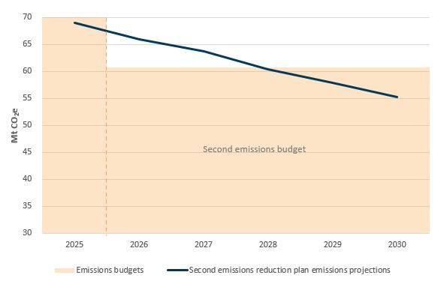

Source: Ministry for the Environment, *New Zealand’s second emissions reduction plan 2026-2030. Detailed results for ERP2 projection scenario.*

## Step 2 Allocate volume to NZ ETS and non-NZ ETS sectors

Step 2 involves allocating the chosen overall allowed emissions volume across all sectors from step 1 to NZ ETS and non-NZ ETS sectors. This is sometimes referred to as setting the NZ ETS emissions ‘cap’.

The Government’s second emissions reduction plan included a decision on a provisional NZ ETS emissions cap, based on the second emissions reduction plan (ERP2) emissions projections.[2] We have chosen to allocate volumes based on the sector pathways laid out in these projections in line with the Government’s decision. We have, however, applied a more granular allocation of emissions between NZ ETS and non-NZ ETS sectors, using the same methodology as we have used in previous iterations of the NZ ETS settings advice.

**Table 1** shows the resulting allocation of emissions to non-NZ ETS and NZ ETS sectors over the period of the settings (2026-2030). **Figure 2** shows the same information in a graph.

The remainder of this section sets out more detail on the allocation of the allowed emissions volume to the six sectors listed below which are not covered by the NZ ETS. We note where we have used the government’s emissions projections as the basis for the allocation, or where other data and analysis has been used to enable a more granular emissions allocation to the sectors outside the NZ ETS.

* Agriculture
* Non-municipal waste
* F-gases
* IPPU
* Biomass combustion
* Forestry

Figure 2*:* Emissions allocated to NZ ETS and non-NZ ETS sectors

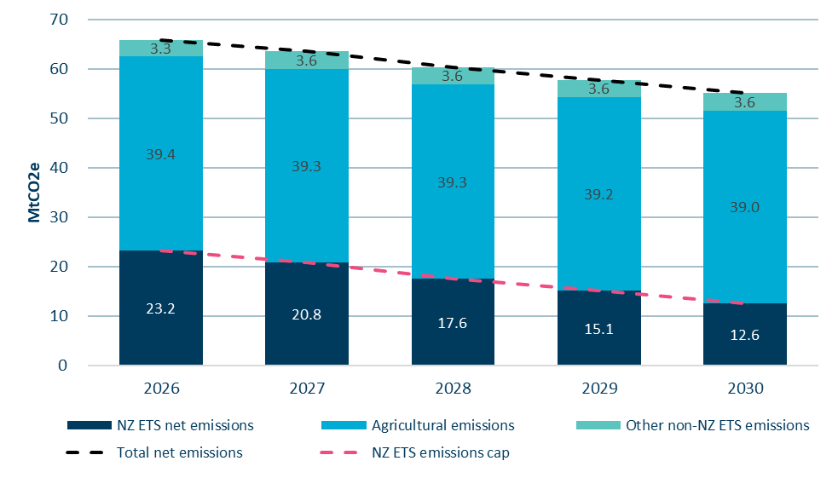

Source: Commission analysis

Table 1: Emissions volumes inside and outside the NZ ETS

|  |  |  |  |  |  |  |  |  |
| --- | --- | --- | --- | --- | --- | --- | --- | --- |
| **MtCO2e** |  | **2026** | **2027** | **2028** | **2029** | **2030** | **Total** | **ERP2\*** |
| **Total net emissions** | | **65.9** | **63.7** | **60.4** | **57.9** | **55.2** | **303.1** | **303.1** |
| Volumes outside NZ ETS | Agriculture | 39.4 | 39.3 | 39.3 | 39.2 | 39.0 | 196.1 | 196.1 |
| Non-municipal waste | 2.3 | 2.2 | 2.2 | 2.2 | 2.1 | 11.0 | 10.2 |
| F-gases | 0.6 | 0.6 | 0.5 | 0.5 | 0.5 | 2.7 | 3.3 |
| Industrial processes and product use (IPPU) | 0.1 | 0.1 | 0.1 | 0.1 | 0.1 | 0.7 | 1.3 |
| Biomass combustion | 0.1 | 0.1 | 0.1 | 0.1 | 0.1 | 0.3 | 0.6 |
| Afforestation | -0.8 | -0.5 | -0.4 | -0.4 | -0.3 | -2.4 | 0.4 |
| Deforestation | 1.0 | 1.1 | 1.1 | 1.1 | 1.1 | 5.3 |
| **Net emissions outside NZ ETS** | | **42.7** | **42.8** | **42.8** | **42.7** | **42.6** | **213.7** | **211.8** |
|  | Gross emissions in the NZ ETS | 32.2 | 31.8 | 30.6 | 29.8 | 28.2 | 152.6 | 151.9 |
|  | Forestry in the NZ ETS | -9.0 | -11.0 | -13.0 | -14.7 | -15.6 | -63.3 | -60.7 |
| **Net emissions in the NZ ETS**  **(the emissions cap)** | | **23.2** | **20.8** | **17.6** | **15.1** | **12.6** | **89.4** | **91.3** |
| *NZ ETS emissions cap used in our 2024 advice* | | *23.4* | *21.4* | *19.4* | *17.4* | *14.5\*\** | *96.1* |

Note that figures may not sum to totals due to rounding.

* Figures from the Government’s provisional cap presented in the second emissions reduction plan are presented here for comparison.

** This 2030 figure was published in our 2024 advice report for visibility but was not used in the development of the 2024-2029 NZ ETS unit limit settings as they do not cover the 2030 year.

### Agriculture

Biogenic methane and nitrous oxide from agriculture are not covered by the NZ ETS. The emissions volume allocated to agriculture aligns with the forecast agricultural emissions in the government’s emissions projections.

### Non-municipal waste

Non-municipal waste emissions are outside the NZ ETS, as only methane emissions from municipal landfill facilities are subject to NZ ETS obligations. The allocation is based on the breakdown of municipal versus non-municipal waste in the government’s emissions projections.

### F-gases

Some fluorinated gas emissions (F-gases) associated with certain goods and vehicles are priced via the Synthetic Greenhouse Gas (SGG) levy instead of being covered by the NZ ETS.

To estimate the percentage of F-gases covered by the SGG levy we reviewed historical data on emissions reported in the NZ ETS, SGG levy and GHG inventory. For this year’s advice we have applied the same methodology as previously used and applied the average percentage of F-gas emissions reported in the SGG levy compared to those reported in the inventory. Our 2024 advice assumed 49% of F-gas emissions are covered by the SGG levy. Based on an additional year of data this has been updated to 52%.

On this basis, F-gases covered by the SGG levy account for approximately 2.7 MtCO2e, and 1.3% of forecast non-NZ ETS emissions over 2026-2030.

### Industrial processes and product use

Several small emissions sources in the Industrial Processes and Product Use (IPPU) inventory category are outside of the NZ ETS. These include:

* non-energy products from fuels and solvent use
* sulphur hexafluoride and perfluorocarbons from medical and other product use
* nitrous oxide from medical applications
* other uses of carbonate.

The ERP2 emissions projections do not separate IPPU emissions into this level of detail. To determine an estimate, we took historical data from the GHG inventory Common Reporting Format (CRF) tables that separate out these categories and determined their average proportion of total IPPU emissions. Over the last 5 years the average percentage was 4.2%, resulting in our estimate that over 2026-2030 these emissions will sum to around 0.7 MtCO2e.

### Biomass combustion

When biomass is combusted, in addition to carbon dioxide emissions, a small amount of methane and nitrous oxide emissions are produced. These methane and nitrous oxide emissions from biomass combustion are not covered by the NZ ETS. In the accounting used for Aotearoa New Zealand’s targets, including for emissions budgets, net CO2e emissions from biomass combustion are accounted for as non-transport energy emissions. The government’s emissions projections do not separate biomass combustion emissions from other sources of non-transport energy. To make this estimate we have used a previous breakdown of non-transport energy types developed for the Commission’s 2021 advice Ināia tonu nei.[3] This results in total biomass emissions of 0.3 MtCO2e over 2026-2030.

### Forestry

For owners of post-1989 forests, participation in the NZ ETS is voluntary.[4] Some deforestation of native forests is also outside the NZ ETS. We remove the net effect of these emissions and removals that are outside the scheme in setting the NZ ETS emissions cap.

To determine the area of post-1989 forest outside the NZ ETS we compare the areas afforested as reported in the GHG Inventory with the area of forest registered in the NZ ETS. This data indicates that for exotic forests planted between 1990 and 2007, approximately 59% of the area is registered in the NZ ETS. For land afforested between 2007 and 2020 approximately 100% of the exotic forest area is registered into the NZ ETS.

There are significant year-to-year differences between the areas of post-1989 native forest reported as established in the GHG Inventory and the areas reported as established registered in the NZ ETS. However, looking over a longer time period (1990-2020), these differences even out and the aggregate figures match very closely. Our assumption is that the year-to-year differences between the two data sets arise from differences in when forests are recorded as having been established. The close match in areas over the longer time period suggests that close to all post-1989 native forests are now registered in the NZ ETS. Accordingly we assume that 100% of post-1989 native forest is in the NZ ETS.

As in previous advice we have assumed that all new afforestation will be registered in the NZ ETS.

The Government has announced a policy of limiting, based on land use class, the land that can register into the NZ ETS for newly-planted forests – to reduce the number of whole farms being converted to forest. It is also seeking to partner with the private sector to plant forests on Crown-owned land. It is currently unclear what impact these policies will have on total afforestation, or on the area of post-1989 forest outside the NZ ETS. We will monitor these policies as they are implemented and reconsider our assumptions of NZ ETS participation if new evidence becomes available.

#### Forecast deforestation outside the NZ ETS

Two categories of deforestation emissions are outside the NZ ETS:

* deforestation of pre-1990 native forest[5]
* deforestation of post-1989 forests that have not registered into the NZ ETS.

The ERP2 emissions projections detail the total area of expected deforestation, but do not break this down by type of forest (e.g., native versus exotic, post-1989 versus pre-1990). This breakdown is needed to estimate net forestry emissions inside and outside the NZ ETS.

The government’s forecasts of area deforested match the Commission’s reference scenario from our advice on the fourth emissions budget. We assume the forecast deforestation matches the breakdown by type from this reference scenario. We have also assumed that all post-1989 native and exotic deforestation occurs among the forests that are not registered in the NZ ETS.

## Step 3: Technical adjustments

Step 3 involves identifying any differences between historical emissions reported in in the NZ ETS compared to the emissions reported in the GHG inventory, and assessing whether these differences justify an amendment to unit limit settings.

The emissions reporting approaches used in the NZ ETS have been designed to broadly mirror the way emissions are accounted for in Aotearoa New Zealand’s emissions reduction targets. However, there can be differences for a range of reasons, including practical issues connected with the different purposes of the GHG inventory and the NZ ETS.

Any consistent differences between the GHG inventory emissions used in target accounting, and emissions reported in the NZ ETS, may affect the NZ ETS settings’ ability to accord with emissions reduction targets. This makes it necessary to identify what differences exist and whether a technical adjustment is needed to keep the units in the scheme aligned with targets.

There is a lag between when emissions occur and when they are reported in the New Zealand greenhouse gas inventory (GHG Inventory). There is an approximate 16 month gap between the end of a calendar year and the publication of the GHG inventory reporting emissions for that year. The reporting delay is approximately 8 months for emissions reported in the NZ ETS. Due to these timings, our NZ ETS settings advice is only able to compare inventory and NZ ETS emissions data up to 2022, as this is the last year covered by the most recent GHG inventory, published in April 2024.

**Table 2** shows the groupings of emissions by NZ ETS activities, which we have compared to the corresponding emissions by GHG inventory category. The analysis used remains generally the same as our previous advice, with minor refinements.

Table 2: NZ ETS activities and corresponding GHG inventory emissions

|  |  |  |
| --- | --- | --- |
| **Grouping** | **NZ ETS activities** | **GHG inventory categories** |
| Liquid fossil fuels and gas | * owning obligation fuels * purchasing obligation fuel * combusting used or waste oil * using crude oil or other liquid hydrocarbons * mining natural gas * importing natural gas * purchasing natural gas * embedded substances | * LFF combustion minus oil refinery* * gaseous fuels combustion * fugitive emissions, natural gas venting and flaring * IPPU chemical industry, excluding H2 production * Liquefied petroleum gas (LPG) |
| Coal and steel production** | * importing coal * mining coal * purchasing coal * producing iron or steel | * solid fuels combustion emissions * fugitive emissions, coal mining * iron and steel production |
| Geothermal | * using geothermal fluid | * fugitive emissions, geothermal |
| IPPU | * producing aluminium * producing clinker or burnt lime * producing glass using soda ash * operating electrical switchgear using sulphur hexafluoride (SF6) | * aluminium production * cement production and lime production * other uses of soda ash * electrical equipment (SF6) |
| F-gases | * importing hydrofluorocarbons (HFCs) * exporting HFCs | * product used as substitutes for ozone depleting substances |
| Waste | * operating a disposal facility | * managed waste disposal sites |
| Forestry | * deforestation of pre-1990 forests * harvest / deforestation of post-1989 forests * post-1989 forest removals | |  | | --- | | * afforestation exotic | | * afforestation native | | * deforestation exotic | | * deforestation native | |

* Refining NZ was exempt from the NZ ETS under a Negotiated Greenhouse Agreement.  
**Emissions from use of coal as a reduction agent in steel production are classified differently in the NZ ETS versus the GHG inventory, so it is necessary to combine total coal and steel emissions in the comparison.

### Liquid fossil fuel and gas

Over the previous two years officials have been investigating the possible cause of a discrepancy between liquid fossil fuel (LFF) and gas emissions reported in the inventory and the NZ ETS. In our 2024 advice we combined the LFF and gas sectors, to address that liquefied petroleum gas (LPG) in the NZ ETS was classified as stationary energy, but in the inventory it was reported under LFFs. Despite this, we found that LFF and gas emissions reported in the NZ ETS had been consistently lower than in the inventory. We therefore applied a technical adjustment, equal to 3% of total LFF and gas volumes, into the calculation of our 2024 recommended unit limit settings, which reduced auction volumes.

Further investigation this year has uncovered there was an error in the assignment of LPG, which resulted in double counting of LPG emissions. We have corrected this, and the historical emissions data now appears closely aligned between the NZ ETS and GHG inventory, as shown in **Figure 3**. As a result, we no longer consider it appropriate to apply a technical adjustment related to LFF and gas emissions.

Figure 3: Liquid fossil fuel and gas emissions reported in the NZ ETS and 2024 GHG inventory

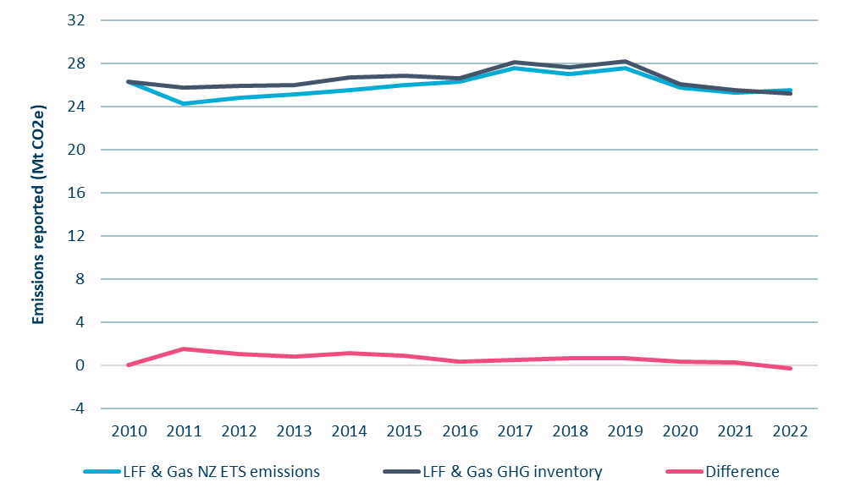

Source: Commission analysis

### Coal and steel production

In our 2024 advice, we observed that a historical discrepancy between NZ ETS and inventory coal and steel emissions had reduced to less than 2% in emissions reported for 2021. We learnt that a technical error in emissions reporting by an emitter had been identified and resolved. As a result, we stopped applying a technical adjustment related to these sectors.

As shown in **Figure 4**, in emissions reported for 2022 the discrepancy increased, with the inventory reporting approximately 0.31 MtCO2e more emissions than the NZ ETS, a difference of 7.3%. The primary source of the discrepancy was between emissions related to the importing and mining of coal reported in the NZ ETS, and solid fuel combustion reported in the inventory. Production of iron and steel remained very closely aligned.

As this discrepancy is relatively small, we have decided not to apply an ongoing technical adjustment related to coal and steel in this year’s advice. We will monitor this issue to evaluate how the discrepancy develops over time, and whether it is necessary to re-apply a technical adjustment.

Figure 4: Coal and steel production emissions reported in the NZ ETS and 2024 GHG inventory

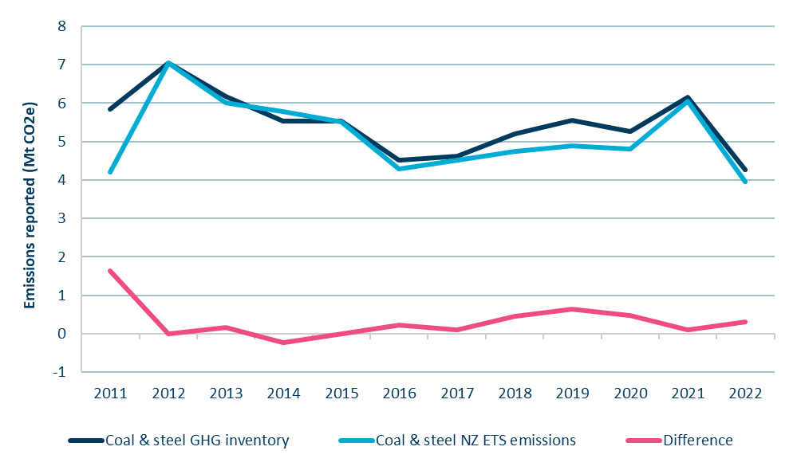

Source: Commission analysis

### Waste

In our previous advice we have not proposed technical adjustments to account for differences in reported waste emissions. There have been historical inconsistencies between the NZ ETS and solid waste disposal emissions reported in the GHG inventory but they have either been minor, or understood to be in the process of being resolved.

As shown in **Figure 5**, there was a marked increase in the difference between NZ ETS and GHG Inventory emissions reported for 2022. The 2022 NZ ETS emissions declined from approximately 1 MtCO2e to 0.6 MtCO2e (-42%), with GHG Inventory emissions dropping much less, resulting in a discrepancy of 0.5 MtCO2e.

We understand that the likely cause of the discrepancy is a significant drop in the Unique Emissions Factors (UEFs) used to calculate NZ ETS emissions for many waste disposal facilities. The Ministry for the Environment has confirmed with the Commission that an error has been identified in the calculation of several waste facility UEFs, and that the error is expected to be fixed for 2025. Based on this, we have decided not to implement a technical adjustment to correct for the observed discrepancy in waste emissions.

Figure 5: Waste emissions reported in the NZ ETS and 2024 GHG inventory

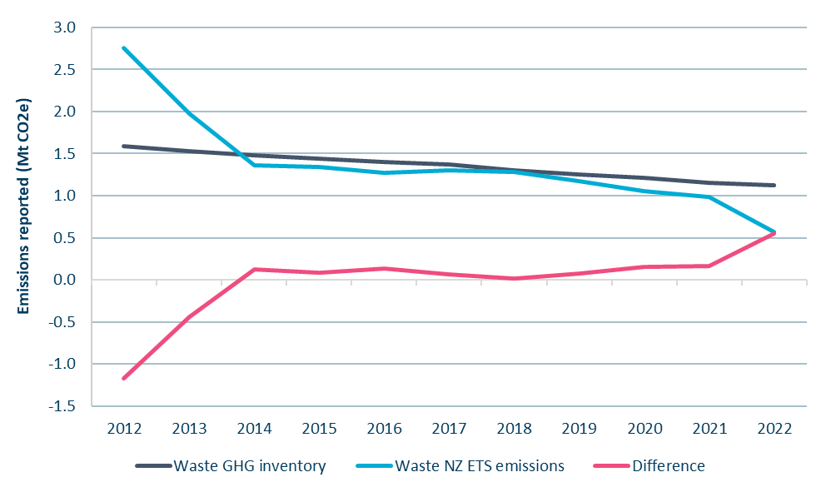

Source: Commission analysis

### Forestry

Comparing forestry emissions and removals reported in the NZ ETS with those used for target accounting reported in the GHG inventory is challenging for several reasons:

* There are two accounting approaches in the NZ ETS for post-1989 forests (stock change and averaging, with most forests using stock change), while in target accounting, most post-1989 forests are subject to accounting that is similar to averaging.
* The NZ ETS does not require annual emissions reporting by forestry participants. Emissions returns are only required at the end of a Mandatory Emissions Reporting Period (MERP),[6] although forestry participants can choose to submit returns more frequently.
* Different carbon yield tables are used in target accounting and the NZ ETS to estimate carbon sequestration.
* There is misalignment in forest area and age classes reported under target accounting and registered in the NZ ETS.

We understand that the government has work underway to update NZ ETS forestry yield tables. This could affect how net forestry emissions reported in the NZ ETS align with target accounting estimates. In December 2024 the Government published additional information on how it expects to account for net emissions by forests under target accounting, including releasing two reports on the forest management reference level. Due to the recent and evolving nature of these developments, we have not undertaken a full analysis comparing NZ ETS and target accounting net forestry emissions.

We have not applied any technical adjustments related to forestry in this advice, but this is an area on which we plan to undertake further analysis as time allows.

### Geothermal, IPPU and F-gases

We provide a summary of our updated comparisons of reported emissions in the GHG inventory and the NZ ETS for additional sectors in **Table 3**. For these sectors, we continue to observe no need to make technical adjustments.

Table 3: Summary of comparisons relating to geothermal, IPPU and F-gas emissions

|  |  |
| --- | --- |
| Grouping | Summary of the comparisons |
| Geothermal | There are no significant discrepancies between emissions reported in the NZ ETS and GHG inventory. No technical adjustment is proposed. |
| IPPU | There are no significant discrepancies between emissions reported in the NZ ETS and GHG inventory. No technical adjustment is proposed. |
| F-gases | Assessing the alignment of F-gases reported in the NZ ETS and the GHG inventory is challenging due to different accounting methodologies, and the fact that F-gases are priced not only by the NZ ETS but also via the SGG Levy. An estimate of the split of F-gas emissions between these two policies is calculated in Step 2.  F-gas emissions reported in the GHG inventory show a relatively consistent path, whereas F-gas emissions in the NZ ETS and SGG levy vary significantly across years. However, when looking long-term (i.e., over 2014-2022), the total F-gas emissions reported in the NZ ETS and the inventory are reasonably aligned. No technical adjustment is proposed. |

## Step 4: Industrial free allocation forecasts

Step 4 involves forecasting industrial free allocation volumes provided by the Government to firms considered emissions-intensive and trade-exposed (EITE). Industrial free allocation uses up a portion of the units that would otherwise be available within the NZ ETS emission cap. It must therefore be subtracted from the cap when determining auction volumes.

Our forecast of industrial allocation volumes has reduced compared to last year, from approximately 27.6 million units over 2026-2030, to 23.2 million. This is due to a combination of:

* an update to allocative baselines for industrial allocation
* reductions in forecast production and plant closures.

The method for forecasting industrial free allocation has remained largely the same as in our previous advice and follows three general steps:

1. Update for the most recent allocation data, broken down by activity, and apply estimated growth of production volumes.
2. Calculate the impact of the industrial free allocation phase-down rate (1 percentage point reduction per annum 2021–2030, 2 percentage point reduction per annum 2031–2040).
3. Apply any new information regarding significant changes that may affect allocations for eligible activities, such as plant closures or changes to less intensive production methods.

For this year’s advice, we have also applied an additional preliminary step to account for the recent update to activities’ allocative baselines.

### Updated allocative baselines

In October 2024, the Ministry for the Environment announced the results of a review into the allocative baselines used to calculate industrial allocation entitlements. Allocative baselines represent the emissions associated with production volumes of various product categories.[7]  This was the first time they have been updated since they were established over ten years ago. The majority of allocative baselines decreased.

Total industrial allocation volumes by entity and activity are publicly available from the Environmental Protection Authority. However, the data does not break down allocation volumes for specific products within each activity.

We have taken the final 2023 allocation levels published by the Environmental Protection Authority, and adjusted them to determine what the allocated volumes would be if the new allocative baselines applied, based on the same production volumes.

In March 2025, the Government released the regulations updating the allocative baselines for the New Zealand Aluminium Smelter (NZAS). This update has also been applied.

### Other updated assumptions

We have incorporated an approximate 25% decrease in production of pulp and paper products in 2025 and 50% from 2026 onwards. This is based on public announcements regarding the closure of Winstone Pulp International in New Zealand, and Oji Fibre Solutions confirming closures at its Penrose and Kinleith Mills from the end of June 2025. We have reviewed production data related to these mills to estimate their approximate production volumes and the impact their closure would have on overall allocations.

We have also updated our estimates of methanol production. Methanex released a report at the end of 2024 showing that total production of methanol in 2025 was projected to be between 500-700kt – approximately 50% of 2023 levels.[8] We have applied this adjustment to 2025, but then increased production forecasts back to 100% of 2023 levels for 2026 and 2027. Production levels then drop by 50% in 2028 and to 0 in 2030, based on the assumptions in the government’s emissions projections about the closure of Methanex’s Motunui trains.

Table 4: Industrial free allocation forecasts

|  |  |  |  |  |  |  |  |
| --- | --- | --- | --- | --- | --- | --- | --- |
| **Forecast allocations (millions)** | **Activity** | **2025** | **2026** | **2027** | **2028** | **2029** | **2030** |
| High allocation | Aluminium | 1.2 | 1.1 | 1.1 | 1.1 | 1.1 | 1.1 |
| Cement and lime | 0.6 | 0.6 | 0.6 | 0.6 | 0.6 | 0.6 |
| Iron and steel | 1.6 | 1.3 | 1.3 | 1.3 | 1.3 | 1.3 |
| Methanol | 0.5 | 1.0 | 0.9 | 0.5 | 0.5 | 0.0 |
| Other - High | 0.0 | 0.0 | 0.0 | 0.0 | 0.0 | 0.0 |
| Urea | 0.3 | 0.3 | 0.3 | 0.3 | 0.3 | 0.3 |
| Moderate allocation | Dairy products | 0.1 | 0.1 | 0.1 | 0.1 | 0.0 | 0.0 |
| Horticulture | 0.0 | 0.0 | 0.0 | 0.0 | 0.0 | 0.0 |
| Meat products | 0.1 | 0.1 | 0.1 | 0.1 | 0.1 | 0.1 |
| Other - Low | 0.2 | 0.2 | 0.1 | 0.1 | 0.1 | 0.1 |
| Pulp and paper products | 0.6 | 0.4 | 0.4 | 0.4 | 0.3 | 0.3 |
| **Total updated forecasts** | | **5.1** | **5.1** | **5.1** | **4.5** | **4.5** | **4.0** |
|  | Previous 2024 forecast | 6.0 | 5.7 | 5.7 | 5.6 | 5.5 | 5.1 |
|  | Difference | -0.9 | -0.6 | -0.6 | -1.1 | -1.0 | -1.1 |

Figure 6: Comparison of previous 2024 and updated 2025 industrial free allocation forecasts

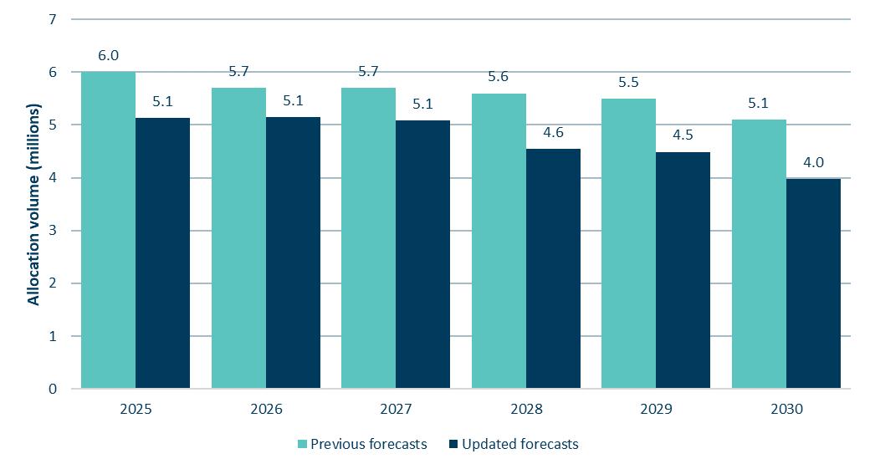

Source: Commission analysis

## Step 5a: Unit surplus estimate

Step 5a involves estimating the volume of surplus units currently held in private accounts. Surplus units are those we assess as posing a high risk of enabling emissions above emissions budgets.

The surplus is calculated by taking the total units held in private accounts and removing our estimates of non-surplus units. These are units that we assess as unlikely to be available for use in the NZ ETS to enable emissions above emissions budgets. In previous advice, we have estimated three categories of non-surplus units:

* Pre-1990 forest allocation units held long-term
* Units held for Post-1989 forest stock change harvest liabilities
* Units held for forward hedging purposes by emitters

This year, we have updated our estimates of the volumes in each of these categories by incorporating new data, updating assumptions and refining the methods we use as part of continuous improvement.

We have also incorporated two new categories of units into the method we use to estimate the surplus:

* Holding volume – units held by emitters for emissions that have already occurred. This is another category of non-surplus units.
* Post-1989 forestry units relating to the fourth mandatory emissions reporting period (MERP4) that may be carried over into the second emissions budget period. We consider that these units will contribute to the surplus.

Some of our refinements result from considering a report commissioned by Ministry for the Environment (MfE) from EY,[9] which reviewed the methodology for estimating the surplus. Others result from our own analysis.

As detailed in step 5 in *Part 3: Unit limits* in the main report, at 50.2 million units our updated estimate of the surplus has reduced compared to our estimate of 67.9 million units in last year’s advice. This is mainly due to the surplus reduction volume implemented into the NZ ETS settings (7.7 million units for 2024), declined auctions in 2024 (meaning 7.1 million fewer units were allocated into the market than expected), as well as the data updates and methodological refinements discussed here.

Below we step through the updated data and methodological changes in each category. Where relevant, for the unit volumes estimated as contributing or not contributing to the surplus, we set out how we have determined a central estimate, as well as the high and low estimate used in determining the overall uncertainty range around the central surplus estimate.

### Total unit holdings

Total unit holdings, commonly referred to as ‘the stockpile’, refers to the total of all privately held units in the NZ ETS registry at a point in time. Data on total unit holdings is reported quarterly by the Environmental Protection Authority (EPA).[10]

In this advice, we have used EPA data as of December 31, 2024, which puts total privately held units at 150.4 million NZUs.

We consider that, as far as possible, unit holdings data used for updated surplus estimates should be taken at a consistent date, which should be in December of each year. Using December data enables the final results of that year’s auctions to be taken into account.

If stockpile data from the middle of the year were used, significant uncertainty would be introduced since units not sold in auctions earlier in the year can still be sold at later auctions. Aspects of how the surplus is estimated would also have to be adjusted. For example, as described later in this section we now include ‘holding volumes’ in how we estimate the surplus. These are units needed by emitters for their emissions over the previous year, but which will be surrendered at the forthcoming May compliance deadline. This volume would have to be adjusted if stockpile data from a date other than December were used. Because the surplus methodology now accounts for these units (albeit on a forecast basis), we consider it unnecessary to re-estimate the surplus based on mid-year data.

Consistent end-of-year estimates will best provide for comparability of estimates from year to year. This will support monitoring of the surplus over time and adjusting settings in response if needed.

### Pre-1990 units held long-term

When the NZ ETS was first established, owners of forests planted before 1990 were allocated units (referred to as pre-1990 units) to partially compensate for the restriction the NZ ETS put on their future ability to change land use. Over 32 million units were originally allocated.

As long as the pre-1990 forests are not deforested, these units are not encumbered by surrender obligations and are theoretically available for purchase and use by other NZ ETS participants. This would make them part of the surplus, as they present a risk of allowing emissions above emissions budget levels.

We continue to assume, as per our previous advice, that a proportion of these pre-1990 units will remain held long-term by those who originally received them. That is, they are unlikely to be available for use by other NZ ETS participants before 2030 and so do not contribute to the surplus.

This assumption is based on feedback from market participants. The reasons cited for why these units may be held long-term include:

* To keep open the option of future land use change, to enable use of land for another purpose (e.g., developed for pasture or for housing).
* As insurance in case requirements to replant post-harvest, or regenerate the land within the criteria and timeframes set by NZ ETS rules, are not met – particularly where the forest owner is asset-poor.
* Some iwi/Māori forest owners may wish to retain the units as an asset for future generations.
* Slow and deliberate decision-making about the sale of units, for example due to collective decision making within iwi/Māori entities.
* Some recipients of pre-1990 units may have low awareness of what the units are, how to sell them, or what the implications of selling them might be.

Estimating how many of these units may be retained is challenging, as to date no information specifically on the intentions or behaviour of the entities who received them has been collected.

The most relevant data that we have been able to source to inform our analysis is from the EPA about transfers of these pre-1990 units out of the accounts that originally received them. This is the closest proxy available to us for estimating the extent to which these units may be available for use in the NZ ETS market.

As of December 2024, there were approximately 11.5 million pre-1990 units held in the original accounts to which they were allocated. This is a reduction from 14.2 million taken as our base point the previous year.

Previously, we had estimated the units that were unlikely to be available for use by using a linear extrapolation of past trends, using different time periods of historical data to determine the central, high and low estimates.

The previously-mentioned EY report that reviewed the surplus methodology suggested that the above approach results in an overly narrow range of estimates, given “the breadth of uncertainties that the estimate is exposed to”.

We have reviewed our approach, the EY feedback, as well as the adjusted approach MfE used in its calculations that informed the updates to NZ ETS settings regulations last year. This highlighted that the previous use of linear extrapolation was very sensitive to changes in the quarterly trend data on transfers provided by the EPA. It also showed that this approach would result in these units declining to zero in the 2030s, which is not consistent with the feedback we have heard on this issue from some of the owners of these units.

We have therefore chosen to use a revised methodology that is based on an average percentage of units transferred each quarter. We have reviewed the historical transfer rates to determine a credible range, and these are shown in **Table 5** below. Based on this data, we have chosen a slow transfers rate of 1% per quarter, a central assumption of 3%, and a fast transfer rate of 5%.

Table 5: Quarterly transfer rates of pre-1990 units from their original accounts, 2017-2024

|  |  |
| --- | --- |
| **Year** | **Average quarterly transfer rate** |
| **2017** | 3.2% |
| **2018** | 5.1% |
| **2019** | 4.2% |
| **2020** | 4.7% |
| **2021** | -0.2% |
| **2022** | 2.9% |
| **2023** | 2.5% |
| **2024** | 3.5% |

The updated calculations of pre-1990 units likely to remain in original accounts in 2030 result in a central estimate of 5.6 million, with a range between 3.4 million and 9.1 million – shown in **Figure 7**. We will continue to monitor updated data on transfers of pre-1990 units in the market and review these assumptions in future advice.

Figure 7: Pre-1990 units remaining in original accounts (historic and projected)

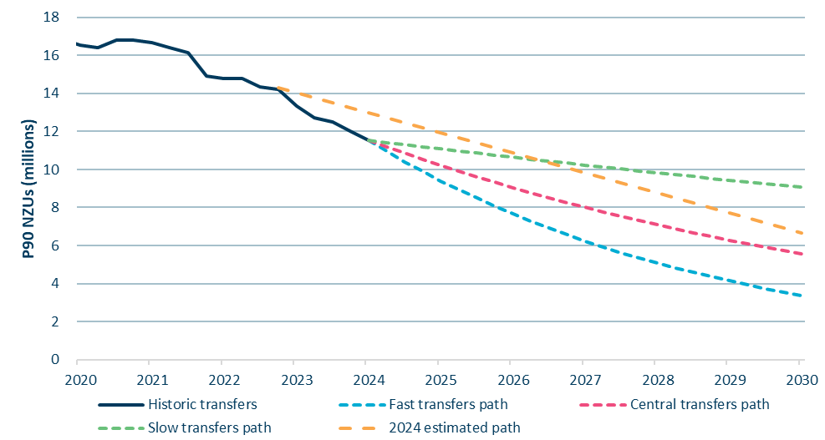

Source: Commission analysis. Unit data supplied by the Environmental Protection Authority.

### Units held for post-1989 harvest liabilities

Two accounting approaches are used to calculate the allocations and liabilities of post-1989 forests registered in the NZ ETS, which affect how forestry units contribute to the surplus.

Since 2023, averaging accounting has been the required approach for newly registered post-1989 forests, other than forests registered in the permanent category. Under averaging, there are no liabilities when forests are harvested, as long as they are replanted. In our assessment of the unit stockpile, all units earned under averaging can contribute to the surplus, if they are not balanced by emitters’ demand within the relevant budget period.

However, most post-1989 forests in the NZ ETS are subject to stock change accounting. Under stock change, forestry participants earn units for the carbon sequestered by their forest while it is growing, but must surrender a significant portion of this volume when the forest is harvested. These units are not considered part of the surplus, as they will not be available for use by other participants to allow emissions above emissions budget levels. In this section we estimate how many units earned by forests using stock change accounting are being held for harvest liabilities and should be considered non-surplus.

To determine our estimate of units held for harvest liabilities we have developed a forestry model that uses data on total area and species of forests registered in the NZ ETS, the mandatory emissions reporting period (MERP) in which the forest was registered, and information on carbon stored by the forests (yield tables).

There are significant uncertainties to consider when estimating units held for harvest liabilities, such as:

* The average age at which forests are harvested.
* The proportion of forests that will remain unharvested.
* The proportion of ‘low-risk’ units available to forestry participants – the units that may never have to be repaid under stock change, based on mix of forest age, rotation and species. These are the units that are more likely to be available for use by other NZ ETS participants and therefore contribute to the surplus.
* The volume of units allocated or surrendered through voluntary annual emissions returns compared to those following the end of a MERP.

#### Weighted average harvest age

The EY report suggested that we consider using a weighted average harvest age by area, to better reflect the spread of ages at which forests are harvested, in our modelling of units held for harvest.[11]

We have applied this suggestion, although we used different data from that used by EY to determine the ages of forest at harvest. We used data from the Ministry for Primary Industries’ 2024 National Exotic Forest Description (NEFD), which covers post-1989 and pre-1990 forests. EY used only pre-1990 forests due to data limitations. We have assumed that forests are harvested across a range of ages around the average harvest age. The proportion of forest assumed to be harvested at each age is shown in **Table 6**. We have applied these assumptions consistently across our low, central, and high estimates of units held for harvest.

Table 6: Distribution of *Pinus radiata* harvest ages

|  |  |  |  |  |  |
| --- | --- | --- | --- | --- | --- |
| Harvest age | 26 | 27 | 28 | 29 | 30 |
| **% of area distribution** | 19% | 23% | 22% | 20% | 17% |

#### Low-risk units

The carbon stock of forests does not return to zero immediately on harvest due to residual carbon stored in roots underground. Some units earned by production forests on their first rotation can be considered ‘low-risk’, as they will never have to be surrendered if the forest is replanted. However, additional units may also be considered low-risk if a forestry participant can manage liabilities across a portfolio of forests of different ages, as harvest liabilities can be met using units allocated for forests at a different stages in their rotation.

We have analysed the range of possible levels for low-risk units available to owners of post-1989 forests registered in the NZ ETS under stock change. For each post-1989 forestry participant, the minimum level of low-risk units is the amount of low-risk units available for a single forest that is planted at one time. The maximum level of low-risk units is the theoretical low risk units for a forest portfolio evenly split across all age classes (equal to the long term average carbon stock).

All NZ ETS forestry participants sit somewhere on a spectrum between these minimum and theoretical maximum levels of low-risk units. **Box 1** below illustrates how these levels work in practice.

|  |
| --- |
| Box 1. Forest owners can manage harvest liabilities to increase low risk units |
| Imagine three different forestry participants each with 100,000 hectares of production forests registered in the NZ ETS in the year they were planted. The units each forest owner would earn and need to surrender at harvest per hectare would be the same over the long run but the timing of when they earn and surrender them will depend on their planting and harvest strategy.  To take radiata pine forests as an example (based on a 28-year harvest cycle), the residual carbon remaining after each harvest cycle will differ for each forest owner as follows:   * If Forest Owner A plants the full amount (and subsequently harvests) in a single year, they would not be liable for approximately 25% of units earned – minimum low risk units scenario. * If Forest Owner B plants at different times and correspondingly staggers harvests, for example around 25,000 hectares roughly every 7-8 years, they would not be liable for around 36% of units earned – central low risk units scenario (the ‘Spread age classes’ in Figure 10 below). * If Forest Owner C plants and harvests a set amount each year, for example 3,570 hectares each year for 28 years to represent the full age class in a rotation, they would not be liable for around 50% of units earned – maximum low risk units.   Forest Owner C with a more diverse forest portfolio has maximised their low risk carbon units compared with Forest Owner A, and is able to sell a higher proportion of the units earned. Figure 10 below provides an illustration of various low risk carbon unit levels using radiata pine under the different hypothetical examples discussed above.  **Figure 8**: Net carbon stored from different illustrative forest planting portfolios    Source: Commission analysis |
|  |

To estimate the level of low-risk units likely to be achieved across all post-1989 forests on stock change in the NZ ETS, we have considered data on the breakdown of total forest area in the NZ ETS by forest estate size, shown in **Table 7**. Theoretically, owners of small forest areas are likely to have a low proportion of low-risk carbon due to the total area being more likely to be planted in a single year or across fewer age classes. Large forest estates are more likely to be made up of diverse portfolios of multiple age classes, allowing increased low-risk units. More than 50 percent of forest area in the NZ ETS is made up of forest estates of larger than 1,000 hectares.

Table 7: Breakdown of total NZ ETS forest hectares by forest estate size

|  |  |  |  |  |
| --- | --- | --- | --- | --- |
| **Forest estate size** | 0-99 hectares | 100-499 hectares | 500-999 hectares | 1000+ hectares |
| **% of total NZ ETS exotic forest hectares** | 16% | 22% | 9% | 53% |

These proportions are combined with assumptions about the additional low-risk units that can be achieved at different sizes of forest estate, shown in **Table 8** below. Here ‘additional low-risk units’ refers to the proportion of low-risk units above the minimum, with 0% representing the minimum low-risk level, and 100% representing the maximum (i.e. the theoretical maximum low-risk units scenario discussed earlier). These are combined to produce a weighted average for the proportion of the additional low-risk units above the minimum level across the total area of post-1989 forests on stock change accounting in the NZ ETS.

Table 8: Assumed low risk units achievable by different sizes of forest estate

|  |  |  |  |  |
| --- | --- | --- | --- | --- |
| **Forest estate size** | 0-99 hectares | 100-499 hectares | 500-999 hectares | 1000+ hectares |
| **Low surplus assumption** | 5% | 30% | 55% | 80% |
| **Central surplus assumption** | 15% | 40% | 65% | 90% |
| **High surplus assumption** | 20% | 50% | 75% | 100% |

This results in the following assumptions for the proportion of additional low-risk carbon:

* 55% of additional low-risk units (low surplus estimate)
* 65% of additional low-risk units (central surplus estimate)
* 75% of additional low-risk units (high surplus estimate).

#### Proportion of forests that may remain unharvested

Some forests using stock change accounting may not be harvested. For example, a forest originally planted as a production forest could be transitioned to being permanent, to keep earning units and avoid harvest liabilities. This could occur for a range of reasons including economic conditions (e.g., log prices, harvesting costs, attractiveness of NZ ETS returns).

Previously we informed our estimate of unharvested forests based on a Ministry for Primary Industries 2018 study of forest deforestation intentions,[12] recent trends, and engagement with foresters.

We have applied the same assumptions as our previous advice:

* 10% remain unharvested (small surplus estimate)
* 20% remain unharvest (central surplus estimate)
* 30% remain unharvested (high surplus estimate).

#### Actual post-1989 forestry surrenders and allocations to date

This year, we have acquired actual data on forestry units allocated and surrendered due to emissions returns submitted on a voluntary basis[13] for 2023 and 2024. The data shows that far more units have been allocated (around 7.4 million) than surrendered (around 1 million).

To determine units held for harvest, we have taken the modelled volume held for harvest at the end of MERP3, removed the total actual units surrendered, and added on the portion of the units allocated for 2023 and 2024 that we estimate will be held for harvest based on the low-risk and unharvested forest assumptions described above.

There is some uncertainty in the level of harvesting emissions that may have already been addressed through surrenders to date. Foresters can net-off liabilities and allocations when submitting an emissions return, and this is not visible in the data available to us. This means that the net allocations to date could represent a higher level of both allocations and surrenders that have been netted off against one another, lowering the volume of units held for harvest liabilities.

However, if the true quantity of units held for harvest is lower than our estimate, this would be balanced out by an equivalently lower estimate of the future units to be allocated at the end of MERP4 that could contribute to the surplus – and so the overall surplus estimate would be unaffected. This is discussed further later in this section under *Surplus units from MERP4 post-1989 forest unit allocations.*

#### Range of estimated units held for harvest

To reach the estimated range of post-1989 units held for harvest, we apply the variable factors discussed in previous sections. shows the range and assumptions that were varied (the weighted average harvest age is the same across the three scenarios). This represents a range of nearly 20 million units.

Table 9: Modelled estimates of post-1989 units held for future harvest liabilities

|  |  |  |  |
| --- | --- | --- | --- |
| (Million NZUs) | Low | Central | High |
| Estimate of units held for harvest at the end of MERP3 | 42.1 | 51.1 | 60.8 |
| Estimate of net MERP4 units already allocated to be held for harvest | 1.5 | 2.0 | 2.7 |
| Total estimate | **43.7** | **53.1** | **63.5** |
| Variables informing estimates | * 30% not harvested * 75% additional low-risk carbon | * 20% not harvested * 65% additional low-risk carbon | * 10% not harvested * 55% additional low-risk carbon |

### Units held for forward hedging by emitters

It is common practice for participants in the NZ ETS to hold NZUs to cover a proportion of their emissions compliance obligations over a certain period in advance (‘hedging’). Hedging involves emitters pre-purchasing NZUs when they fix prices with customers or suppliers, to manage their exposure to NZU forward price risk.

As in our previous advice, our methodology assumes a portion of units in the registry are held by (or for) emitters for forward hedging purposes. These units need to be present in the scheme for the proper functioning of the NZ ETS, and they are unlikely to available for use to enable emissions above emissions budgets given emitters’ need to constantly hold and refill their hedges over time. However, this year we have made two changes to our assumptions that reduce our hedging estimates compared to previous years:

* We have reduced our estimate of hedging by the liquid fossil fuel (LFF) sector, having considered feedback on this from the EY report.
* We have adjusted the base year to use the hedging volume forecast for 2030 instead of the volume for the most recently completed calendar year (2024).

#### Hedging assumptions

We estimate the portion of units held for hedging using the NZ ETS emissions cap volumes related to non-forestry sectors (resulting from step 1 and 2), taking into account that some emissions will be automatically hedged due to industrial free allocation (step 4).

The EY report advised on lower hedging volumes for the LFF sector. We tested this information through targeted engagement with participants, and have revised our LFF hedging assumption. We have otherwise kept the hedging assumptions the same as in our previous 2024 advice. The central assumptions by sector are shown in **Table 10**.

Table 10: Sector hedge profile assumptions

|  |  |
| --- | --- |
| Sector | Hedge profile assumption |
| Liquid fossil fuels | On average, a hedge profile of approximately 31% of future annual liabilities, given many LFF participants can rapidly pass on NZ ETS price changes. |
| Stationary energy | On average, a hedge profile that drops from 100% to 0% over three years forward. This reflects that stationary energy participants often set prices with customers using relatively long-term contracts |
| IPPU and synthetic greenhouse gas (SGG) | On average, a hedge profile that drops from 100% to 0% over three years forward, but with a more steeply dropping profile in year three compared to stationary energy. Based on engagement feedback we understand that businesses in this sector fix prices in advance to a lesser extent than stationary energy. |
| Waste | On average, a full year hedged in advance, as landfills generally set their prices on an annual basis. |

Our low, central and high forward hedging estimates reflect that:

* Different industries have different hedging practices due to their varying ability to pass costs on to customers and differing approaches to managing financial risks.
* Several large emitters in the stationary energy and IPPU sector (which might be expected to have extensive hedging practices) are in practice hedged to a large extent by the industrial free allocation they receive.

#### Base year for hedging estimates

This year we have updated our methodology to reflect that the hedging volume used should relate to the target year of reducing the surplus (2030), not to the current year (2024).

As emitters decarbonise, their need for forward hedging will also reduce. Over time, some units they hold for hedging now will no longer be needed, and will instead contribute to the surplus. Taking the hedging volumes as of 2030, instead of 2024, accounts for this. This aligns with our treatment of pre-1990 units held long-term, where we use an estimate of units held in 2030.

This means that even if the surplus units that have accumulated in the NZ ETS due to historical factors are eliminated by 2030, we will still need to account for a small amount of units that will free up each year as non-forestry participants’ hedging volumes decline.

**Figure 9** illustrates a theoretical estimate of the surplus, if it were based on hedging and pre-1990 units held as of 2024. If only this ‘2024’ surplus volume is drawn down by 2030, the surplus will persist past 2030 as the units held for hedging are freed up and more pre-1990 units become available.

Figure 9: Components of the unit surplus if assessed using hedging and pre-1990 units held at the end of 2024 compared to at the end of 2030[14]

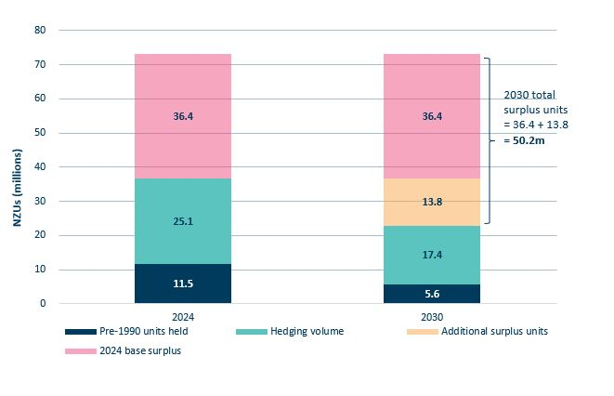

Source: Commission analysis

To estimate the hedging volume in 2030, we have had to assume an NZ ETS emissions cap over the third emissions budget period. We could not use the ERP2 emissions projections as the basis for the hedging volume, because those projections do not meet the third emissions budget.

Instead, to provide an assumed emissions cap, we adjusted the emissions projections over 2031-2035 down to a level slightly below the notified level of the third emissions budget. This is to align the assumed cap to a volume reflecting methodological updates to the GHG Inventory that have occurred since the budget was set (see the Commission’s 2024 NZ ETS settings advice for an explanation of the rationale for this).[15] The adjustment was made by dividing the 10.4 MtCO2e gap between the projections and the Inventory-adjusted budget volume by five, and subtracting the resulting volume from each year of the projections for NZ ETS sectors over 2031-2035.[16] See the text on hedging volumes in *Part 3: Units limits* in the main report for further commentary about this choice.

**Table 11** shows the resulting hedging volumes by sector estimated to be held in 2030.

Table 11: Estimated range of forward hedging volumes in 2030 by sector and scenario

|  |  |  |  |
| --- | --- | --- | --- |
| **Sector (Million NZUs)** | **Low** | **Central** | **High** |
| Liquid fossil fuels | 3.7 | 4.9 | 6.3 |
| Stationary energy | 8.2 | 11.0 | 13.7 |
| IPPU and F-gases | 0.8 | 0.9 | 1.1 |
| Waste | 0.6 | 0.6 | 0.6 |
| **SUM** | **13.3** | **17.4** | **21.5** |

### Holding volume

The EY report suggested the inclusion of new category of non-surplus units referred to as ‘holding volume’. The EY report distinguished between units held for future emissions (hedging) and units held for surrender for emissions that have already occurred (holding).

‘Holding volume’ refers to the units accumulated by emitters as emissions occur. This volume increases over the calendar year to reach 100% of an emitter’s surrender obligations by the end of December. It rises further the following year as units are accumulated for the next compliance period, until surrenders for the previous year are made in May – at which point it falls to a minimum before growing again. EY considered that this volume of units is needed for the functioning of the market, that they should be allowed for in estimating the non-surplus units, and that they were additional to the units held for forward hedging.

The EY report proposed that the minimum holding volume be incorporated into the calculations for estimating the surplus. This is the volume held in June, after surrenders have occurred for the previous year’s emissions, but when units have already been accumulated for emissions occurring in the first few months of the current year.

We agree with EY’s general logic on holding volumes. However, as we propose to use stockpile data as of end December each year for estimating the surplus, we consider it more appropriate use the estimated holding volumes at that same date. This volume is equivalent to the total estimated gross emissions in the NZ ETS cap for that year.[17] We have used a single estimate of holding volumes across our range of surplus estimates.

### Surplus units from MERP4 post-1989 forestry unit allocations

This year we identified the need to anticipate the impact of forestry units expected to be allocated at the end of MERP4. MERP4 covers 2023-2025, and post-1989 forestry participants are only required to submit emission returns after it ends, in 2026 (although some will report more frequently on a voluntary basis). Participants may receive (or surrender) units in 2026 for all their forestry activities over 2023-2025.

The timing of MERP4 allocations means that forestry units will be allocated in 2026 for removals that occurred in the first emissions budget period, and which have already been counted against that budget in the GHG Inventory. These units could therefore contribute to the second emissions budget being missed, because emitters could use them to emit but they do not correspond to a removal occurring in the relevant budget period.

In theory, the forestry units generated from removals over 2023-2025 are needed by emitters to meet their obligations over those years. However, in our calculation of the unit surplus, the demand from emitters for emissions in 2023 and 2024 is already accounted for.

Demand from 2023 emissions was addressed in the May 2024 surrenders. We start our estimation of the surplus with the units in the registry as at 31 December 2024, after those surrenders. Demand from 2024 emissions is now provided for by the new ‘holding volume’ category (see previous section). Only demand from 2025 emissions remains to use up the further units that will be allocated for MERP4.

Demand from foresters’ own harvesting of post-89 forests is already provided for by the non-surplus category, units held for harvest obligations. These units will be surrendered as forests are harvested, reducing the stockpile. This will not, however, change the surplus – since it is the volume of non-surplus units that will decrease through the surrenders.

As units are allocated for the growth of post-1989 forests, a portion earnt under stock change accounting will be needed for future harvest liabilities. When allocated, these will contribute to the non-surplus estimate – similarly not changing the surplus estimate.

It is only the forestry unit allocations considered ‘low-risk’, i.e. free of harvest obligations, that could contribute to the surplus.

In determining our estimate of MERP4 surplus units, we first estimated the still-to-come unit allocations that represent low-risk carbon. **Table 12** sets out these figures based on our low, central and high estimates of low-risk carbon units.

Table 12: Low-risk forestry unit breakdowns based on forecast and actual MERP4 allocations

|  |  |  |  |
| --- | --- | --- | --- |
| **Category** | **Low** | **Central** | **High** |
| **Total forecast forestry unit allocations for MERP4 (2023-2025)** | **35.2** | **37.0** | **36.9** |
| Estimated allocations to be held for future harvest liabilities | 17.9 | 15.3 | 12.8 |
| Estimated low-risk forestry unit allocations | 17.3 | 21.8 | 24.1 |
| **Actual forestry units already allocated for MERP4** | **7.4** | **7.4** | **7.4** |
| Estimated actual allocations held for harvest | 3.8 | 3.1 | 2.6 |
| Estimated actual low-risk forestry unit allocations | 3.6 | 4.3 | 4.8 |
| **Estimated remaining low-risk forestry unit allocations for MERP4** | **13.7** | **17.4** | **19.2** |

In considering the forestry units allocated to date for MERP4, it is possible that the net allocations to date represent a higher level of allocations that have had harvest liabilities netted off them by foresters in their emissions returns.[18] This does not affect the unit surplus any differently. The lower-than-actual level of low-risk allocations would be matched by units freed up from the pool of units assessed as held for harvest, as demand from forest harvesting has already been met.

We then assess gross emissions demand in the NZ ETS in 2025, compared to the unit supply theoretically available under the NZ ETS emissions cap. The difference between forecast gross emissions and NZ ETS cap is the demand that must be met from forestry allocations.

Table 13: 2025 demand to be met by forestry units

|  |  |
| --- | --- |
| **Category** | **Volume (millions)** |
| 2025 gross emissions | 33.6 |
| 2025 net emissions – ‘NZ ETS cap’ | 26.2 |
| **2025 demand to be met from forestry unit allocations** | **7.4** |

Finally, we subtract the estimated 2025 demand to be met from forestry allocations (7.4 million units) from the estimated still-to-come MERP4 low-risk forestry unit allocations (17.4 million for the central estimate). The remaining units are set out in **Table 14** and have been added to our estimate of the surplus, as set out in **Table 15.**

Table 14: Estimated range of MERP4 surplus units yet to be allocated

|  |  |  |  |
| --- | --- | --- | --- |
|  | **Low** | **Central** | **High** |
| Additional MERP4 units above 2025 demand (millions) | 6.3 | 10.0 | 11.8 |

Figure 10: Step through of calculation of surplus units from MERP4 post-1989 forestry unit allocations

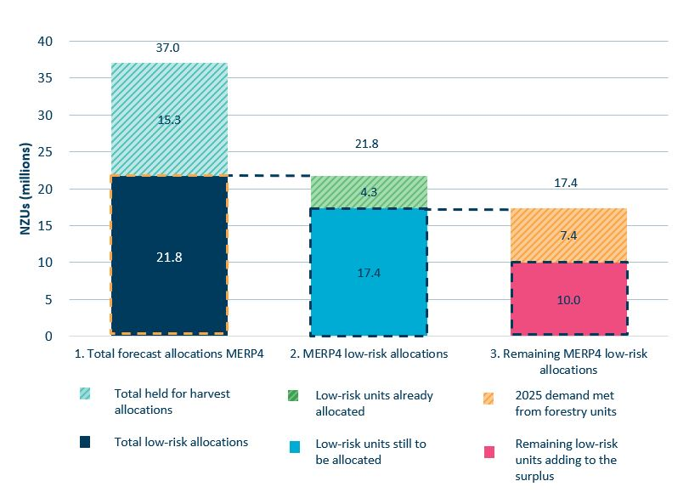

Source: Commission analysis. Allocation data supplied by the Ministry of Primary Industries.

### Base surplus estimate

The calculation of our surplus units estimate, based on all the previous estimates made as part of step 5, is set out in **Table 15.** For each category of units estimated, we have presented a range of low, central, and high values, except for holding volumes which use the same estimate across the range. We use the central estimate as the basis for the surplus reduction volumes used to calculate available auction volumes.

Table 15: Calculation of central surplus estimate, with high-low estimate range (million units)

|  |  |  |  |
| --- | --- | --- | --- |
| Total privately held units (31 December 2024) | 150.4 | | |
| Breakdown of surplus estimate | Low | Central | High |
| Pre-1990 units held long-term | -9.1 | -5.6 | -3.4 |
| Units held for post-1989 harvest liabilities | -63.5 | -53.1 | -43.7 |
| Units held for hedging in 2030 | -21.5 | -17.4 | -13.3 |
| Holding volume | -34.2 | -34.2 | -34.2 |
| Surplus units from MERP4 forestry allocations | +6.3 | +10.0 | +11.8 |
| **Total surplus estimate** | **28.4** | **50.2** | **67.7** |

While we calculate a central estimate of the surplus, the surplus is dynamic. It can change over time based on NZ ETS participants’ changing intentions and decisions. In particular, the flexibility afforded to foresters under NZ ETS rules means choices are available with respect to forests on stock change accounting – for example, to delay harvesting or to not harvest their forest – that could significantly impact the size of the surplus.

The uncertainty range around the central surplus estimate has increased compared to last year, from approximately 33 million to 49 million.

This is due to the cumulative, significant uncertainties in the estimates used to calculate the surplus. Of the categories incorporated into the surplus estimate, the largest uncertainty range relates to the estimate of post-89 units held for harvest, at approximately 20 million. We expect this will always remain a highly uncertain category and the large range is a fair representation of how variable it may be.

We have considered the implications of the uncertainty range, in terms of whether the surplus in fact lies closer to the low or high estimates. As the surplus is drawn down closer to zero, the uncertainty in the estimate becomes more important, since there is less time to adjust as new information becomes available.

If the surplus is closer to the low estimate, the proposed surplus reduction volumes in this advice for 2025-2027 would fully draw it down before the end of 2027. In that case, it could be difficult to adjust unit limits in response, given the strict criteria for changing unit limits in the first two years. However, the low surplus estimate is still greater than the planned surplus reduction volume for 2025-2026. Therefore, if needed, more immediate changes could be made in 2026 to update volumes from 2027 onwards if the statutory test to amend the settings for those years were judged to be met.

If the surplus was at the lower end of our estimated range, we would expect to see greater upward pressure on NZU prices – which is not currently occurring. This supports our view that it is unlikely that the surplus is at the low end of our estimated range.

If the surplus is closer to the high estimate, there is still enough auction volume planned for the latter years of the current settings period that can be reduced to allow for higher surplus reduction volumes, to draw down the currently surplus units by 2030.

**Figure 12** compares the range of surplus estimates from the 2024 EY report, our 2024 estimate, and our updated 2025 estimate. To enable comparison, the EY and our 2024 estimates have been adjusted down by 14.8 million units. This reflects the 2024 unit surplus reduction volume (7.7 million) and units that went unsold in 2024 auctions (7.1 million).

Figure 12: Comparisons of unit surplus estimate ranges

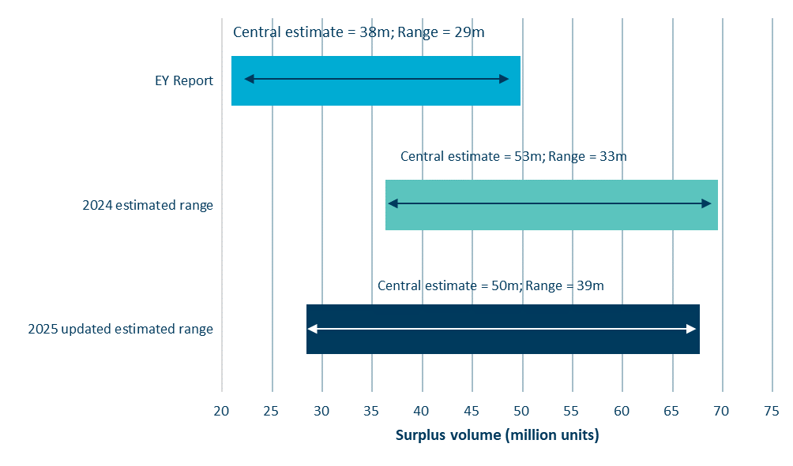

Source: Commission analysis

### Annual surplus reduction volume calculations

As in previous advice, we continue to aim to draw the surplus down to zero by 2030. We do this by implementing surplus reductions to auction volumes over the years to 2030, so that NZ ETS participants use up the surplus units that are already in the market.

**Table 16** shows how surplus reductions equating to the updated central surplus estimate (50.2 million) are applied over 2025-2030. As the unit limit settings for 2025-2027 are fixed, the surplus reductions used to determine the settings in regulations are subtracted from the updated estimate of the base surplus estimate. The remaining surplus volume is spread over 2028 – 2030 in proportion to the NZ ETS emissions cap.

Table 16: Annual surplus reduction calculations

|  |  |  |  |  |  |  |  |  |
| --- | --- | --- | --- | --- | --- | --- | --- | --- |
|  | **Fixed** | | | **Updated** | | | | **Total** |
| **2025** | **2026** | **2027** | | **2028** | **2029** | **2030** |
| Annual surplus reduction volume (million) | 12.5 | 11.5 | 10.5 | | 5.4 | 5.3 | 5.0 | **50.2** |
| % of total surplus estimate | 25% | 23% | 21% | | 11% | 10% | 10% | 100% |
| % of NZ ETS emissions cap allocated to surplus reduction | 49% | 50% | 50% | | 31% | 35% | 40% | 44% |

## Step 5b: Discrepancy adjustment

This step adjusts for differences in unit volumes relevant to the settings for years that cannot be changed, due to the rules limiting how the regulations can be updated.

In this advice we propose to update the unit limits only from 2028 onwards. This means we need to calculate a discrepancy adjustment related to unit volumes over 2025-2027, as the unit limits for those years are fixed. The discrepancy adjustment is then applied to the volumes for 2028-2030.

The discrepancy adjustment factors in the following differences in this year’s updated volumes compared to those used to determine the unit limits currently in regulations:

* A lower NZ ETS emissions cap, based on the provisional cap set out by the Government in ERP2.
* A technical adjustment no longer being applied with respect to liquid fossil fuels.
* Reduced forecast industrial allocation volumes.
* A recalculation of the previously applied discrepancy adjustment.

The summary of the discrepancies is shown in **Table 17**.

Table 17: Difference in current settings from updated volumes across these categories (million units)

|  |  |  |  |  |  |
| --- | --- | --- | --- | --- | --- |
| **(Million units)** | **2025** | **2026** | **2027** | **SUM 2025-2027** | **Impact on 2028-2030 auction volumes** |
| Step 2. NZ ETS cap | 0.0 | 0.2 | 0.6 | 0.8 | Reduce |
| Step 3. Technical adjustments | -0.8 | -0.7 | -0.7 | -2.2 | Increase |
| Step 4. Industrial free allocation forecasts | -0.9 | -0.6 | -0.6 | -2.0 | Increase |
| Step 5b. Discrepancy adjustment | -0.3 | -0.3 | -0.3 | -0.9 | Increase |
| **Total net impact** | **-2.0** | **-1.4** | **-1.0** | **-4.4** | **Increase** |

The total discrepancy 2025-2027, 4.4 million units, is added to auction volumes over 2028-2030, in proportion to the NZ ETS emissions cap over this period.

Table 18: Annual discrepancy adjustment volumes

|  |  |  |  |
| --- | --- | --- | --- |
| **(Million units)** | **2028** | **2029** | **2030** |
| Annual discrepancy adjustment  (increase in auction volumes) | 1.7 | 1.5 | 1.2 |

## Step 7: Calculate auction volumes

Step 7 takes the NZ ETS emissions cap and subtracts volumes estimated in the other steps of the methodology, to determine the final proposed auction volumes.

Base calculations in each step are not rounded until the final auction volumes are calculated, potentially resulting in some minor inconsistencies with the numbers shown in **Table 19**.

See *Part 3: Te Herenga utu - Unit limits* in the main report for information on our judgement about how to distribute auction volumes across the 2028 – 2030 years.

Table 19: Unit supply steps and final proposed annual auction volumes

|  |  |  |  |  |  |  |  |  |  |
| --- | --- | --- | --- | --- | --- | --- | --- | --- | --- |
| **Units (millions)** | **Current settings** | | | **Updated** | | | **New** | | **Total** |
|  | **2026** | **2027** | **2028** | | **2029** | **2030** | |  | |
| Step 1: Align with emissions reduction targets | 65.7 | 63.4 | 60.4 | | 57.9 | 55.2 | | 302.6 | |
| Step 2: Allocate volume to sectors outside the NZ ETS | -42.3 | -41.9 | -42.8 | | -42.7 | -42.6 | | -212.4 | |
| Step 2: Allocate volume to NZ ETS sectors (NZ ETS cap) | 23.4 | 21.4 | 17.6 | | 15.1 | 12.6 | | 90.1 | |
| Step 3: Technical adjustments | 0.7 | 0.7 | 0.0 | | 0.0 | 0.0 | | 1.4 | |
| Step 4: Industrial allocation | 5.7 | 5.7 | 4.6 | | 4.5 | 4.0 | | 24.4 | |
| Step 5a: Surplus reduction | 11.5 | 10.5 | 5.4 | | 5.3 | 5.0 | | 37.7 | |
| Step 5b: Discrepancy adjustment | 0.3 | 0.3 | -1.7 | | -1.5 | -1.2 | | -3.8 | |
| Step 6: Approved overseas units | 0.0 | 0.0 | 0.0 | | 0.0 | 0.0 | | 0.0 | |
| Step 7a: Auction volumes under linear cap | 5.2 | 4.3 | 9.2 | | 6.8 | 5.1 | | 30.5 | |
| **Step 7b: Final proposed auction volumes** | **5.2** | **4.3** | **7.0** | | **7.0** | **7.0** | | **30.5** | |

### Comparing the updated proposed volumes to the status quo

**Table 20** shows the change for each of the seven steps used to determine our updated proposed auction volumes, compared to the auction volumes available under current regulations.[19] Only the limits on NZUs available by auction (including cost containment reserve volume) are set in regulations, but this table contains the information used to calculate the auction volumes.

Table 20: Differences between calculations for updated auction volumes (2026-2030) and status quo in regulations (2025-2029).[20]

|  |  |  |  |  |  |
| --- | --- | --- | --- | --- | --- |
| Change in units (millions) | Current settings* | | Updated | | New |
|  | 2026 | 2027 | 2028 | 2029 | 2030 |
| Step 1: Align with emissions targets | 0 | 0 | -0.6 | -0.7 | -0.1 |
| Step 2: Set the NZ ETS cap | 0 | 0 | -1.2 | -1.5 | -1.8 |
| Step 3: Technical adjustment | 0 | 0 | 0.7 | 0.7 | 0.6 |
| Step 4: Industrial allocation volumes | 0 | 0 | 1.0 | 1.0 | 1.1 |
| Step 5a: Surplus reduction volumes | 0 | 0 | 4.1 | 3.2 | 2.1 |
| Step 5b: Discrepancy adjustment | 0 | 0 | 1.8 | 1.7 | 1.4 |
| Step 7a: Initial auction volumes | 0 | 0 | 5.9 | 4.4 | 3.4 |
| Step7b: Final auction volumes | 0 | 0 | 3.7 | 4.6 | 5.3 |

*Our advice this year does not propose any changes for unit limits for 2026 or 2027, in line with the requirements of the Act. See step 5b in *Part 2: Te herenga utu – Unit limits* in the main report for more detail.

References



**He Pou a Rangi  
Climate Change Commission**

Level 21, 1 Willis Street  
Wellington 6011  
PO Box 24448  
Wellington 6142  
  
[www.climatecommission.govt.nz](http://www.climatecommission.govt.nz)

1. Ministry for the Environment. (2024). *Detailed results for ERP2 projection scenarios.* <https://environment.govt.nz/assets/publications/climate-change/ERP2/Detailed-results-for-ERP2-projection-scenarios.xlsx>
2. Ministry for the Environment. (2024). *New Zealand’s second emissions reduction plan 2026***–***30: Technical annex*. Appendix 4, page 90. <https://environment.govt.nz/publications/second-emissions-reduction-plan-technical-annex/>
3. The emissions pathways from *Ināia tonu nei* were updated for methodological improvements to the estimation of emissions in 2023. This updated path was used to determine the proportion of biomass emissions.
4. Post-1989 forest refers to land first planted in forest in New Zealand on or after 1 January 1990.
5. Ministry for Primary Industries. (2023). *Deforesting pre-1990 forest land.* <https://www.mpi.govt.nz/forestry/forestry-in-the-emissions-trading-scheme/deforesting-and-the-ets/deforesting-forest-land/>
6. MERPs generally cover five years, although the current MERP4 is only three years long, 2023-2025.
7. Ministry for the Environment. (2025). *Results of the 2023 data collection process*. [environment.govt.nz/Overview of industrial allocation](https://environment.govt.nz/what-government-is-doing/areas-of-work/climate-change/ets/participating-in-the-nz-ets/results-of-the-2023-data-collection-process/)
8. Methanex. (2024). *Methanex Reports Higher Production and Adjusted EBITDA in Fourth Quarter 2024*. <https://www.methanex.com/news/release/methanex-reports-higher-production-and-adjusted-ebitda-in-fourth-quarter-2024>
9. Ernst & Young (2024). *New Zealand’s Emissions Trading Scheme (ETS) NZU Surplus Advice*. <https://environment.govt.nz/assets/publications/climate-change/nzets-nzu-surplus-advice.pdf>
10. Environmental Protection Authority. (2024). *Privately held units*. <https://www.epa.govt.nz/industry-areas/emissions-trading-scheme/market-information/privately-held-units/>
11. This methodology has only been applied to *Pinus radiata*, not all exotic species, as pine makes up the significant majority of approximately 85% of total exotic forest hectares
12. Ministry for Primary Industries. (2018). *Deforestation Intentions Survey*. <https://www.mpi.govt.nz/dmsdocument/37110-Deforestation-Intentions-Survey-2018>
13. Post-1989 forestry participants are only required to submit an emissions return at the end of a Mandatory Emissions Reporting Period (MERP). However, on a voluntary basis they can submit provisional emissions returns more frequently. Provisional returns can be submitted over 1 January – 30 June in the year after the year covered by the return. Note, MERPs generally cover five years, although the current MERP (MERP4) covers only 2023-2025.
14. This graph does not show the estimated forestry units held for harvest or the annual holding volume (described below). These categories of units are directly associated with surrender obligations and will not contribute to the surplus in the same way.
15. He Pou a Rangi Climate Change Commission. (2024). *Advice on NZ ETS unit limits and price control settings for 2025-2029.* <https://www.climatecommission.govt.nz/our-work/advice-to-government-topic/nz-ets/our-advice-on-the-nz-ets/nzets-advice-2025-29/>
16. The ERP2 emissions projections did not provide a breakdown of non-transport energy emissions by fuel type to apportion the emissions reductions by sector. So we also applied an assumption that these reductions match the relative shares of those emissions from the Commission’s modelled demonstration path from our advice on the fourth emissions budget.
17. More specifically, we assume that the units to be surrendered exist in the stockpile by the end of the calendar year. Whether they are held by emitters directly, indirectly via third parties, or are yet to be purchased does not affect the overall calculation of the surplus so long as the units are in the registry.
18. The data that we have categorises a return as ‘an allocation’ or ‘a surrender’ based on the net impact of the return across all of its forest areas. In an emissions return surrender obligations and allocations can be netted off against one another.
19. The current unit limit regulations are set out in Schedule 3 of the Climate Change (Auctions, Limits, and Price Controls for Units) Regulations 2020 available on the New Zealand Legislation website: <https://www.legislation.govt.nz/regulation/public/2020/0264/latest/LMS375230.html?src=qs>.
20. Sign convention used to show differences here reflects the impact of each change on auction volumes. Differences for 2030 are estimated against the forecast values for 2030 from our 2024 advice.